**T5L_DGUSII application** development guide.

**V1.0**

The first chapter of the catalog starts quickly 5.

1.1 Model Naming Rule  5.

1.2 Interface definition and wiring  6.

1.3 Screen power  8  .

1.4 Drive Installation  8  .

1.4.1 Serial drive  8  .

1.4.2 Software operating environment driver  10.

1.5 Software installation  10  .

Chapter II Introduction T5L_DGUS II  Development System  11.

2.1 T5L ASIC 芯片简介 11

2.2T5L_DGUS 13  of the Development System  ii.

2.3T5L_DGUS II Development System Feature  14.

2.4T5L_ DGUS II Software Process  15.

2.5 FLASH Memory Allocation  16.

2.6 RAM memory variable address space  17.

2.7 RAM describes pointer space  18.

第三章 SD 接口 20

3.1 MicroSD(TF) 卡格式 20

3.2SD card interface download method  20.

3.3 Download file description  21.

3.3.1 Download file type  21.

3.3.2 Download file generation  21.

3.3.3 Download File Process  30.

3.4SPI FLASH 存储器空间 31

3.5 RAM memory space  31  .

Chapter 4 UART2  Serial Communication Protocol  32.

4.1 Data frame structure  32.

4.2 UART2 Debug Interface Directive  33.

4.2.1 Write variable memory instruction instruction (0x82) 0x82 ） 34.

4.2.2 Read variable memory instruction instruction (0x83) 0x83 ） 34.

4.2.3 Touch the button to return to serial data (0x83) 0x83 ） 35.

Chapter 5 System Variable Interface 36.

5.1 System Variable Interface  36.

5.2 Network interface  41.

Chapter 6 Touch Variable Configuration (13.BIN) Description  45.

6.2 Variable data entry  47  .

6.2.1 Variable data entry instruction format  47.

6.2.2 Variable data entry software setting 49.  49

6.3 Pop-up menu  51  .

6.3.1 Pop-up menu instruction storage format  51.

6.3.2 Pop-up menu software settings  52.

6.4 Incremental  adjustment 54  .

6.4.1 Incremental adjustment instruction storage format  54.

6 .4.2 Incremental  adjustment software setting  55.

6.5 Drag adjustment  57  .

6.5.1 Drag adjustment instruction storage format  57  .

6.5.2 Drag adjustment software setting 58  58  .

6.6 The key value returns  59.

6.6.1 The key returns the  command storage format  59  .

6.6.2 The button returns software setting  60.

6.7 Text entry  61  .

6.7.1 ASCII 文本录入 62

6.7.2 GBK 汉字录入 64

6.8 Touch screen press status data returns  67  .

6.8.1 Touch screen press status data returns instruction storage format  67.

6.8.2 Touch screen press status data return software setting  68.

6.9 Slide (gesture) to adjust  69  .

6.9.1 Slide (gesture) to adjust the instruction storage format  69.

6.9.2 Slide (Gesture) Adjustment Software Settings Note  69  .

6.10 Swipe (gesture) to turn page  70.

6.10.1 Slide (gesture) page-turning instruction storage format  70.

6.10.2 Slide (Gesture) Page-turning software settings note  70.

6.11 Slide icon select  71  .

6.11.1 Slide icon select instruction storage format  71.

6.11.2 Slide icon select software settings instruction  71.

Chapter 7 shows the variable configuration function (14.BIN) Description  72.

7.1 Display variable function at a glance  73  .

7.2 Icon variable  75  .

7.2.1 Variable chart  shows  75  .

7.2.2 The animation icon shows  77  .

7.2.3 Slider scale indicates  80  .

7.2.4 The art word variable shows  82  .

7.2.5 Picture animation shows  84  .

7.2.6 Icon rotation indicates that  85 is displayed.

The 7.2.7-bit variable icon shows  87.

7.2.8 JPEG icon pan shows  90  .

7.3 Text variable  91  .

7.3.1 The data variable shows  91  .

7.3.2 Text shows  96  .

7.3.3 The data window indicates  100  .

7.3.4RTC 显示 103

7.3.5HEX 变量显示 107

7.4 Graphic variable  109  .

7.4 .1 The  real-time curve (trend chart) shows  109  .

7.4.2 Basic graph shows  114  .

7.4.3 Zone Roll 129.  区域滚屏显示

7.4.4 QR code shows  130  .

Chapter 8 Software common features use 132.

8.1 Import Restore  132.

8.2 Key alignment  133  .

8.3 Key  front and rear function 133.  键置前、置后功能

8.4 View variable address usage planning  134.

8.5 Software Feature Preview  134  .

8.6 New resolution  135.

8.7 Conversion resolution  135  .

附录 1 ： T5L_DGUS II 屏常见应用问答 FAQ 137

Appendix 2: Revised record  138.

# The first chapter starts quickly.

## **1.1** Model naming rules.

Table 1.1 Model Naming Rules.

|  |  |  |
| --- | --- | --- |
| Product line coding. | DM | Devon Smart Screen Product Line. |
| Color coding. | 1 character. | B-单色D-256色 T-65K 色 G-16.7M 色 |
| Resolution. | 5 digits. | 32240=320*240 48270=480*272 64480=640*480 80480=800*480 85480=854*48080600=800*600 10600=1024*600 10768=1024*768  12720=1280*720 12800=1280*800 13768=1364*768或1366*768  19108=1920*1080 |
| Classification. | 1 character. | The消费级 C-商业级商业级 T-工业级工业级K-医级 Q船级车船级'S' 工级 K= S= |
| Size number. | 3 digits. | 022=2.2 寸 024=2.4 寸 028=2.8 寸 035=3.5 寸 040=4.0 寸 043=4.3 寸  047=4.7 寸 050=5.0 寸 056=5.6 寸 057=5.7 寸 064=6.4 寸 070=7.0 寸  080=8.0 寸 084=8.4 寸 090=9.0 寸 097=9.7 寸 101=10.1 寸 104=10.4 寸  121=12.1 寸 150=15.0 寸 156=15.6 寸 185=18.5 寸 |
| _ | _ | Separator. |
| Property encoding. | 1 digit or character. | 0 - Basic type.  1 - Basic type with housing.  2 - Analog video processing platform products.  3 - Android platform products.  4 - Digital video processing platform products.  A=DGUS2 内核产品 B=DGUS3 内核产品 |
| The hardware serial number. | 1 digit. | 0-9 to distinguish between different hardware versions. |
| LCD temperature level. | 1 character. | N=温 W=宽温 |
| Touch screen category. | 1 或 2 位字符 | N - No touch screen TR - Resistance touch screen TC - Capacitive touch screen. |
| Custom tags. | The two-bit serial number of the Z-plus. | Z01-Z99,standard item is empty. |
| Extended memory tags. | The number of the F-1 digits. | F0=512MB F1=1GB F2=2GB F3=3GB,标准品此项为空。 |

## **1.2** Interface definition and wiring.

Table 1.2 Interface definition and wiring.

|  |  |  |  |  |  |
| --- | --- | --- | --- | --- | --- |
| Pin name. | Pin type. | Pin description. |  | The type of socket. |  |
| CN1 Pin No. | CN2 pin sequence number. | C3 Pin No. |
| **VCC** | P | Power supply input. | 1,2 | 1,2,3 | 1 |
| **TX4** | The | Serial 4 output. | 3 | 4 | 2 |
| **TX2** | The | Serial 2 output. | 4 | 5 | 3 |
| **RX2** | I | Serial 2 input. | 5 | 6 | 4 |
| **RX4** | I | Serial 4 input. | 6 | 7 | 5 |
| **GND** | P | Public places. | 7,8 | 8,9,10 | 6 |

Note:

1. I:INPUT,O: OUTPUT,，P: POWER 根据选型手册或数据手册确认屏幕对应的电压和功耗，通过直流稳压电源 lights up the screen with a DC-stabilized power supply of 5V/12V/24V, depending on the selection manual or data sheet to confirm the voltage and power consumption of the screen. The power supply has a very important role in the normal display of the screen, the voltage is too small, the current is unstable, the power is too low may lead to flash screen, black screen and other abnormal display phenomenon.
2. The PCB pins of the same defined pins are already connected in a union.
3. CN1：采用 8 Pin 2.0mm 间距贴片插座；

CN2：采用 10 Pin 1.0mm 间距 FPC 贴片座；

CN3：额外提供 6Pin 2.54mm 间距通孔焊盘。

1. Serial 2 develops a communication protocol for Devin's DGUS2 mode, please refer to the fourth chapter of this article for detailed instructions; ；

T5L DGUS products all have extended serial port, 扩展串口为 the extended serial port is UART4,its configuration and communication needto be done through the DWIN OS program.

Serial instruction set mode only serial 2 communication other non-serial 2 communication temporarily no open function.

1. Some Of the Devine models feature a TTL/RS232 兼容接口，用户可以用 compatible interface, where the user can select the TTL level input with， 选择 a 0 欧电阻或者焊锡直接短接 ， Euro resistor or solder direct short, 断开 R232-0 TTL (short) and（短接）选择 R232-1 (disconnect) to select the RS232 level. Figure 1.0,where there is a white silk mark, factory by default to disconnect 232 levels, short 为 on the TTL,，即 that is, OFFs232,，ONs TTL.

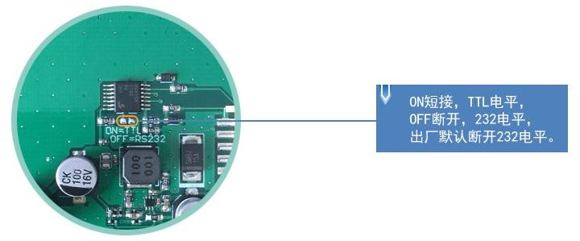

Figure 1.0 level selection.

1. **10pin** 接口

FCC hetero-line one end connected screen terminal base, blue side up, the other end connected HDL662B 转接板，同样蓝色面朝上，双公头 adapter board, the same blue side up, double male USB cable one end connected adapter board, one end connected to the computer to achieve communication.

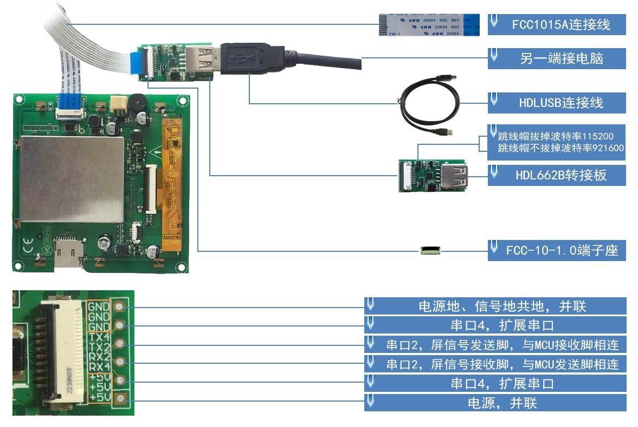

Figure **1.1 10pin interface** definition and wiring instructions.

1. **8pin** 接口

8PIN 接口为 2.0mm 间距。

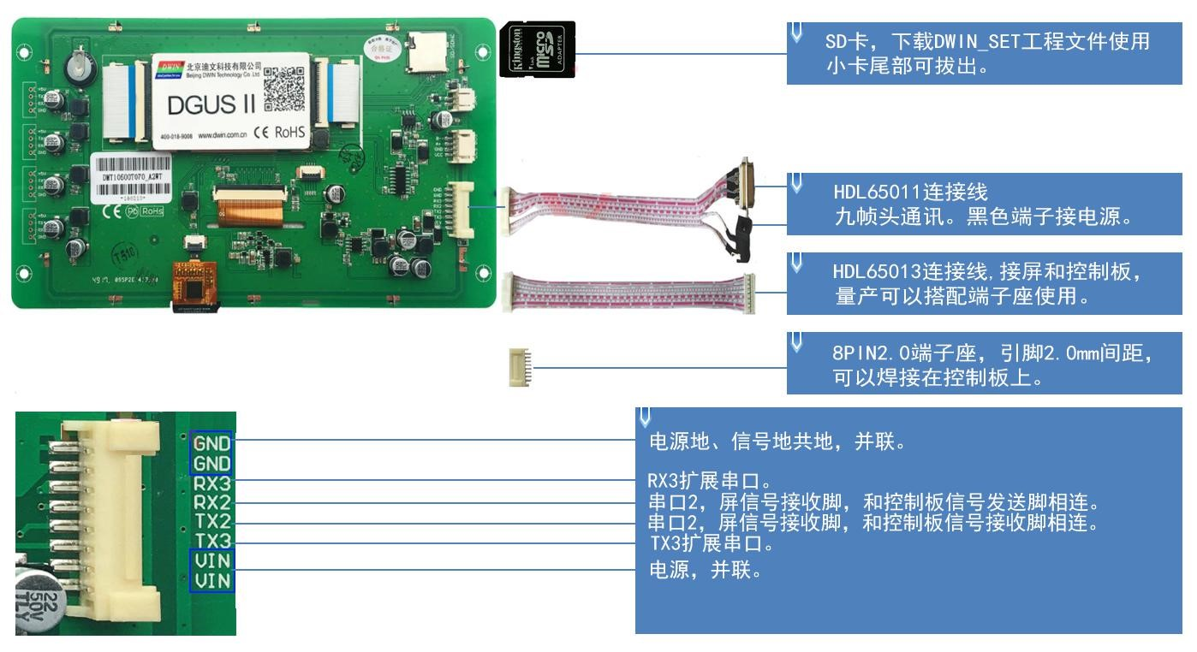

Figure **1.2 8pin2.0** Wiring, interface definition description.

## **1.3 Screen** power.

Confirm the screen voltage and power consumption according to the selection manual or data sheet and light the screen with switching power. Switch power supply to the normal display of the screen has a very important role, voltage is too small, current instability, low power may lead to flash screen, black screen and other abnormal display phenomenon, due to insufficient power supply caused by flash screen phenomenon is the most common.

## **1.4** Drive installation.

#### **1.4.1** Serial drive .

Devin serial adapter board USB-to-UART chip 芯片有 has XR21V1410 chip 芯片和 and CP2102 chip two, depending 芯片两种，根据芯片类型，可到迪文官网下载或咨询 on the type of chip, can download to Devin official website or consult 400 technical support to 技术支持获得并安装相应驱动，以便 obtain and install the corresponding driver, so that DGUS screen communication.

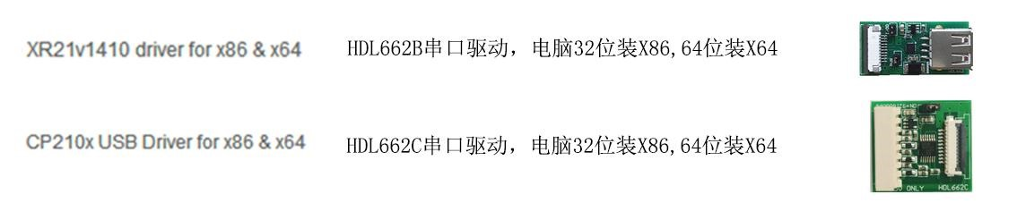

Figure **1.3 Serial** drive .

The steps are as follows: .

第一步：右键单击“我的电脑”；点击最下方“属性”；点击左上方“设备管理器”，弹出“设备管理器”操作框，右击“USB Device”，选择“更新驱动程序”。

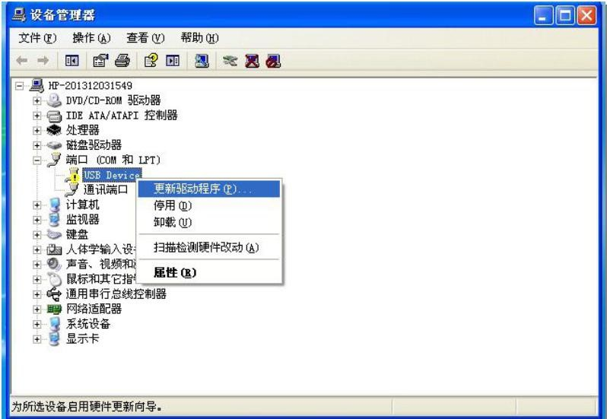

Figure **1.4 Choose to** update the driver.

Step 2: Select Next in the “ pop-up window.

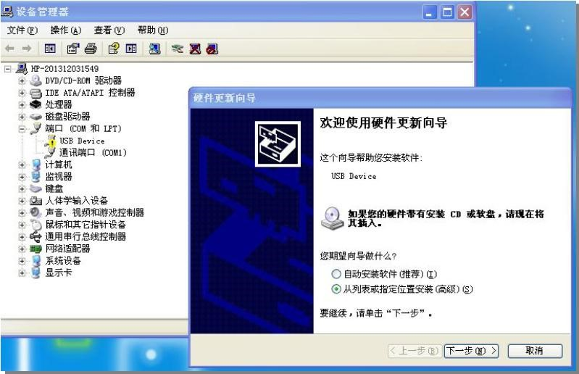

Figure **1.5 Serial** drive path selection.

Step 3: Select the serial-driven path to complete the driver update.

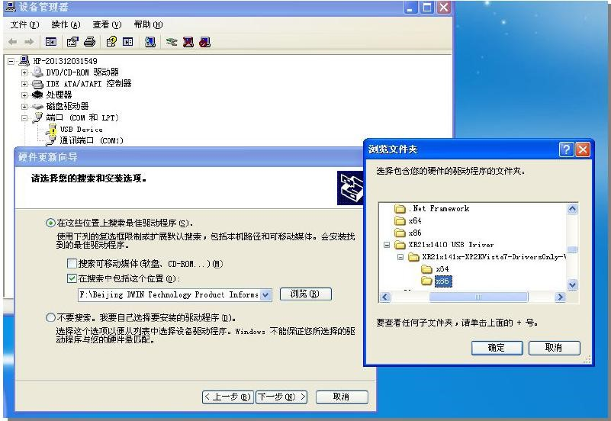

Figure **1.6 Serial** drive path selection.

Step 4: The installation is complete and the port number for the driver can be viewed in Device Manager.

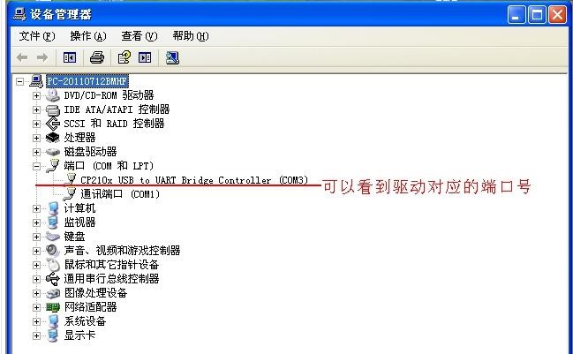

Figure **1.7 Serial** drive installation is complete.

#### **1.4.2 Software** operating environment driven.

Installation steps: Get the software operating environment, double-click on the installation.

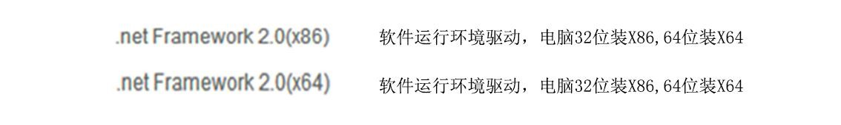

Figure **1.8 Software** operating environment-driven.

## **1.5** Software installation.

Download the software from our [**http://www.dwin.com.cn/**](http://www.dwin.com.cn/下载DGUS_T5L开发软件或向400) [website](http://www.dwin.com.cn/下载DGUS_T5L开发软件或向400) [DGUS_T5L software](http://www.dwin.com.cn/下载DGUS_T5L开发软件或向400)  [or get](http://www.dwin.com.cn/下载DGUS_T5L开发软件或向400) [400](http://www.dwin.com.cn/下载DGUS_T5L开发软件或向400)  technical support.

# Chapter II: **Introduction T5L_DGUS II** Development System.

## **2.1 Introduction to T5LASIC** chips.

The T5L 应用设计的低功耗、高性价比、 Series ASIC is a low-power, cost-effective, GUI and highly integrated single-chip dual-core ASIC designed by Devon Technologies for AIoT applications.

IC，包括T5L1（55nm工艺）和T5L2（40nm工艺）两个版本，其主要特点包括：

1. With the most widely used, mature and stable 8051 cores,1T(single instruction cycle)high-speed operating, up to 300MHz.
2. 独立的CPU核（GUI CPU）运行DGUS 2系统：
   * 内置高速显存，2.4GBytes/S显存带宽，24bit彩色显示分辨率支持到800*600（T5L1）或1366*768（T5L2）。
   * Full hardware 2D acceleration, supporting image hardware rotation.
   * 200MPPS 的图片显示仅需 ，动画和图标为主的 硬件解码器，分辨率 （(1920 x 1080@100fps)）的 JPEG hardware decoder, 800 x 600 image display only 5mS,animation and icon-based UI is extremely cool and smooth.
   * JPEG compression mode stores pictures and icons, greatly increasing storage density.
3. The CPUCPU核(OS ： CPU)(いい8051码或迪DWIN统 OS系统代码或迪文
   * 标准8051架构和指令集，64Kbytes代码空间，32Kbytes片内RAM。
   * 64bit 整数型数学运算单元（MDU），包括64bit MAC和64bit 除法器。
   * Built-in software WDT,，3 个 16bit Timers,，12 interrupt signals support up to four levels of interrupt nesting.
   * 22个IO，4 路UARTs，1 路CAN接口，最多8路12bit A/D，1 路16bit分辨率可调的PWM。
   * IAP online simulation and debugging is supported, with an unlimited number of break IAP points.
4. 1Mbytes in-chip Flash, Devonpatented encryption technology to ensure code and data security, eliminate shanzhai and cloning.
5. Oscillators and PLLs designed for a wide range of inexpensive tuning impedancecrystals reduce crystal requirements and PCB design difficulties.

63.3V IO电压.可以适应1.8/2.5/3.3 各种电平）。

1. Supports SD interface download and configuration, and SD card files are read and overwrite.
2. Supports Devon WiFi Module 模块 0 code access to The Devon Cloud to easily develop a variety of cloud applications.
3. -40C - s85C 工作温度范围（可定制 operating temperature range (customizable -55C - 105C operating temperature range IC).
4. Low power consumption and strong anti-jamming capability make it easy to passEMC/EMI testing in a two-sided PCB design.
5. In a 0.4mm ELQFP128 package, manufacturing is difficult and costly.
6. For industry customers to provide T5L IC plus LCD screen and touch screen cost-effective package sales and full-service support.

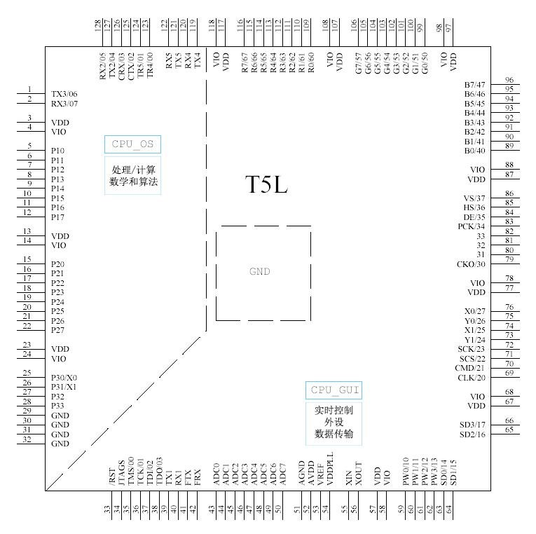

Figure **2.1T5LASIC** pin arrangement chart.

## **2.2T5L_DGUS ii** development system.

The DGUS development system consists of DGUS screens and DGUS development software. DGUS is an abbreviation for DWIN Graphics Utilized Software. The DGUS screen works on a profile-based basis, so the entire development process is a process in which users complete variable 端 profiles using PC-side DGUS development PC software-assisted design.

1. Variable planning.

Users can make a table before doing the work, boxing and planning the required variable addresses for subsequent modifications and maintenance.

1. Interface design.

Simple interface users can make their own, complex or aesthetic requirements of the interface can let professional art production. Icon picture making is the same as picture.

1. Interface configuration.

， 生成 Configure 选项的 “ 保存 the interface with PC-side T5L_DGUS2 软件对界面进行配置，做完工程，依次点击软件左上角 software, complete the project, click "Save" and "Build" 文件 in the upper left corner of 与 the 生成 software option to generate a 13.BIN touch profile,a14.BIN display profile, 显示配置文件，以及 and a 22.BIN variable initialization file. .

1. Test the modifications.

Put the required files DWIN_SET folder and download them to the screen via the SD card. The order is: screen off - plug-in card - power-on - blue screen read.

SD 卡内容，下载完成显示“SD Card Process … END！”——掉电、退出 SD 卡——上电。

1. Final archive.

After the final version of the profile, picture files, icons, word libraries, etc. into the DWIN_SET folder, production can be downloaded through the SD card.

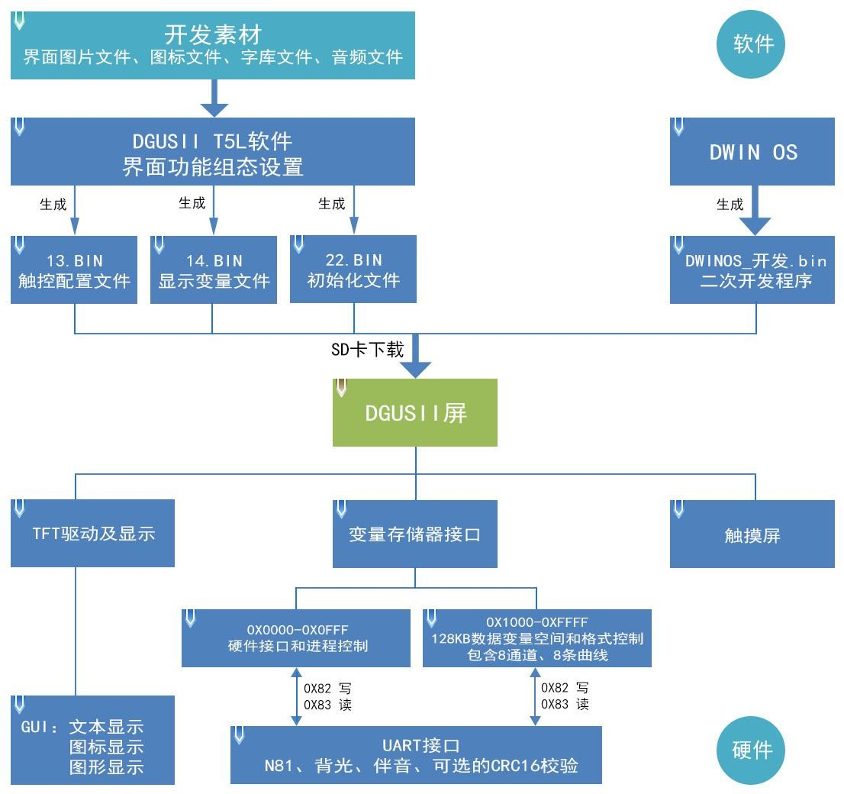

Figure **2.2T5L_DGUS2 development** system illustration.

## **2.3T5L_DGUS ii** development system features.

Unlike traditional LCM displays through timing or instruction control,DGUS screens use direct variable-driven displays,all of which work based on pre-set variable profiles, and two different ways of working result in completely different software architectures and secondary development difficulties when developing applications.

In the DGUS development platform, it is developed by using controls. The control encapsulates the properties and methods of the defined data, and the user only needs to be in .

The PC side configures and uses the controls. The controls required for common human-computer interaction functions have been defined in DGUS, and the software is easy to use and efficient. In some small and medium-sized industrial automation project applications, when the entire system is composed of relatively independent, fully functional components (such as modbus protocol-enabled thermostats or other secondary meters), users can directly use DGUS 当作主机使用，用 as a host, with 485 network 网络把设备和 devices and DGUS 屏组成一个网络，基于 screen into a network, based on the DGUS screen mounted 屏上搭载的二次开发平台来直接开发用户主控软并直接在 on the secondary development platform to directly develop user-controlled soft and directly on the DGUS screen. The CPU is working.

T5L_DGUS II 的周期内，要将 platform specifies that the refresh cycle 和 for DGUS 的刷新周期是 is 20ms,，这意味着在每一个 which means that everything in 13.BIN and 14.BIN is read once in each 20ms 20ms cycle. Currently,the development platform for DGUS II 的开发平台已经支持每一个页面放置高达 already supports up to 256 个变量，可见 variables per page, which shows that DGUS II is very powerful. At the same time, the CPU running the secondary developer has no run cycle and is completely independent of the DGUS run. Therefore, developers don't have to worry about whether DGUS 和 and DWIN OS will affect each other when the system is running at the same time.

The main features are as follows: .

1. 基于T5L双核ASIC，GUI和OS核均运行在200MHz主频，功耗极低。
2. 16Mbytes low-cost SPI Flash,，JPEG pictures, icon compression storage, you can specify the size of the background picture storage space.
3. 320Kbytes Nor Flash用户数据库。
4. 128Kbytes data variable space.
5. Up to 255 display variables per page.
6. 支持标准T5 DWIN OS平台或标准8051开发OS CPU核：硬件可以引出20个IO、4 路UART、多路AD，提供定制服务。
7. 20mS DGUS 周期，UI 极其流畅。
8. Display variables can be turned on, off, or modified in your app for complex display combinations.
9. Touch instructions can be turned on, off, or modified in an app for complex touch combinations.
10. Supports SD interface download and configuration, download file statistics show.
11. Capacitive touch screen sensitivity adjustment is supported for user front panel applications up to 6mm tempered glass.

## **2.4T5L_ the DGUS II** software process.

T5L_DGUSII In the T5L_DGUSII development platform, feature properties of ）、 各类动画等功能的特征属性通过代号来表示，并按照地址储存在了 the variables (characters, data), animations, and other features to be displayed are represented by code names and stored in a 13.BIN 文件中；将触摸屏的触摸操作的配置也通过同样的方式储存在了 file by address; What you do in the development software of DGUS II is actually to configure the controls that display the functionality or the controls that touch the functionality. When powering the system makes it work, the system calls the 13.BIN 文件和 file and the 14.BIN file to make the human-machine interface work properly.

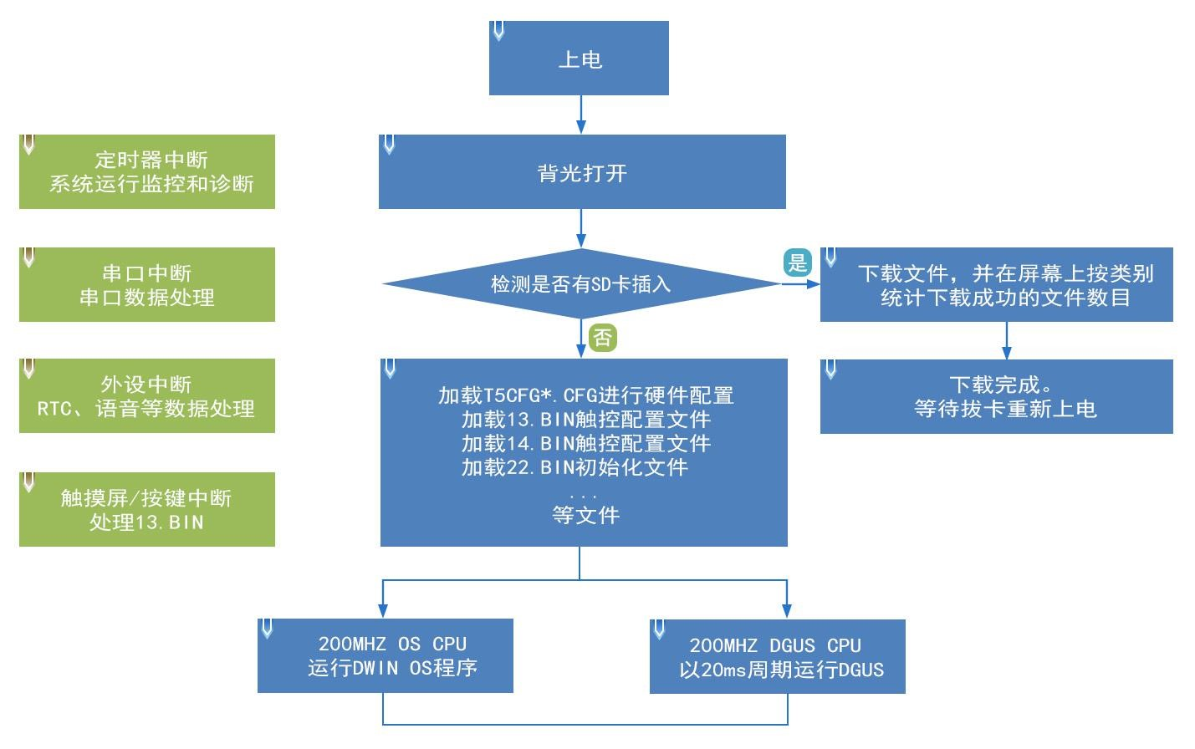

Figure **2.3DGUSII_T5L run** a flowchart.

## **2.5 FLASH** memory allocation.

A 16MB Flash memory can be thought of as splitting into 64 个容量固定为 subspaces with a fixed capacity of 256KB, 的子空间，可存放的文件 with a file ID number 号范围为 range of 0-63. The memory is divided into two parts, depending on the contents of the stored file: .

（1）4-12MB 的字库空间，可以保存 BIN、HZK、DZK 格式文件，文件 ID 范围 00~31。

(2)4-12MB picture 的图片空间，可以保存背景图片库 space, you can save the background picture library ICL file, 文件、图标库 icon library ICL file storage space, file ID 范围 range 16 to 63.

Note that there are overlaps between the word library space and the picture space,and IDs need to be named with care to avoid conflicts.

For T5L1 CPU platforms, a single picture file size should not exceed 文件中，单个图片文件大小不要超过 252KB inpackaged ICL filesandno more than 764KB in a single file on theT5L2 CPU 平台单个文件不超过 platform. The download file must be placed in the SD 卡根目录 DWIN_SET directory folder and must be in 4KB sector,FAT32 format.

SD 或 SDHC 卡。

It is recommended that users start with files such as a word library or icon library from the 23rd starting position, and a background picture from the 32nd starting position. ICL file, background picture storage location 卡配置 needs to be configured through SD card CFG 文件自定义 file customization,CFG file 0x08 location value call background picture . ICL file save location ID,e.g. 32 - background picture . ICL,CFG file 文件 0x08 address is required to write 0x20.

Once the common interval range is familiar, the user can set up the assignment themselves, for example, the user's location 23 号位置字库文件占用 library file occupies 10 个区间，此时背景图片位置则不能从 intervals, where the background picture position does not start at 32, 开始，而是需要从 but needs to start from the 33rd position. If a user has a page ID picture that appears as a black screen and the other ones appear correctly, this is because a single picture file size exceeds 256KB. 缘故

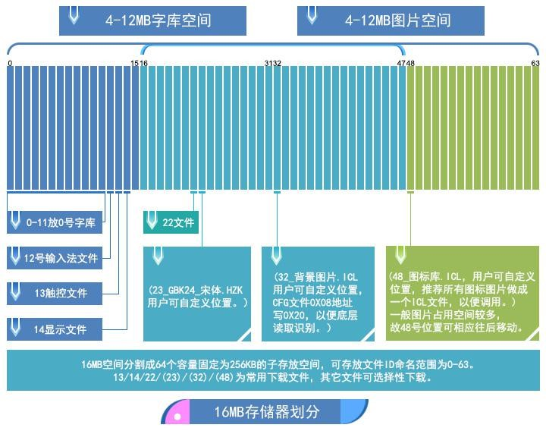

Figure **2.5 16MB** memory space map.

## **2.6 RAM** memory variable address space.

The RAM 个字节对应相应空间的 space is fixed at 128KB，分割为 and split into 0x0000-0xFFFF subspace 子空间范围，每 ranges, with 2 个变量地址对应相应空间的 bytes for each variable address and 字节，每 8 bits for the corresponding space for each 1 byte. Where 0x0000-0x0FFF is the system variable interface address space,0x1000-0xFFFF the user can not customize; If the 8-channel curve is used at the same time,0x1000-0x4FFF will act as the curve buffer address, at which point the variable address cannot be used by other keys, and the other key addresses can be used in the range of0x5000-0xFFFF.

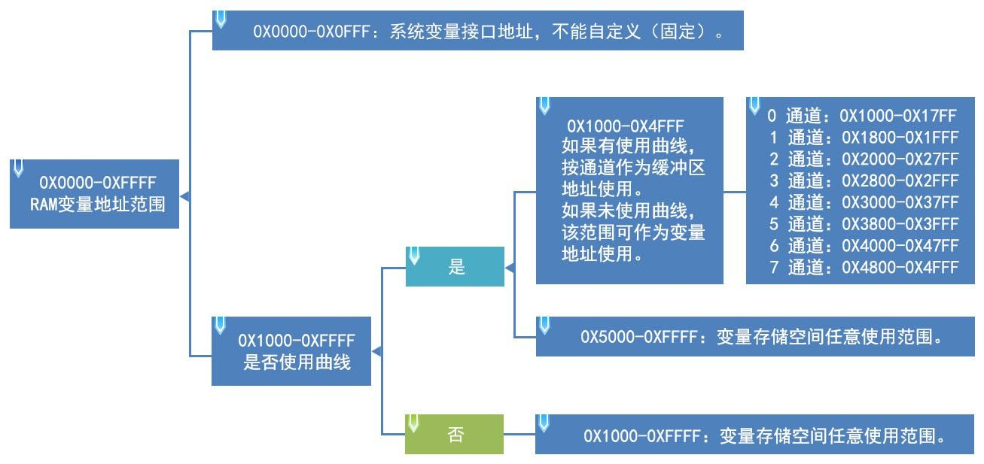

Figure **2.6**  **Ram** memory space division.

A variable address is the first address that stores a subspace of one or more variables in RAM space, and the value of the display variable's encoding or state variable is stored in the space that the address points to. For example, if you set the variable address of a text display control to 0x1000，控件中显示的文本内容为 and the text content displayed in the control is，那么在 "Beijing 北京迪文科技 Devon Technology,"store it in RAM space as shown in the following “ image. As you can see, 2 Byte can be stored in each address.

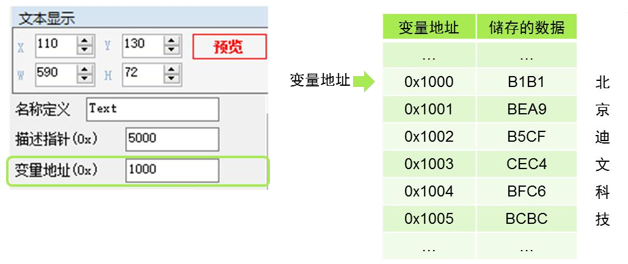

Figure **2.7 How data** is stored in variable addresses.

If you need to change the characters displayed in this text display control, you only need to change the character encoding stored in the address of the variable. The data stored in the variable address can be modified by sending instructions and entering the touch screen. For example, modifying the text display control can be implemented by text entry control, simply set the two controls the same variable address, at the same time, by sending instructions can also modify the value stored in the variable address, detailed instructions please refer to the variable display key section.

## **2.7 RAM** describes the pointer space.

A description pointer is the first address in RAM space that stores subspaces that describe the properties of a variable, and stores the properties values of the display variable, such as display coordinates, colors, font size, and so on, in the space that the address points to. It should be noted that the description pointer shares RAM space with the variable pointer and should avoid space-free re-matching when assigning variable addresses.

The following continues to be explained in conjunction with the display text controls (more instructions for specifying pointer usage are provided in the "Show 显示变量配置功能（variable configurationfunction (14.BIN)）说明 description" data variable display section in this document section). As shown in the following illustration, according to the text display control instruction storage format table, the text control describes the space to which the pointer points to the variable address, the upper-left coordinates of the character display position, the character color, the upper-left and lower-right coordinates of the text box, and so on. The figure 0x5000_H high bytes and0x5000_Las low bytes.

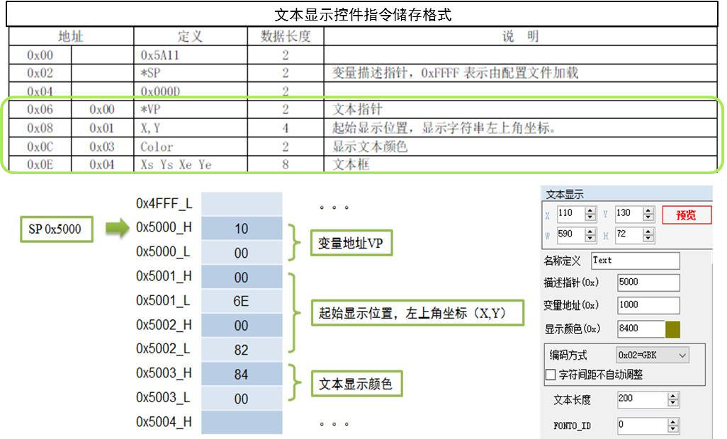

Figure **2.8 describes** how the data in the pointer is stored.

Example: 5AA5**05 82**  **5003**  **F800**  (Effect: Character color changes from olive green to red). . .

**5003:**The storage address of the text color.

**F800:**Red code.

Other description pointers are applied for example: .

|  |  |  |
| --- | --- | --- |
| Function. | Send instructions. | Effect. |
| Change the position of the data display. | **5A A5 07 82 5001 0000 0000** | The upper-left coordinate of the character display position changesto ( 0,0). |
| Change the ASCII character dot matrix size. | **5AA5 05 82 500A 30 60** | Change the character dot matrix to 48 x 96, note:Thedot matrix values in theX 和 and Y directions need to be modified. |
| Hide characters. | **5AA5 05 82 5008 0000** | Change the character length value to 0to hide the character. |
| Replace the word library file. | 5AA5 07 82 5009 003C 10 10 | Call the 60-word library, which has a dot matrix size of 16 x 16. That is, the character size changes at the same time after replacing the word library file. |

Describes a pointer setting problem: .

1. No curves aredisplayed, 0X1000-0X7FFF 可以作为变量地址区间使用；can be used as a variable address interval,and 0X8000-0XFFFF can be used as a description pointer interval, separated to avoid conflicts caused by pointer address confusion.
2. With curves displayed and all 8 channels in use,0X1000-0X4FFF will be used as a curve buffer address, this part of the address user will not be used as other 可作为 variable addresses, 将作为曲线缓冲区地址，这部分地址用户不要用作为其他变量地址，0X5000-0X7FFF can be used as a VP variable address interval,0X8000-0XFFFF 可作为 can be used as an SP description pointer interval. In the application VP variable address and SP description pointer address range users can plan their own according to actual needs, where the VP 变量地址和 variable address and SP description pointer address division is only used as a recommended reference.
3. : The same display key description pointer can be set to 10H addresses, different types of display keys can be set to 30H,and the separation is to avoid displayconflicts caused by pointer address confusion.
4. : The same type of display handle If the description pointer is to be set to the same, it can only be copied by Ctrl C-Ctrl V, that is, to other pages, the key can no longer change properties such as font size, can not move a pixel position, otherwise it will cause an abnormal display.

# Chapter III **SD** Interface.

## **3.1 MicroSD(TF)**卡格式

The T5L displays all the hardware parameter settings and information of the terminal, which can be done through the SD/TF card interface above the screen, and the files must be in **FAT32** format.

SD cards sold at non-Devon plants often have to be formatted under a DOS system. Otherwise, the download phenomenon is usually just a blue screen after showing the number of downloaded files is .

0,or the display terminal failed to recognize that the card could not enter the download interface properly. The formatting operation is as follows: .

第 1 步：开始=》运行=》输入 command（win7 系统则输入 cmd）进入 DOS 系统；

第 2 步：键入指令：format/q g:/fs:fat32/a:4096（注：q 后面是一个空格），输入完成之后点击回车按键。

where g is the disk number of the SD card displayed by the user's computer, and the disk characters for different users are not fixed (e.g. h, i replacement is available).

Note: Formatting operations after right-clicking 卡后的格式化操作一般不能彻底格式化为 on an SD card generally cannot be completely formatted into FAT32 format, and in general only the SD card size range is supported.

1-16G的。

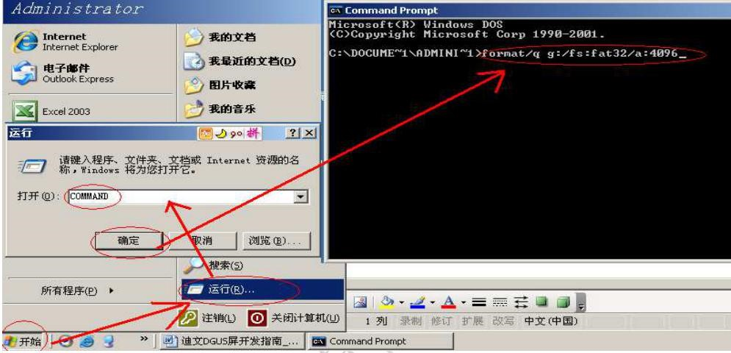

Figure **3.1 SD SD**  card formatting steps.

## **3.2SD** card interface download method.

**SD** card upgrades do not support online hot-swap updates, and in order to prevent hot-swappables from **affecting Flash** operations, the screen must be powered down and **inserted into the SD strictly in accordance with the first instructions.** 必须严格按照先给屏幕断电，插入

card, and then power on before you can download the operation. During the re-download process, be sure to maintain normal power supply, and a power outage in the middle may cause a black screen anomaly.

In particular, . 和 T5L_DGUSII, 与的 unlike DGUS and T5_DGUSI, 不同，the background picture ofthe T5L screen needs to be generated uniformly with The Devon tool software in practice. iCL file format download, can not use JPEG pictures directly.

DWIN_SET folder content generation process is shown below.

①在 SD 卡更目录下建立 DWIN_SET 文件夹。

(2) Put the pictures that need to be downloaded . ICL packages, word libraries, profiles, and so on are DWIN_SET folder.

(3) When the LCD terminal is powered on, an SD 卡，会识别 card is detected and the SD card is identified as having an DWIN_SET named file in the 卡根目录是否有 SD card, 命名文件，如果 and if this file is named in the SD 卡中存在此文件命名，则液晶终端将文件里面相关符合格式要求文件内容拷贝下载到到 card, the LCD terminal downloads a copy of the relevant format-compliant file content from the file to FLASH. DWIN_SET folders under the folder cannot be read properly.

(4) Wait until the blue screen download list prompts that the download is complete, power off the terminal, unplug the SD card, and then power up again before entering normal operating mode.

Devon standard model screen, if not special customization or use the download encryption function, will only recognize this folder name, other named folders will not be recognized, users can also be their own folder to be backed up as a different name, download is not affected.

## **3.3 Download** the file description.

#### **3.3.1** Download file type.

The T5L-based serial screen SD/SDHC interface supports the download and update of the following files. SD card upgrades do not support online hot-swappable updates and must power down the screen, plug in the SD card, and then power up before you can download them.

Table 3.1 Download file types.

|  |  |  |
| --- | --- | --- |
| The file type. | Naming rules. | Description. |
| The program file. | T5L_UI*. BIN T5L_OS*. BIN | The underlying kernel firmware application. |
| DWIN OS 序 | DWINOS*. BIN | DWIN OS program, the code must start at 0x1000. Users use selectively based on the actual situation. |
| OS CPU 8051 序 | T5L51*. BIN | Applications developed by users based on the standard 8051 platform. Users selectively download based on usage. |
| NOR Flash 数据库 | ID plus(optional) file name . LIB . | 每个ID对应2KWords存储器，ID范围0-79。  The database is located in on-chip NOR Flash and is 160KWords，可以用于用户数据或者 in size and can be used for user data or DWIN OS library file saving. The user chooses to use based on the actual situation. |
| 字库文件（4~12MB） | The word library ID plus (optional) file. （  名. BIN/DZK/HZK,字库ID 00-47； | 0_DWIN_ASC. The HZK is the standard library of 0-word for ASCII 编码的标准 encoding. Factory products have been pre-downloaded. |
| DGUS input method file. | 12*. BIN | Fixed stored in a 12-word library location. |
| DGUS Touch File. | 13*. BIN | Fixed stored in a 13-word library location, the file must not exceed 32KB. |
| DGUS variable file. | 14*. BIN | Fixed stored in a 14-word library location with no more than 256KB offiles, must be in DGUS2 format. |
| The DGUS variable initializes the file. | 22*. BIN | Fixed stored in the 22-word library location, load 0x2000-0x1FFFF address 地址内容初始化 content initializes the variable space of 字库位置，加载 0x1000-0xFFFF. 的变量空间 |
| JPEG pictures, icon files. | 字库 ID+（可选的）文件名. ICL | 必须是 DGUS3 格式的 JPEG ICO 文件格式。 |
| The hardware profile. | T5LCFG*. CFG | Configure CRC on, modify Baud rate, touch screen accompaniment control, touch upload mode, display direction, and more. |

#### **3.3.2 Download** the generation of the file.

From DGUSII_T5L introduction of the development system, we learned that through the DGUSII screen development project, you need to prepare the footage files have pictures, icon libraries, word libraries and so on. DGUSII_T5L the footage file is made by file number when it is called. Therefore, when the footage file is named, itshould all start with Arabic numerals, and other Chinese and English or punctuation can be added to the serial number as an annotation note description, for example: 宋体 23 sic 24 点阵 dot matrix GBK word library 23_ . HZK,、32- Background Picture . ICL,、48- Icon Library . ICL.

**3.3.2.1ICL** Background Picture Library File.

* PC 软件工具可处理 JPEG、BMP、PNG 格式的图片文件。
* Picture resolution and screen consistent;JPEG format;24-bit color.
* The power-on default displays page number 0 in the ICL 文件中的 file. The picture is named after Arabic numerals inorder of function, such as: 菜单页面 ... 功能页面 、 00? 开机页面、01_ .
* The picture needs to be compressed into . The ICL file format is then downloaded to the screen instead of directly downloading JPEG images, which can be understood as packaging and downloading the images in the format of a library file.
* The background picture library ICL file is used to display the background picture. To generate a 文件，需要在 文件 位置写上 "32- background picture ICL"file, you need to write 0x20 at the CFG file 0x08 so that the underlyingprogram can read and recognize the file “correctly. If the CFG file is configured to be empty, the download appears as a black screen (with a weak backlight), and if this is the ）， 用户如果遇到这种情况，请仔细检查 case, double-check the CFG 文件 file 0x08 location.
* For T5L1 CPU platforms,do not exceed 图片文件大小不要超过 256KB fora single JPG picture file in an 平台单个文件不超过 ICL fileandno more than 768KB for a single file foraT5L2 CPU ICL platform. There is no limit to the file size of the original picture footage, in the ICL file generated with the Devon PC 软件 software 文件时，由于图片渐变色等图像的显示复杂程度不同，如果生成后大于对应的最大值 软件是会提示，用户需要将 生成工具生成的 ICL generation tool, due to the image gradient color and other image display complexity is different, if the generated larger than the corresponding maximum PC software is prompted, the user needs to JPG picture quality percentage ICL slightly lower. You can also view the ICL file using the ICL build tool, where you can see the size of the individual pictures in the package.

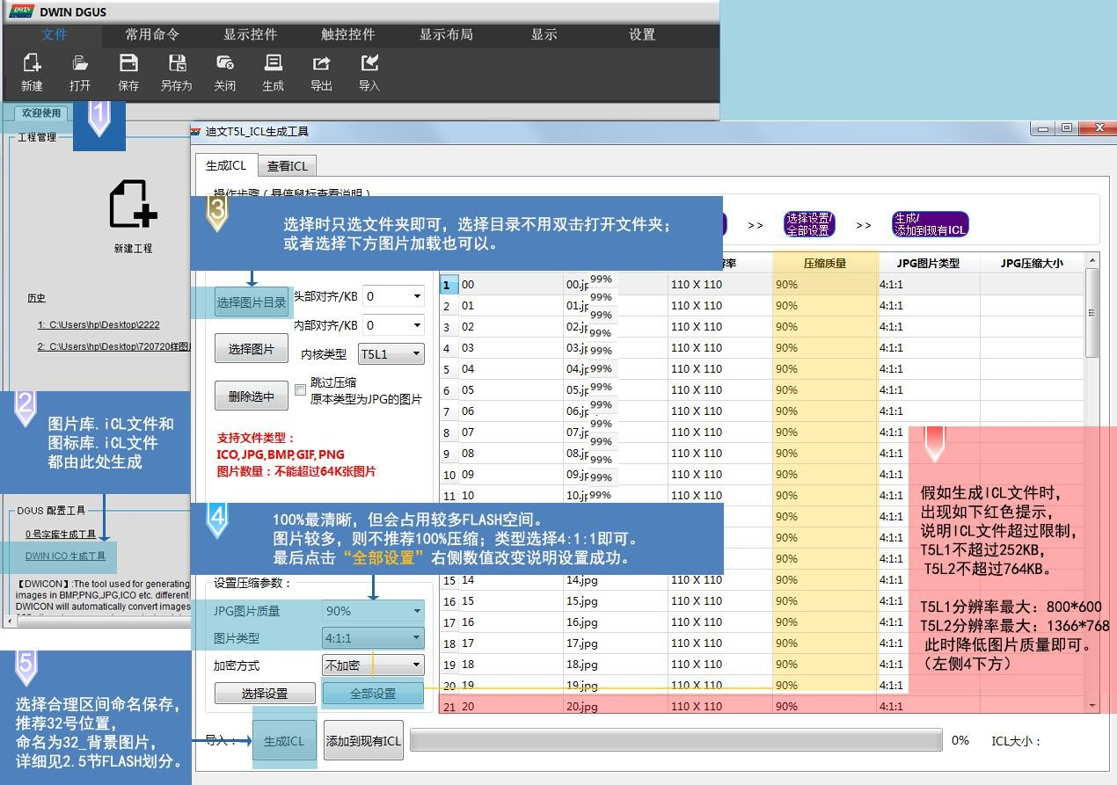

Figure **3.3ICL Picture** Library File Generation.

**3.3.2.2 ICL** Icon Library File.

* The maximum resolution of the picture in the icon library is no more than 1024 x 1024 pixels, and the software will automatically compress to 1024 x 1024 resolution; ；
* 图片原文件可以是 JPEG、BMP、PNG 格式，图片必须是 24 位色；
* Pictures need to be named sequentially, starting with Arabic numerals.

In FLASH storage, the single-word library space is 256KB in size. When a single icon library file exceeds 256KB, the icon library's occupied interval needs to be strictly calculated, as this may cause the icon interval location to conflict, resulting in an abnormal display. For example:48-icon 图标 .iCL 文件 file 1.23MB size, calculated formula: file size s.1024/256 、 这 、，即占用 s/1024/256 所占区间值，s/4.92, i.e. occupied 48,49,、50,、51, 52, these 5-word library 52 interval, As long as it is not divided, occupying one more byte counts as a word library interval. Therefore, the next icon library name needs to start at 53. 开始

Icon library ICL files are generated in the same way as picture libraries.

**3.3.2.3** Word Library File.

DGUS supports a wide variety ofinternationally used word library codes: 8-bit,，ASCII,，GBK,，GB2312,，UNICODE. The DGUS screen is pre-installed at the factory with an 的全部 ASCII-coded 编码的 0-word library 字库，其中包含了点阵大小为 that contains all ASCII characters with dot matrix sizes of 4 x 8 to 64 x 128. Users can call the library directly to display numbers, letters, and symbols. When you need to use a different encoded word library, you need to generate it through the word library generator. DGUS 、 supports 、bin, DZK,HZK, and three formats of word library BIN files.

1. The generation of the library of the word library of 0 .

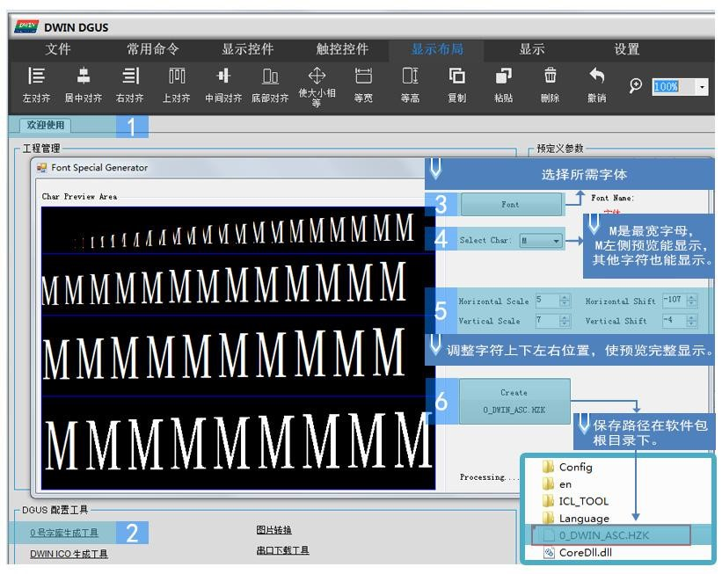

Figure 3.4 0 is generated by the word library.

1. The generation of the UNICODE encoding word library.

Some common foreign Chinese corresponding to the UNICODE encoding range (specifically can be queried online) Arabic numerals:U0030—- U0039.

大写字母：U0041—U005A ，小写字母：U0061—U007A 中文：U4E00—U9FFF 俄语：U0400—U052F

韩语：UAC00—UD7AF

.....

English, Dutch, Spanish, Italian, Portuguese, Danish, German, Finnish, Norwegian, Swedish, French, Turkish: .

U0000-U01FF, the Latin alphabet parts of these languages are much the same, so you can put itinto a small range, called after generation.

The DGUS screen 屏 "Data Variable Display Control" can directly handle 能直接处理调用 calls to the UNICODE word 字库显示数据，例如显示数据 library to display data, such as display data 100 instructions:5AA5 05 82 6000 0064. Therefore, UNICODE encoding word library is suitable for doing different data variable fonts, word library generation occupies the encoding U0000-U007F can meet the number, English, part of punctuation, the resulting word library volume occupies a small amount of memory, font style can also be selected a variety. For example, if a project is to apply to 2 different data variable fonts, the first can use the 0-word library itself 号字库本身字体，另外一个用字库生成器生成 font, and the other can generate UNICODE encoded fonts using the word library generator, the most common of which is the digital tube font display. Because the range of wide dot matrix is fixed when the word library is generated, it must also be set according to that dot matrix range. But .

|  |  |  |  |  |  |  |  |  |
| --- | --- | --- | --- | --- | --- | --- | --- | --- |
| When the text control is displayed. | ， | The instruction data to be sent must be coded according to the UNICODE. 编码 | ， | For example, display 12. | ： | 5AA5 07 82 5000 0031 0032 | ， | And. |

不是 5AA5 05 82 5000 3132。

U0000-UFFFF 为整个 encodes the entire UNICODE range, which generates a word library that displays all language 编码范围，该范围生成的字库可以显示所有语言文字，生成出的 text, resulting in a 16 x 16 dot 点阵字库为约 matrix library of approximately 2MB in size, with the larger the dot matrix, the larger the space.

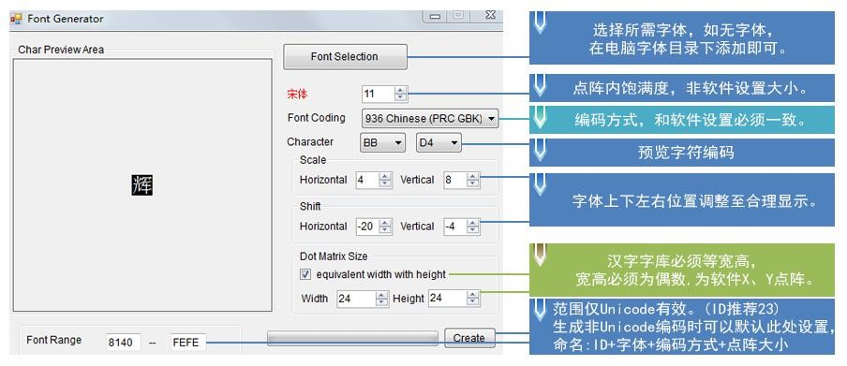

Figure **3.5GBK Chinese** character library generation.

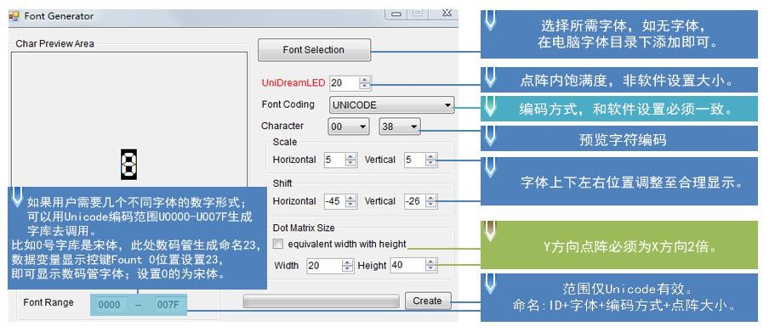

Figure **3.6 Digital** tube font word library generation.

**3.3.2.4 22.bin** Initialization variable file.

The initial value of the variable address power-on is defaulted to 0, and if you，如果需要设置不为 need to set an initial value that is not 0, you need to turn on the power-on loading of 22 files, the user is in .

CFG file 0x05.5-bit configuration open power-on loading 22 file initialization variable space.

Typically,22 files can be generated directly through the DGUS tool software,the initial values in the 22 文件中的初始值可在 files can be configured in the DGUS software, and when the profile is generated, the initial values can be automatically written to the 22 files. At the same time, users can manually edit the value of 22 files for software such as UltraEdit. DGUS variable addresses （are in 文件用 文件 字初始值时，应寻址 ）为单位，当修改变量地址 words,）为单位，22 files are edited in software such as UltraEdit to open displays inbytes,and when modifying the initial value of the variable address 0x2000 words, the 22 file 0x4000 byte address should be addressed for correct modification.

When you edit a 22 file, you need to copy the edits separately on the desktop, 文件夹，原工程下修改当编辑工程保存生成后会将之前已修改的 edit them and put them in the DWIN_SET folder, and the original modifications under the original project will overwrite the previously modified 22 files when the editing project saves the build.

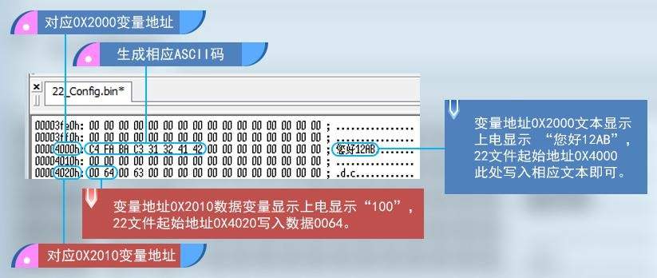

Figure **3.7 Initial** value **22 file** modification demonstration. 初始值

**3.3.2.5 CFG** 文件

T5LCFG. CFG hardware profiles are in binary data format and can be edited using software such as UltraEdit, as described in the following 表 table: Table 3.2CFG Profile List.

|  |  |  |  |  |
| --- | --- | --- | --- | --- |
| Class No. | Address. | Length. | the meaning of the . | Say Ming. |
| Configuration identification. | 0x00 | 5 | 0x54 0x35 0x4C 0x43 0x31 | Fixed content. |
| configuration values. | 0x05 | 1 | The parameter configuration. | .7：串口CRC 校验选择 0=关闭 1=开启。  .6：保留，写0。  .5:Power-on load 22 file initialization variable space 1 - Load 0 - Do not load.  .4:Touch variable change automatic upload control 0 - not automatic upload 1 - auto upload.  .3：触摸屏伴音控制，0=关闭 1=开启。  .2:Touchscreen backlight standby control 1 - On 0 - Off.  .1-.0:Power-up display direction 00 s 0 s 01 s 90 s 10 s 180 s 11 s 270 s. |
| 0x06 | 2 | Keep. | 写 0x00。 |
| 0x08 | 1 | Background picture ICL file save location. | 0x10-0x3F（16-63），对应 12MB-0.25MB 背景图片空间。 |
|  | 0x09 | 1 | Touch screen point rate settings. | 设置范围 0x01-0xFF，出厂值为 0x28，报点率=400Hz/设置值。 |
|  | 0x0A | 2 | Serial port rate setting. | Baud Rate Setting Value : 3225600 / Set Baud Rate .  115200bps，设置值=0x001C ，设置值最大 0x03FF。 |
| Backlight standby configuration. | 0x0C | 1 | Normal operation and power-on brightness. | 0x00-0x64，单位 1%。 |
| 0x0D | 1 | Standby brightness. | 0x00-0x64，单位 1%。 |
| 0x0E | 2 | Wake up after standby to light up the time. | 0x0001-0xFFFF，单位 10mS。 |
| The display is configured. | 0x10  0x12  0x13  0x14  0x15 | 2  1  1  1  1 | Display_Config_En  PCLK_PHS  PCLK_DIV  H_W  H_S | 0x5AA5 - The display configuration is valid, the factory has been configured, the user does not configure.  Data latch phase setting:0x00 -PCLK drops 下降沿 along 0x01-PCLK rise edge.  像素时钟 PCLK 频率设置，PCLK 频率（MHz）=206.4/PCLK_DIV。 |
| 0x16 | 2 | H_D | The horizontal(X-direction) resolution of the screen. |
| 0x18 | 1 | H_E |  |
| 0x19 | 1 | V_W |  |
|  | 0x1A | 1 | V_S |  |
|  | 0x1B | 2 | V_D | The vertical(Y-direction) resolution of the screen. |
|  | 0x1D | 1 | V_E |  |
|  | 0x1E | 1 | TCON_SEL | 0x00=不需要配置 TCON 。 |
| Touch screen configuration. | 0x1F  0x20 |  | Keep.  TP_Set_En | 写 0x00  0x5A indicates that this configuration is valid. Factory has been configured, the user do not configure. |
| 0x21 | 1 | TP_Mode | Touch screen mode configuration.  .7-.4（高4bit），选择触摸屏类型： 0x0*=电阻触摸。  0x1*=GT911、GT9271、GT9110 驱动IC 电容触摸屏。  0x2*=ILI9881H Incell CTP  .3 Resistance touch screen test:0 s off 1 s on, enabled only when the SD is downloaded.  到 .2 X轴数据选择:0-0到Xmax 1Xmax到0;； Xmax  .1 Y 轴数据选择：0=0 到Ymax 1=Ymax 到 0； .0 X、Y 交换： 0=XY 1=YX 。  (7 寸RTP 为0x07；8 寸RTP 为0x05；10.4 寸为0x03) |
| 0x22 | 1 | TP_Sense | 触摸屏灵敏度设置：0x00-0x1F，0x00 最低，0x1F 最高。 |

|  |  |  |  |  |
| --- | --- | --- | --- | --- |
|  |  |  |  | 出厂默认值是 0x14，灵敏度较高。 （ILI9881 是0x01-0x06）。 |
|  | 0x23 | 1 | TP_Freq | 频段选择，ILI9881H 适用，0x01-0x14 为固定频段，0x00 跳频。 |
| Clock output configuration. | 0x24 | 1 | CKO_Set_En | 0x5A indicates that this configuration is valid. |
| 0x25 | 1 | CKO_En | Set 0x5A to turn on CKO (P3.0) clock output, with the rest indicating off. |
| 0x26 | 1 | CKO_DIV | CKO output clock setting, output clock frequency: 825.7536/CKO_DIV MHz. |
| Buzzer settings. | 0x27 | 1 | BUZZ_Set_En | 0x5A indicates that this configuration is valid. |
| 0x28 | 1 | BUZZ_Freq_DIV1 | 蜂鸣器频率=825753.6（/ BUZZ_Freq_DIV1*BUZZ_Freq_DIV1）KHz |
| 0x29 | 2 | BUZZ_Freq_DIV2 | 出厂设置：DIV1=0x6E，DIV2=0x0BB8，对应2.5KHz 频率。 |
| 0x2B | 2 | BUZZ_Freq_Duty | Buzzer space-to-air ratio setting: High-level space-to-air ratioBUZZ_Freq_Duty/BUZZ_Freq_DIV2. Factory settings:0x00F0 corresponds to 8% high level space ratio. |
| 0x2D | 1 | BUZZ_Time | Touch screen accompaniment buzzer time, 10mS；出厂设置 per unit; |

Note that some parameters on the green background must be configured.

(1)）CFG profile address 配置文件地址 0x05 hardware parameter configuration e.g. set the initial value of the power-on display, touch data is automatically uploaded, touch screen accompaniment is turned on, backlight off, display direction 0 degree configuration: .

|  |  |  |
| --- | --- | --- |
| Open. | 0 | off. |

.7 位校验配 0 1

|  |
| --- |
| Keep 0. |

.6 位配 0

|  |  |  |
| --- | --- | --- |
| Open. | 0 | off. |

.5 位初始值配 1 1

|  |  |  |
| --- | --- | --- |
| Open. | 0 | off. |

.4-bit data upload with 1 1 .

|  |  |  |
| --- | --- | --- |
| Open. | 0 | off. |

.3-bit touch voiceover 1 1.

|  |  |  |
| --- | --- | --- |
| Open. | 0 | off. |

.2 位背光配 0 1

|  |
| --- |
| The selection ofdirections, .1 和 and .0 bits are associated. |

.1 位方向配 0 4

0 in the .0-bit direction.

Here 1 byte corresponds to 8 bits, each bit corresponds to on and off two states, the corresponding bit write 1 is turned on, and write 0 is turned off. Converting 0011 1000 换算成 to 16 进制为 is 0x38,，cfG 文件 file 0x05 地址写入 address is written to 0x38,，下载 and downloading the CFG file to complete the configuration takes effect.

以 DMG10600C070-03W（出厂横屏系列）为例，0°，90°，180°，270°软件开发和 CFG 文件配置：

0°横向：图片 1024*600 分辨率组态；图片 1024*600 分辨率做成. ICL 文件；CFG 文件 0x05 配 0x38。

90°竖向：图片 600*1024 分辨率组态；图片 600*1024 分辨率做成. ICL 文件；CFG 文件 0x05 配 0x39。

180°横向：图片 1024*600 分辨率组态；图片 1024*600 分辨率做成. ICL 文件；CFG 文件 0x05 配 0x3A。 270°竖向：图片 600*1024 分辨率组态；图片 600*1024 分辨率做成. ICL 文件；CFG 文件 0x05 配 0x3B。

以 DMG85480C050-03W（出厂竖屏系列）为例，0°，90°，180°，270°软件开发和 CFG 文件配置：

0°竖向：图片 854*480 分辨率组态；图片 854*480 分辨率做成. ICL 文件；CFG 文件 0x05 配 0x38。

90°横向：图片 480*854 分辨率组态；图片 480*854 分辨率做成. ICL 文件；CFG 文件 0x05 配 0x39。

180°竖向：图片 854*480 分辨率组态；图片 854*480 分辨率做成. ICL 文件；CFG 文件 0x05 配 0x3A。

270°横向：图片 480*854 分辨率组态；图片 480*854 分辨率做成. ICL 文件；CFG 文件 0x05 配 0x3B。

1. CFG profile address 0x0C turn on the backlight screensaver configuration.

CFG 文件 file 0x05 地址配 address with 0x3C;

CFG 文件 0x0C 地址点亮亮度值配 0x64，范围：0x00-0x64。

CFG 文件 0x0D 地址待机亮度值配 0x32，一半亮度。 范围：0x00-0x64

CFG 文件 0x0E 0x0F 点亮时长两字节地址写 0x03E8；10S 不点击进入背光，10*1000/10=1000，换算成 16 进制为 0x03E8。 点亮时长范围：0x0001-0xFFFF，单位 10ms。

Note: When the backlight standby screensaver is turned on, the first touch screen click is the wake-up backlight, and the second click triggers the touch control.

1. CFG profile address 0x08 Background picture location settings.

If the picture background file is set to a 32-picture 图片 .iCL file, you need to write 0x20 to the CFG 文件 file 0x08 地址写入 addressforthe underlying read and display.

If it is a different value for thepassword, 0X08 needs to be overwrite.

1. CFG profile address 0x0A Baud rate setting.

Baud Rate Setting Value : 3225600 / Set Baud Rate. Factory default configuration 115200bps,，设置值 set the value of 0x001C, set the maximum value of 0x03FF.

3225600/115200=28，28 换算成 16 进制为 0x1C，因为波特率占 0x0A 0x0B 2 个字节，CFG 文件 0x0A 地址开始写

0x001C 即可。 9600 波特率配 0x0150。

1. CFG profile address 0x21 touch screen configuration.

Show configuration mode, touch configuration mode factory configured, under normal circumstances, the user does not use configuration. If a sliding page turn or touch reverse, the configuration process results in a flower screen, white screen, the user needs to re-download the factory CFG file.

1. CFG profile address 0x22 touch screen sensitivity settings.

Only for 位置配置，出厂默认为 ，范围 capacitive screens Increase yagrion panel or tempered glass modification sensitivity, configured in CFG 文件 file 0x22 location, factory default 0x14,range 0x0000-0x1F. At the same time,0x20 needs to write 0x5A. Generally, the greater the thickness of the agri-panel or tempered glass, the greater the corresponding modified value. Note: .

DMG72720C041-03W、DMG12720C050-03W 这两款 Incell 屏天厂 0X21 配 20.0X22 天厂配 0X06,范围 0X01-0X06♡

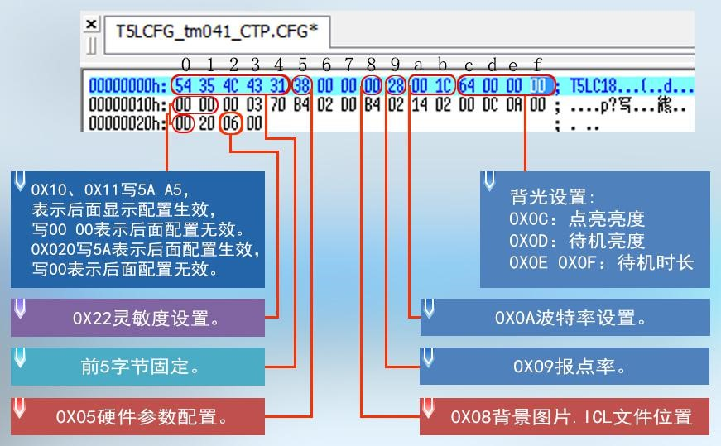

图**3.8 CFG**文件设置

1. CFG profile address 0x2D 蜂鸣器鸣叫时长设置蜂鸣器 buzzer time setting buzzer "drop" 滴滴 sound can only set the length of its tweeting time.
2. The display configuration reference.

Table 3.3 shows the configuration reference list.

|  |  |  |  |  |  |  |  |  |  |  |  |  |  |  |
| --- | --- | --- | --- | --- | --- | --- | --- | --- | --- | --- | --- | --- | --- | --- |
| Dimensions . . . resolution. | Display configuration value(HEX format). | | | | | | | | |  |  |  |  |  |
| **0x12** | **0x13** | **0x14** | **0x15** | **0x16** | **0x17** | **0x18** | **0x19** | **0x1A** | **0x1B** | **0x1C** | **0x1D** | **0x1E** | **0x1F** |
| 2.4_240*320  （IPS） | 01 | 26 | 0A | 14 | 00 | F0 | 0A | 02 | 02 | 01 | 40 | 02 | 05 | 00 |
| 2.8_240*320A | 01 | 26 | 0A | 14 | 00 | F0 | 0A | 02 | 02 | 01 | 40 | 02 | 03 | 00 |
| 2.8_240*320B | 01 | 20 | 10 | 20 | 00 | F0 | 20 | 02 | 0e | 01 | 40 | 08 | 01 | 00 |
| 3.5_320*240 | 01 | 1C | 1e | 14 | 01 | 40 | 40 | 03 | 0F | 00 | F0 | 10 | 02 | 00 |
| 3.5_320*480 | 01 | 14 | 0A | 04 | 01 | 40 | 0A | 02 | 02 | 01 | E0 | 02 | 04 | 00 |
| 3.5_320*480  （IPS） | 01 | 14 | 0A | 04 | 01 | 40 | 0A | 02 | 02 | 01 | E0 | 02 | 06 | 00 |
| 3.5_480*640 | 01 | 0A | 10 | 20 | 01 | E0 | 20 | 02 | 03 | 02 | 80 | 02 | 07 | 00 |
| 4.0_480*480  （IPS） | 00 | 0e | 08 | 08 | 01 | E0 | 08 | 02 | 0C | 01 | E0 | 06 | 08 | 00 |
| 4.0_480*800  （IPS） | 00 | 08 | 08 | 08 | 01 | E0 | 08 | 04 | 0A | 03 | 20 | 0A | 09 | 00 |
| 4.0_720*720 （IPS Incell） | 00 | 03 | 70 | B4 | 02 | D0 | B4 | 02 | 14 | 02 | D0 | DC | 0A | 00 |
| 5.0_720*1280 （IPS Incell） | 00 | 03 | 04 | 14 | 02 | D0 | 14 | 02 | 12 | 05 | 00 | C8 | 0A | 00 |
| 5.0_480*854  （IPS） | 00 | 08 | 08 | 08 | 01 | E0 | 08 | 02 | 0C | 03 | 56 | 06 | 0C | 00 |
| 480*272 | 01 | 16 | 29 | 02 | 01 | E0 | 02 | 0A | 02 | 01 | 10 | 02 | 00 | 00 |
| 640*480 | 01 | 08 | 1e | 72 | 02 | 58 | 10 | 03 | 20 | 01 | E0 | 0A | 00 | 00 |
| 800*480 | 01 | 06 | 1e | 10 | 03 | 20 | D2 | 03 | 14 | 01 | E0 | 0C | 00 | 00 |
| 800*600 | 01 | 05 | 1e | 10 | 03 | 20 | D2 | 03 | 14 | 02 | 58 | 0C | 00 | 00 |
| 1024*600 | 01 | 04 | A0 | 88 | 04 | 00 | 18 | 06 | 1d | 02 | 58 | 03 | 00 | 00 |
| 1024*768 | 01 | 04 | 10 | 40 | 04 | 00 | 20 | 04 | 08 | 03 | 00 | 04 | 00 | 00 |
| 1280*720 | 01 | 03 | 10 | 40 | 05 | 00 | 20 | 08 | 20 | 02 | D0 | 20 | 00 | 00 |
| 1280*800 | 01 | 03 | 10 | 1C | 05 | 00 | 10 | 08 | 10 | 03 | 20 | 10 | 00 | 00 |
| 1366*768 | 01 | 03 | 10 | 20 | 05 | 54 | 20 | 06 | 10 | 03 | 00 | 08 | 00 | 00 |

#### **3.3.3 Download** file process.

DWIN_SET folder is the only recognizable named folder name on the screen and contains all the files that will eventually be downloaded to the screen. These include profiles such as the "13 Touch Profile .bin" file, 文件、"14 变量配置文件 Variable Profile .bin,"、22_Config .bin, and so on. When a new project is created, the software automatically generates a series of files in which "DWprj.hmi" 是 is the only recognizable editing program for the DGUS software, and the file cannot be renamed or deleted.

Because the T5L screen can't read JPEG pictures directly, in practice you need to make pictures and icons into an ICL file format and download them.

DWIN_SET folder content generation process is shown below.

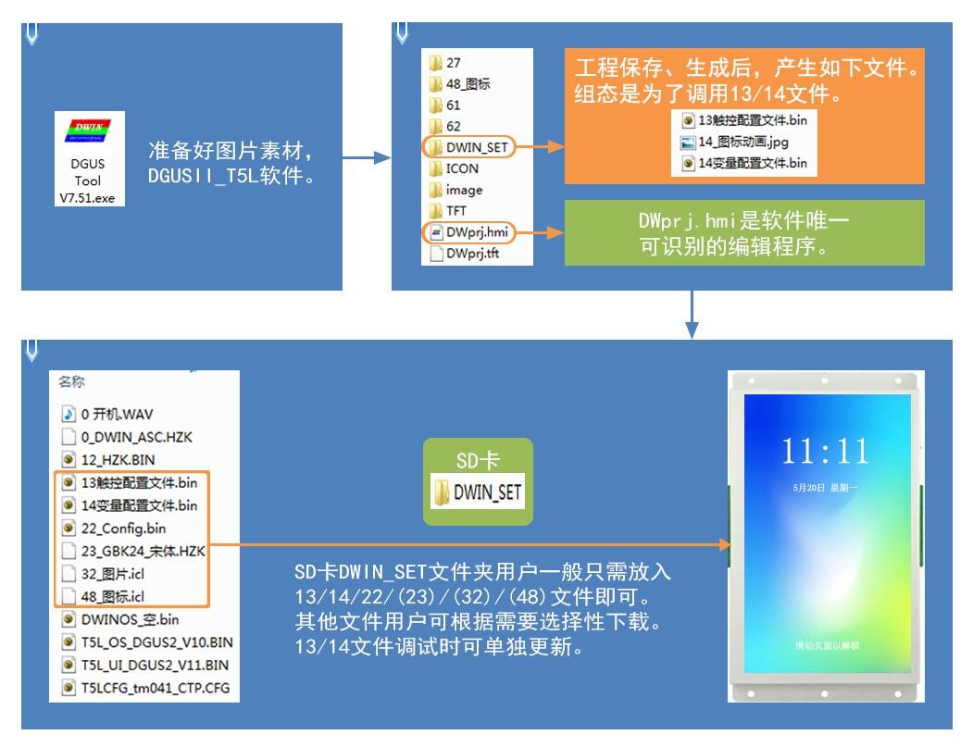

Figure **3.9DWIN_SET folder** to download files to produce a diagram.

## **3.4SPI FLASH** memory space.

The 16MB Flash memory is split into two parts: ： .

(1)4-12MB of word library space, subspace 256KBytes,you can save wordlibrary, configuration files.

（2）4-12MB 的ICL图片文件空间，子空间256KBytes。 对于 T5L1 CPU 平台，ICL文件中单个JPG 图片文件大小不要超过252KB，T5L2 CPU 平台单个文件不超过764KB。

Users can allocate their own storage space without consuming the system profile.



Figure **3.1016MB** memory space map.

## **3.5** RAM memory.

The RAM 个字节对应相应空间的 space is fixed at 128KB，分割为 and split into 0x0000-0xFFFF subspace 子空间范围，每 ranges, with 2 个变量地址对应相应空间的 bytes for each variable address and 字节，每 8 bits for the corresponding space for each 1 byte. Where 0x0000-0x0FFF,system variable interface use, can not be customized,，系统变量接口使用，不能自定义；0x1000-0xFFFF 为用户任意使用范围，如果 for the user any range of use, if the 8 channel curve is used at thesame time, 0x1000-0x4FFF will be used as a curve buffer address,at this time this part of the variable address can not be occupied by other keys, other key address use range is:0x5000-0xFF.

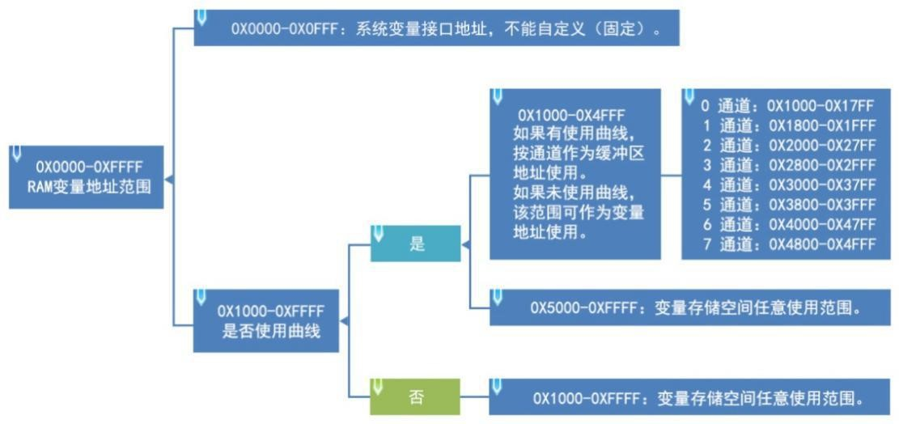

Figure **3.11 Ram** Memory Space Division.

# Chapter 4 **UART2** Serial Communication Protocol.

The DGUS screen uses an asynchronous,full-duplete serial port(UART)）， with 串口模式为 a serial mode of 8n1,i.e. tenbits per data transfer, including one starting bit.

8 data bits,1 stop bit. 232/TTL 通讯和主板 communication and motherboard T/R 输入输出信号交叉接线，地线必须接上；485 通讯 485+ 接 input and output signals are cross-wiredand the ground wire must be connected;

485-接 B-。 TTL 通讯不超过 0.5m，232 通讯不超过 1m，485 通讯不超过 12km。

All instructions or data for serial porting are in 16-step (HEX) 进制（format. For type type(2 bytes) data,a high-byte first transfer(MSB)）方式，如 method is always used, such as 0x1234 先传送 first transfer 0x12. The maximum amount of data that a 周期能够传送的最大数据长度取决于用户界面的复杂程度；推荐客户在一个 周期内不要发送超过 DGUS cycle can transmit depends on the complexity of the user interface, and it is recommended that customers do not send more 波特率连续发送）的数据给 than 4KB(approximately equal to 230400-691200bps consecutively) of data to the DGUS screen during a DGUS DGUS cycle.

## **4.1** Data frame structure.

The system debug serial UART2 mode is fixed to 8N1, theBaud rate can be set, andthe data frame consists of 5 blocks: ： .

Table 4.1 Data Frame Structure Table.

|  |  |  |  |  |  |
| --- | --- | --- | --- | --- | --- |
| Blocks of data. | **1** | **2** | **3** | **4** | **5** |
| Defined. | The frame head. | The length of the data (bytes). ) | Instructions. | Data. | CRC validation of instructions and data (optional). 校验（可选 |
| Length. | 2 | 1 | 1 | Up to 249 bytes. | 2 |
| Description. | Fixed to 0x5AA5. | The number of bytes + of instructions, data, and checks. | 0x82写  0x83读 |  | CRC-16(x16+x15+x2+1) |

CRC check on / off by . 0x05.7 bit control of the CFG profile. A comparison of CRC post-check instructions is enabled, such as the following table: ： .

Table 4.2 Enables the check instruction table.

|  |  |  |
| --- | --- | --- |
| Examples of instructions. | CRC **validation is not** enabled. | 启用 **CRC** 校验 |
| **83** Read the instruction. | Tx:5AA5 04 83 000F 01 | Tx:5AA5 06 83 000F 01ED 90 |
| **83** Instruction Answer . | Rx:5AA5 06 83 00 0F 01 14 10 | Rx:5AA5 08 83 00 0F 01 14 10 43 F0 |
| **82** Write instructions. | Tx:5AA5 05 82 10 00 31 32 | Tx:5AA5 07 82 10 00 31 32 CC 9B |
| **82** Instruction Answer. | Rx:5AA5 03 82 4F 4B | Rx:5AA5 05 82 4F 4B A5 EF |
| **83** Touch Upload . | Rx:5AA5 06 83 10 01 01 00 5A | Rx:5AA5 08 83 10 01 01 00 5A 0E 2C |

## **4.2 UART2** debug interface instructions.

The DGUS screen works in variable-driven mode, and the working mode of the screen and the state of the GUI are completely controlled by the data variables. Therefore, serial instructions only need to read and write variables, the instruction set is very simple, users only need to use 82/83 instructions.

表4.3 DGUS指令说明

|  |  |  |  |
| --- | --- | --- | --- |
| Function. | Instructions. | Data. | Description. |
| Access registers. | 0x80 | 下发：寄存器页面 ID（0x00-0x08）+寄存器地址(0x00-0xFF)+写  data. | The specified address starts writing data strings to the register. |
| 应答：0x4F 0x4B 。 | Write instructions to answer. |
| 0x81 | 下发：寄存器页面 ID（0x00-0x08）+寄存器地址(0x00-0xFF)+读取数据字节长度(0x01-0xFB) | Read the data from the specified register. |
| Answer: ： .  寄存器页面 ID（0x00-0x08）+寄存器地址(0x00-0xFF)+数据长度  The data. | The data answer. |
| 寄存器 的  读取  **5AA5 04 81 00 0A 04 00** 000000000页0000000000~R1据3 寄存器页面  个字节长度的数据  **The 80 81 directive** is not intended for general use by the general user and is **typically used for debugging** 功能的调试访问，可以参考 **access to OS functions and can be viewed by reference to the os** application guide register table. The OS register register page 开发指南 》 的 , 详见《基于 ID(0x00-0x07)）和接口寄存器寄存器页面 and the interface register page ID（（(x08)）are detailed in Section 3.4 of the T5-based DWIN OS Development Guide. | | |
| Access variable memory.  **(RAM)** | 0x82 | Release: .  The variable space first address (0x0000-0xFFFF) is written to the data. | Specify the address to start writing strings (word data) ) into the variable space. The space reserved by the system should not be written. |
| Answer: ： .  0x4F 0x4B 。 | Write instructions to answer. |
| 0x83 | Release: .  Variable space first address (0x0000-0xFFFF) and read data word length (0x01-0x7D). | Read the specified length word data from the variable space specified address. |
| Answer: Variable space first address , variable data word length , and read variable data. | The data answer. |
| The DGUS II screen has 128KB of variable memory and is primarily used for variable data storage,addressed by word. 寻址操作 | | |

Note:**DGUS**  **II has** switched common hardware-related operation registers to system variable address interface access instructions. The space reserved by the system does not have to be accessed.

The register page is defined as follows: .

|  |  |  |
| --- | --- | --- |
| Register page  **ID.** | Defined. | Description. |
| 0x00-0x07 | Data register. | 每组 256 个，R0-R255 |
| 0x08 | Interface register. | DR0-DR255。  《基于 T5 的 DWIN OS 详发》 3.4接口寄存器定义接 寄存器定义说 |

#### **4.2.1** Write variable memory instruction instruction (0x82).**0x82**）

Here's an example of writing a value of 2 to a 1000 variable address: ： .

**5AA5 05 82 1000 0002**

5AA5 表示：帧头

05 for: Data length.

82 means: Write variable memory instructions.

1000 means: variable address (two bytes). ）

0002 means: Data 2(two bytes).

Explanation: Assign 2 to the address of 0000 地址里面赋值 by instruction,display onthe screen, data variable integer type 2.

ا:DGUS 屏读、写变اا址都اا看ا为ا始址:-لاا a 、b 指ا 的cubic于 c a: 5A A5 05 82 1001 000A b: 5A A5 05 82 1002 000B

c: 5A A5 07 82 1001 000A 000B

#### **4.2.2** Read variable memory instruction instruction (0x83).**0x83**）

Here's an example of reading the value in the 1000 variable address (assuming the current value is 2):）为例： .

**5AA5 04 83 1000 01**

5AA5 表示：帧头

04 means: Data length.

83 means: Read the data store instruction.

1000 means: variable address (two bytes). ）

01 means: 从 ： Read 1 word length from 地址开始读 数据指令最大容许长度 1010 00 1 address, and the screen returns a read answer to the serial port after reading the data instruction maximum allowable length of 0x7c.

**5AA5 06 83 1000 01 0002**

5AA5 表示：帧头

06 means: Data length.

83 means: Read variable memory instruction instructions.

1000 means: variable address (two bytes). ）

01 means: 从 Read 1 word length data from 1000 地址开始读 1 addresses.

00 02 means that the datavalue in the1000 address is 2.

#### **4.2.3** Touch the button to return to serial data (0x83).**0x83**）

Here is the example of pressing the **return variable address 0x1001**and **the key value 0x0002** 为例 .

**5AA5 06 83 1001 01 0002**

5AA5 表示：帧头

06 means: Data length.

83 means: Read variable memory instruction instructions.

1001 means: variable address (two bytes). ）

01 means:1 word length data.

00 02 表示：键值 0002

The key return (non-basic touch) can be sent through a serial port after the system configuration CFG file is configured for data upload.

Uploaded protocol format :( button return address 1001 键值 key value 000A) ）5AA5 06 83 1001 01 000A key returns the value screen inside the address is not automatically emptied when pressed.

For RS485 half-duplete communication, you can read the command read key value with 5AA5 04 83 10 01 01, and the read instruction answer format is consistent with the touch upload format.

RS485 communication semi-duplendcommunication can not be sent and received at the same time, that is, the receiving data and sending data can not be at the same time,otherwise it will cause the data to be displayed abnormally;

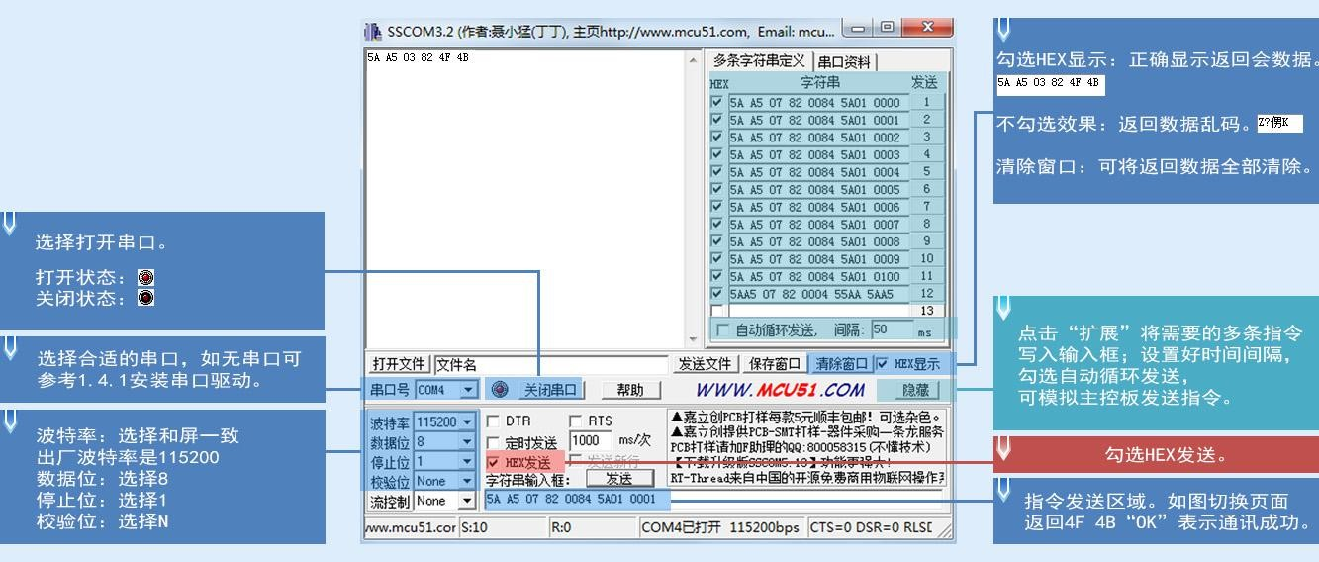

Figure **SSCOM32** Serial Tool Diagram.

# Chapter 5 System Variable Interface.

## **5.1** System variable interface.

System variable occupies address range:0x0000-0x0FFF.

Table 4.4 A list of system variable interfaces.

|  |  |  |  |  |
| --- | --- | --- | --- | --- |
| Address. | Defined. | **R/W** | Length. | Description. |
| **0x00** | Keep. |  | 4 | There is no definition. |
| **0x04** | System_Res  And | W | 2 | 写入 0x55AA 5AA5 将复位 T5L CPU 一次。 |
| Example of an instruction: .  5AA5 07 82 00 04 55 AA 5AA5 （重置 T5 芯片，数据清 0,相当于掉电重启） |
| **0x06** | OS_Update  _CMD | W | 2 | D3:0x5A 启いい次いい DWIN OSい序いいい ( いいいい Flash),完CPU D2 :0x10：固定为 0须0从 0x10码00 开始的 代码  D1:0:The data variable space first address that stores the upgrade code must be even. |
| Example of an instruction: .  This instruction is used for download updates to user os programs, and the "DWIN OS Build" PC software has integrated the ability to download os.bin files into the screen via serial 2 after ， compilation. |
| **0x08** | NOR_FLAS  H_RW_CM  D | W | 4 | D7：操作模式 0x5A=读 0xA5=写，CPU 操作完清零。  D6:4：片内 Nor Flash 数据库首地址，必须是偶数，0x000000-0x02:7FFE，  160KWords. D3:2:Data variable space first address, must be even.  D1:0:Read and write length, must be even. |
| Example of an instruction: .  ①将数据 0x12345678 写入变量存储空间 0x1002：  5AA5 07 82 10 02 12 34 56 78  (2) Store the 2-word-long data for the variable storage 地址的 2 0x1002 address at the first address of the Nor Flash database.  0x000002：  5AA5 0B 82 0008 A5 000002 1002 0002  ③将 Nor Flash 数据库 0x000002 读取数据到变量存储空间地址 0x2000：  5AA5 0B 82 0008 5A 000002 2000 0002  After reading and storing the database with OS, it is necessary to determine whether the D7 address has been automatically zeroed out, if the undressing does not do anything until the zeroing and other operations, otherwise there will be a logical disorder; |
| **0x0C** | Keep. |  | 3 |  |
| **0x0F** | See | R | 1 | 应用软件版本。 D1示 GUI 软大大版大,D0示表示 DWIN OS 软大版大> |
| Example of an instruction: .  5AA5 04 83 000F 0返回：5AA5 06 83 00 0F 01 11 10 （11 为 GUI 10 为 DWIN OS 软：软1  (1) In the use of the display terminal, due to the control system, display terminal start-up time is inconsistent (depending on the user's 取决于用户的电源容量和上电速率 power supply capacity and power-on rate), inorder to ensure that the control system sent at the beginning of the data can correctly receive and execute the corresponding functions and commands, it is necessary to confirm that the display terminal is in a normal operating state, the user can confirm through thisinstruction;  (2) This instruction can also be read when you need to know if the version, configuration, etc. of the system are correct during debugging.  (3) The sending and answering of this instruction is also often used to verify that communication between the computer serial port and the serial screen is normal. |

|  |  |  |  |  |
| --- | --- | --- | --- | --- |
| **0x10** | RTC | R/W | 4 | D7=年(0-0x63) D6=月(0-0x0C) D5=日(0-0x1F) D4=星期（0-0x6）D3=小时(0-0x17)  D2=分钟(0-0x3B) D1=秒(0-0x3B) D0 未定义，数据均为 HEX 格式。 需要硬件支持（无内置 RTC 的硬件，RTC 时间由用户写入）。 |
| Example of an instruction: .   |  |  |  | | --- | --- | --- | | 13 0A 01 | 00 | 0B 0C 0D |   写：5AA5 0B 82 001000   |  |  | | --- | --- | | 2019-10-01 | 11:12:13 |   The text RTC shows the SUN, 年系统自动补齐 the annual system is automatically complemented by 20,and the week is displayed in English and the system is automatically adjusted.  读:5AA5 04 83 00 10 04 应答:5AA5 0C 83 00 10 04 13 0A 01 00 0B 0C 0D 00 |
| **0x14** | PIC_Now | R | 1 | The page ID is currently displayed. Read-only. |
| Example of an instruction: .  读：5AA5 04 83 0014 01 应答：5AA5 06 83 00 14 01 00 07(0007 为 07 号页面) |
| **0x15** | GUI_Status | R | 1 | GUI 操作状态反馈：0x0000 表示空闲，0x0001 表示正在处理 13、14 变量文件。 |
| The operational status feedback is at the millisecond unit level and is generally used in special cases, with the user using the DWINOS program to determine if the GUI kernel is in use. |
| **0x16** | TP_Status | R/W | 4 | D7:0x5A indicates that touch screen data has been updated. Other : The touch screen coordinates have not been updated.  After the user reads the data, they can write a tag of 0x5A, so long as they do not touch it, the tag is no longer updated.  D6:触摸屏状态 0x00=松开 0x01=第一次按压 0x02=抬起 0x03=按压中 D5:D4= 触摸屏按压的坐标位置 X 坐标  D3:D2 - The coordinate position Y coordinate pressed by the touch screen.  D1:D0=0x0000。 |
| Example of an instruction: .  读：5AA5 04 83 0016 03  应答：5AA5 0A 83 00 16 03 5A 02 02 55 00 E5  Read touch coordinates write:5AA5 05 82 0016 0000 Zero touch screen data update mark. You can usually use the DWIN OS program to handle the judgment of whether to touch, press, press, and so on. |
| **0x1A-**  **0x30** | Keep. |  | 23 | There is no definition. |
| **0x31** | LED_Now | R | 1 | D1:0x5A indicates that the backlight brightnessvalue, the momentary value of AD0-AD7, has been updated.  D0:当前背光亮度值，0x00-0x64。 |
| Example of an instruction: .  读：5AA5 04 83 0031 01 应答：5AA5 06 83 00 31 01 5A 64 |
| **0x32** | AD0-AD7 瞬时值 | R | 8 | AD0-AD7通道的瞬时值.每通道 1 个字。 电压"AD 值"3300/4095 mV。 |
| **0x3A-**  **0x7F** | Keep. |  | 70 | There is no definition. |
| **0x80** | System_Co nfig | R/W | 2 | D3:The user writes 0x5A to initiate a system parameter configuration, and theCPU completes the zeroing.  D2:Touch screen sensitivity configuration value, read-only.  D1:Touch screen mode configuration value, read-only.  D0:System status settings.  .7：串口 CRC 校验设置，1=开启，0=关闭，只读。  .6：保留，写 0。  .5:Power-on load 22 file initialization variable space 1 - load 0 - do not load, read-only.  .4:Variable auto-upload settings 1 - on,0 - off, read and write. |

|  |  |  |  |  |  |
| --- | --- | --- | --- | --- | --- |
|  |  |  |  | .3:Touch screen accompaniment control 1 s on 0 s off, read and write.  .2:Touch screen backlight standby control 1 s on 开启 0 s off, read and write.  .1-.0：显示方向 00=0° 01=90° 10=180° 11=270°，读写。 | |
| Example of an instruction: .  读：5AA5 04 83 0080 02  应答：5AA5 08 83 00 80 02 00 14 10 38  Read instructions are typically used to view the screen.. CFG system configuration.  文件 D0 can 条指令是开启对应的 触摸屏伴音控制关闭或者开启，可以应用于触摸的按键的蜂鸣器的 静音 overwrite the configuration CFG file 0x05 地址，例如下 address, for example, the next 2 instructions are to turn on the corresponding .4=1 .5=1, ， touch screen accompaniment control off or on, can be applied to the touch of the key of the buzzer "mute" “ function.  Note: Power-down does not save after writing instructions are sent.  写：5AA5 07 82 0080 5A 00 00 30 写：5AA5 07 82 0080 5A 00 00 38 | |
| **0x82** | LED_Confi g |  | 2 | Touch screen backlight standby settings: .  D3=开启亮度，0x00-0x64；背光待机控制关闭时，D3 为软件亮度调节接口。 D2= 关闭亮度 0x00-0x64； D1:0=开启时间/10mS 。 | |
| Example of an instruction: .  When CFG address 地址 0x05 is configured to turn on touch screen backlight standby control: ： .  5AA5 07 82 0082 6432 03E8 ，10 秒后屏幕背光自动降低为 0x32 亮度。  5AA5 07 82 0082 2020 ， 直接指令控制背光亮度为 , direct command control backlight brightness of 0x20 亮度 brightness, and backlight screensaver brightness on and standby consistent.  Note: After turning on backlight standby, the first physical touch screen click after a period of time is the wake-up screensaver backlight function, even if the brightness and standby brightness settings are the same, after a period of time still need "extra first wake-up touch click operation."  When CFG address 地址 0x05 is configured with light ratio touch screen backlight standby control: ： .  5AA5 05 82 0082 0A, direct command control backlight brightness of 0x0A brightness. 亮度 | |
| **0x84** | PIC_Set | R/W | 2 | D3:：0x5A means that page processing is initiated andcpu processing is zeroed.  D2:Processing mode.  0x01 - Page switching (show the picture specified by the picture store to the current background page).  0x02 - This mode is reserved and the feature is not supported at this time.  D1:D0：图片 ID。 | |
| Example of an instruction: .  5AA5 07 82 0084 5A01 0001, showing the 文件下的 01 序号图片（如果发送指令的序号图片 serial number picture under the background picture 显示背景图片 ICL file (if the serial number picture ID of the sending instruction does not exist, the instruction operation is determined not to take effect). . . | |
| 0x86 | PWM0_Set | R/  W | 2 | D3=0x5A 启动一次 PWM0 设置，CPU 处理完清零。  D2=分频系数 D1:D0=PWM0 精度 PWM1 载波频率=825.7536MHz/(分频系数*PWM0 精度)。 | |
| 0x88-0x91 | Keep. |  | 10 | Undefined. | |
| 0x92 | PWM0_Out | R/  W | 1 | D1:D0=PWM0 输出高电平宽度，0x0000-PWM0 精度 。 | |
| 0x93-0x9A | Keep. |  | 8 | Undefined. | |
| 0x9B | Buzzer switch. | W | 1 | D1=0x5A 启动即关闭。 | A buzzer chirp;D0 - Buzzer time, 10mS in units,，0x00 standing. |
| Example of an instruction: .  5A A5 05 82 | 00 9B 5A FF sends a buzzer tweet for 2.55 seconds. |
|  |  |  |  | 5A A5 05 82 | 00 9B 5A 00 is shutting down immediately after sending the buzzer. |
|  |  |  |  | Undefined. |  |
| 0x9C-0xA9 | Keep. |  | 14 |  | |

|  |  |  |  |  |  |  |
| --- | --- | --- | --- | --- | --- | --- |
| **0xAA** | 16Mbytes  External memory write operations. | R/W | 6 | Update 16Mbytes external memory content based on 32Kbyes blocks.  D11：0x5A=启动一次外部存储器（16Mbytes）写操作， CPU 操作完清零。  D10：固定为 0x02 。  D9:D8:0x0000-0x01FF，对应整个 32K储址块储bytes 存储器块地址， 存储器  D7:D6:The first address where the updated data is stored in the data variable space must be even.  D5:D4: The time to wait for the next write after thisoperation is completed, in 1mS.  The DGUS refresh stops during the delay wait to prevent the update from not completing causing an error.  D3:D0：未定义，写 0x00。 | | |
| Example of an instruction: .  This address operation can realize the update function of serial 2 such as picture library and word library. The 16Mbytes memory can 存储器既可以看做是分为了 be considered neither as an update for writing operation data in 个 空间，如下指令 个容量固定为 的单个字库 空间用于写操作数据的更新，另外被定义为 也可以看做是表示更新到 512 32Kbytes spaces, or as 64 single-word library ID spaces with a capacity of 256KB, or as an update to a 22-word library 字库序号 serial number ID, as follows. | | |
| 5AA5 0F 82 00 AA 5A 02 | 00 B0 | 80 00 00 14 00 00 00 00 |
| **0xB0** | Touch instruction provider. | W | 36 | 0xB0:：0x5AA5 starts a touch command access and theCPU operation is zeroed.  0xB1: The page IDon which the touch instruction needs to be accessed.  0xB2:High bytes are touch instruction IDs(DGUS II form development software settings) that require access. ）， （  0x01-0xFF;；低字节为触控指令代码 0x00-0x7F  0xB3:Access mode.  0xB4-0xD3：模式 0x02、0x03 的修改数据。  Mode 0x0000:Turn off this touch instruction. Mode 0x0001:Turn this touch command on.  Mode 0x0002:Read this touch instruction to the data space starting at 0xB4. 开始的数据空间  Mode 0x0003:Replace this touch instruction data with data starting with 0xB4, and the format and data length must be consistent. | | |
| Example of an instruction: .  5AA5 0B 82 00B0 5AA5 0001 0905 0000 (Close 关闭 the 9th touch file on page 页面的第 表示触控按键值返回的指令代码 ， 0001, 05 indicates the command code returned by the touch key value (Touch 触控指令代码值参考触控变量功能一览表 command code value reference touch variable function list), 0000 9 个触控文件，close 0001 touch. The underlying touch cannot be controlled to turn on/off, and if there is a ranking serial number on the PC software, it does not need to be counted as the number of active touches.  If you need to change the specific properties of touch, you need to replace the 将 pre-written touch file starting with mode 0xb4 起始预先写好的触控文件在 under the property configuration of the 13bin 03 file. | | |
| **0xD4** | Touch screen operation simulation. | W | 5 | 0xD4:：0x5AA5 starts a touch screen simulation operation andtheCPU operation is cleared.  0xD5：按压模式 0x0001=按下 0x0002=松开 0x0003=持续按压 0x0004=点击（按下+抬起）  0xD6:按压位置的 x 坐标。 0xD7:按压位置的 and 坐标。  After analog press modes 0x0001 和 and 0x0003, there must be an analog lift mode of 0x0002. 的模拟抬起模式  The touch screen(x,，y)coordinates are set relative to the screen at 0 degrees, and theCPU automatically handles the display flip. | | |
| Example of an instruction: .  5AA5 0B 82 00D4 5AA5 0004 00EE 008F  （0004 为点击，按下加抬起，00EE 008F （283，143）坐标，  按压模式 0x0001=按下 0x0002=松开 0x0003=持续按压 0x0004=点击  After applying analog press modes 0x0001 和 and 0x0003, there must be an analog lift mode of 0x0002. 的模拟抬起模式  (The touch screen operation “ simulation also triggers a touch screen buzzer when touch screen accompaniment control is turned on. | | |
| **0xD8** | Keep. |  | 8 |  | | |

|  |  |  |  |  |
| --- | --- | --- | --- | --- |
| **0xE0** | Memory.  CRC 校验 | R/W | 2 | D3：写入 0x5A 进行一次存储器 CRC 校验，CPU 操作完清零。  D2:Memory type selection.  0x00=字库（16Mbytes 存储器）0x02=DWIN OS 代码 0x03=Nor 数据库（LIB 文件）  D1:D0:Data interface.  When the user starts the CRC. 时  字库校验模式:D1=起始字库 ID(每个字库 256KB);）；D0=校验的 4KB 块数量,  0x00-0xFF。  THE码验模1:D0=D1:D0=从0x1000,需1000,码验 OS 代码字节长度需1000,the 开始，需要校验的  0x0001-0x7000。  Nor 数据库校验模式：D1:DO=Nor 数据库 ID，每次固定校验 4KB 数据。  The CRC value returned after the CRC check is complete. |
| **0xE2-0xFF** | Keep. |  | 30 | Undefined. |
| **0x100-0x2FF** | Keep. |  | 512 |  |
| **0x300-0x37F** | Dynamic curve interface. | R/W | 128 | 0x300-0x30F:：State feedback for 8 channel curve buffers (recommended user read-only), ）， 每通道占 2 words per channel, high characters.  The storage pointer location(0x0000-0x07FF) where curve data is stored,andthe effective data length of the low-word storage curve buffer.  (0x0000-0x0800).） Writing 0x0000 of the valid data length of the curve buffer will cause the curve not to be displayed.  0x310-0x311:Curve buffer data write starts.  D3：D2：0x5AA5 启动一次曲线缓冲区数据写操作，CPU 操作完清零。  D1：数据块个数，0x01-0x08。  D0：未定义，写 0x00。  0x312-0x37F:The block of data that needs to be written to the curve buffer is 16bit unsigned.  A single block of data is defined as a data channel ID+ (0x00-0x07)）and a data word length（(0x01-0x6E)）plus 数据字长度（ data. When dynamic curve display is enabled, a data buffer is established 开始，按照每通道 for each curve at 2Kwords per channel, starting 为 at 0x1000. 每条曲线建立数据缓冲区  CH0 缓冲区为 0x1000-0x17FF，CH1 缓冲区为 0x1800-0x1FFF，以此类推，不使用的曲线缓  Punches can be used as user variable areas. Users can also directly overwrite the curve buffer data and then modify it.  0x300-0x30F  The corresponding storage pointer position and data length ensure that the curve is displayed correctly. |
| Example of an instruction: See section "Real-time curve (trend chart) display(0x20)"in thesection . |
| **0x380-0x3FF** | Keep. |  | 128 | Undefined, users cannot use . |
| **0x400-0x4FF** | The network communication interface. | R/W | 256 | Internet communication devices such as WiFi apply control interfaces.  Examples of instructions: See section "Devin Screen Network Configuration Notes" for details. |
| **0x500-0xEFF** | Keep. |  | 2660 | Undefined, users cannot use . |
| **0x0F00** | Variable change indication. | R | 2 | This feature is enabled after setting variables to change the automatic upload function. D3-5A means that there is a variable that changes D2:D1-variable 变量存储器指针 memory pointer D0-variable length (word). |
| Example of an instruction: .  Read: 个字长的数据，类似 5AA5 04 83 0F00 02 Answer: 应答：5AA5 06 83 10 01 01 00 05 indicates 说明用户有对触摸控件，控件地址 that the user has a touch control, the control address 0x1001 串口发出了 serial port issued 1 word long data, similar to 5AA5 06 83 10 01 01 . |
| **0xF02-0xFFF** | Keep. |  | 254 | Undefined, users cannot use . |

## **5.2** Network interface.

|  |  |  |  |  |
| --- | --- | --- | --- | --- |
| Defined. | Address. | Length.  **(**字  **)** | The recommended value.  **(16**进  制**)** | Description. |
| Network interface switch. | 0x400 | 1 | 5AA5 | 0x5AA5 indicates that the network communication interface is turned on. |
| Recommended value description: Typically 0x5AA5 is written to a 22 file load as a fixed value. Touch controls such as configuration key return or incremental adjustment can also be used to write trigger key values 0x5AA5 写入地址 write address 0x400 to enable the network interface to turn on. |
| **RMA** 报警 | 0x401 | 3 | 0000  0000  0000 | D5-D4:：0x5AA5 means 表示立即启动一次指定 that a designated RMA spatial data upload is immediately initiated to the server to complete the clearance.  D3-D2:RMA variable memory word address that needs to be uploaded.  D1-D0: The lengthof the RMA variable memory word that needs to be uploaded (currently up to 4KBytes). |
| Recommended Value Description: Cloud call viewing for passing data from on-screen variable addresses to cloud servers, typically for parameters such as alarm history information. If you don't need this feature to fill in 0000 by default in 22 文件默认填 files. |
| Keep. | 0x404 | 12 | 全 00 | Keep . |
| The device description. | 0x410 | 1 | 5A45 | High byte:0x5A indicates that the device description is valid.  Low bytes: The device describes how and how long the text is encoded.  .7- .6：编码方式 0x00=UNICODE 0x01=GBK，推荐用 GBK。  .5- .0：描述文本长度 0x00-0x34。 |
| Recommended value description: Write configuration in 22 files corresponding to fixed address values, written here in GBK,text length 05. |
| 0x411 | 2 |  | Equipment manufacturer ID,Devon factory assignment,0xFFFF:0000 - 0xFFFF:FFFF segment reserved.  When a device is added to the Devon Cloud platform, it is automatically generated by the platform. |
| 0x413 | 1 |  | Classification of equipment for each manufacturer, classified according to Devine Classification Standard Equipment.  When a device is added to the Devon Cloud platform, it is automatically generated by the platform. |
| 0x414 | 2 |  | A single device number under each type of device.  When a device is added to the Devon Cloud platform, it is automatically generated by the platform. |
| 0x416 | 26 | 44475  55332  5F543  55549  4431  (Full in the back.  00） | Device description text, up to 52Bytes. |
| Recommended value description:44475553325F543555494431,，对应 corresponding to asCII 码字符 code character DGUS2_T5UID1,，已作为固定值写入 loaded as a fixed value written to 22 files. The user can also make a text variable address association for display. |
| Example of a cloud platform interface: . | | | |

模组 Devine developed the WIFI module "WIFI-10"and the cloud platform “"Devon WIFI Cloud" for AIOT applications. 迪文云 WIFI-10 is designed 是专为 for the DGUS development platform, and the data interfaces are defined, greatly reducing the difficulty and time of development for customers. The Devon DGUS 2 platform, 平台（含 which includes the T5 CPU 系列和 Series and the T5L CPU 系列）均已开放了网络接口，配合 Series, has opened up the network interface to connect 模组，通过简单的 to the Devin Cloud with wIFI modules through simple DGUS development. Based on Devin's cloud platform, customers can achieve remote APP control, data analysis, device operations, and more.

Note: The table green fill section indicates that users are required to selectively modify according to the actual situation, and other sections generally recommend that you configure the 22.bin file to double byte address by reference to the Devin default recommendation.

Table 4.5 Network Interface Configuration Table.

|  |  |  |  |  |
| --- | --- | --- | --- | --- |
|  |  | | | |
| The device description.  （**RMA** 映射） | 0x430 | 1 | 012C | RMA automatically refreshes the server atintervals of 0x0000-0xFFFF，单位为 in 0.1 seconds. |
| Recommended value description: Writing to 0x0000 indicates that no automatic refresh is required. 0x012C indicates an automatic refresh interval of 30 seconds. |
| 0x431 | 1 | 1000 | The RMA(variable memory mapped to the server) reads the space start address, the word address, and cannot read below the boundary. |
| Recommended value description:0x1000 indicates read space starting from the 0x1000 address. |
| 0x432 | 1 | 0004 | RMA 读空间大小，单位为 128Words，目前最大2KBytes，0x0000表示禁止读。 |
| Recommended value description:0x0004 means 表示读空间大小为 that the reading space size is 512Words and canbe setto 0x01F4. |
| 0x433 | 1 | 2000 | RMA write space start address, can overlap with reading space, cross the line can not write. |
| Recommended value description:0x2000 indicates read space starting from the 0x2000 address. |
| 0x434 | 1 | 0004 | RMA 写空间大小，单位为 128Words，目前最大2KWords，0x0000 表示禁止写。 |
| Recommended value description:0x0004 means 表示读空间大小为 that the reading space size is 512Words and canbe setto 0x01F4. |
| 0x435 | 3 | 全 00 | Keep . |
| The device description.  (Remote upgrade). ） | 0x438 | 1 | 5AA5 | Remote upgrade interface enable,0x5AA5 means that the device turns on the remote upgrade interface, the system will automatically detect Buffer. |
| Recommended value description: Typically 0x5AA5 is written to a 22 file load as a fixed value. Touch controls such as configuration key return or incremental adjustment can also be used to write trigger key values 0x5AA5 写入地址 write address 0x438 to implement a switch. |
| 0x439 | 1 | 0064 | Remotely upgraded package timeout timer configuration in 0.1 seconds. |
| 0x43A | 4 | 5A  00010  00000  0F00 | The device's 1st remote upgradeable space (aligned to 4KB)is defined as : .  D7:：0x5A means that the remote upgrade space is enabled.  D6-D3：可升级空间的32bit起始地址（低12bit为0），最大4GB。  D2-D0:可升级空间的大小,单位 4KB,最大 4GB。 |
| 0x43E | 4 | 5A00  0000  0000  8000 | The device's 2nd remotely upgradable space definition. |
| 0x442 | 4 | 全 00 | The device's 3rd remote upgradeable space definition. |
| 0x446 | 4 | 全 00 | The device's fourth remote upgradeable space definition. |
| 0x44A | 2 | 5A  00  08 B0  00 | Remote upgrade Buffer interface definition: ： .  D3：0x5A 表示远程升级 Buffer 有效。  D2:Upgrade mode 0x00 - The communication side is responsible for verifying the data CRC, andthe error frameinforms the host to re-issue.  D1：远程升级可以使用的Buffer数量，0x01-0x10，最多16个。  D0：Buffer0 的起始地址高字节（字地址），地址低8bit是0x00。  Each Buffer is fixed to take up 2304 words(0x900)of 个字（space, in order back.  A single Buffer definition (the first 512 bytes are the control interface and the next 4KB is the data): .  D0：0x5A 表示启动一次这个 buffer 的远程升级，CPU 处理后清零。  D1:Remote upgrade space selection,0x00-0x03,，one of4 remote upgrade spaces.  D2-D5：写远程升级空间的目标地址，低12bit 为 0（对齐到 4KB）。  D6-D7：数据字节长度，0x0001-0x0FFF。  D8-D9：数据 CRC 校验和。  D10-D511：保留。  D512：数据开始，最多 4096 字节。 |
| 0x44C | 4 | 全 00 | Keep . |
| The device describes a QR code. | 0x450 | 48 |  | QR_Code device QR code. |

|  |  |  |  |  |
| --- | --- | --- | --- | --- |
|  |  |  |  | Based on the device description data、of 0x411, 0x413,、0x414, the QR code is automatically generated, which can be combined with the mobile phone to download the APP,bind the 0x411device, pay attention to the public number and other functions. |
| Description of the communication device. | 0x480 | 16 | The user definition. | D31:：0x5A indicates that the communication device description data is valid.  D30:The device describes how and how long the text is encoded.  .7-.6:编码方式0x00=UNICODE 0x01=GBK，推荐用GBK。  .5-.0: Description text length 0x00-0x14 .  D29:通设备类别0x01WiFi  D28:Communication device status, bit definition.  .7 设备工作状态 0=配置中 1=正常；  .6-.3 未定义，写 0；  .. 2-.0信号质量，0x00-0x07一共8档，0x00表示最差，0x07表示最好。  D27-D20：8Bytes通信设备MAC地址，低位（D20）对齐。  D19-D0:： Text-formatted communication device description information, up to 20 Bytes. Using a 16-step system, the information is described as a corresponding ASCII code character. |
| The user can set it up in the 22 configuration of the Devine 可通过 example,0x480 写入 write 0x5A 47 01 00 0x0482 can display the 变量显示控件来显示 8Bytes communication device 通信设备 MAC address value through the HEX variable display control. |
| Communication devices. | 0x490 | 8 | The user definition. | Restarting the WIFI module is valid.  D15-D14:Baud rate setting reservation. Currently fixed 921600bps,not set.  D13-D9：保留。  D8：WIFI模块切换 Debug固件 5A表示有效。  D7:D0:：WIFI 模块类型识别息默认"DWD100" |
| The network configuration.  （**WiFi_Config**） | 0x498 | 4 |  | D7：写入5A表示启动WIFI配网，配网完成，该值清0。  D6:0x5A means to start the network name, password way to connect the router (network name and password saved in 0x4B0)） D7-D6,as long as the start once,after completion, D7-D6 都会同时清零，两者上网方式不可同时启动，如果都是 will be zeroed at the sametime,both Internet access can not be started at the same time, if both are 5A, then a one-clicknetworkpriority.  D5：网络时间5A表示屏幕自带RTC(0x9C)；5B表示RTC库RTC(0xF430)  D4-D2：保留。  D1：WIFI 模块自动升级。 5A 表示使能。  D0:Soft reset. 5A start reset, reset complete clear 0. |
| The user can design the wiring button in the UI.  Start the manual network touch button (write 0x005A 地址写 by building back 地址写 0x498 address)）启动一键配网触摸按键（按建返回 and start the one-click network touch button (write 0x5A00 by building back to 0x498address). |
| Keep. | 0x49C | 4 | 全00 | Keep . |
| The network state. | 0x4A0 | 8 |  | D15-D14: WIFI 版  D13-D12: 配网状态反馈 Network status feedback 00: 未配网 Unreundered 01: Start distribution 02:In distribution.  03:Networking success 04: Networking failed.  D11-D10: Network connection status 00:User name and password 01:：WIFI router connection was successful.  02:：WIFI module from upgrade 03: Connected server. 模块自升级中  04:Logged in server 05:Connected to the cloud. |
| Users can do the interface variables directly display, with 0x4A0 address with data variable display controls to display the wifi version number, .  The 0x4A1 address uses the icon variable as 5 small icons to display the communication status. The 0x4A2 address is used with 6 small icons to display the status of the network connection. |
| The status machine. | 0x4A8 | 4 |  | D7:State machine.  D6：UART 状态机。  D3-D0:The remaining stack space. |
| **RTC** | 0x4AC | 4 |  | D7：5A 表示时间有效。  D6-D0:年月日星期(0-6) 时分秒。 |
| Network information. | 0x4B0 | 32 |  | 0x4B0：SSID，末尾必须 0xFF 结束。  0x4C0：SN，末尾必须 0xFF 结束。 |
| You can enter and display using the text ASCII entry and display controls. |

Description: .

WIFI-10每 0.1s-0.2s动读取主动读取 0x490等寄 器(DGUS 向 WIFI-10 等寄存器（发命令寄器)

WIFI-10每3-5 秒 WIFI-10 -状态写到DGUS 寄器 (WIFIWIFI 模块状态:0x480,0x4A0 等)

When the networking operation is completed on the DGUS screen or mobile APP app,WIFI-10 automatically nets the Internet and starts running data synchronization.

The device description information is configured by 22 初始化文件对应 initialization files corresponding to the 0x0800-0x09FF byte address, regardless of whether or not 22 files are enabled.

The starting variable buffer function, the underlying automatic processing of loads).

Cloud platform address:[httphttp://merchant.dwinhmi.com.cn/](http://merchant.dwinhmi.com.cn/) server-mapped memory debug interface page:[http://tools.dwinhmi.com.cn/.](http://tools.dwinhmi.com.cn/) [http](http://tools.dwinhmi.com.cn/)

# Chapter 6 Touch Variable Configuration**(13.BIN)**Description.

The touch profile is stored in a 13.BIN file and 文件中，它是由 consists 条按照页面配置的触控指令组成，每条触控指令固定占用 of N touch instructions configured according to thepage, each of which is fixed to occupy 16.

32 or 48 bytes of storage space. A touch instruction consists of six parts, as shown in the following table.

Table 6.1 The composition of a touch instruction.

|  |  |  |  |
| --- | --- | --- | --- |
| Serial number. | Defined. | The length of the data. | Description. |
| **1** | Pic_ID | 2 | 页面 ID。 |
| **2** | TP_Area | 8 | The upper-left coordinates(Xs, Ys) and the lower-right coordinates(Xe, Ye) of the touch button）和右下角坐标（area. |
| **3** | Pic_Next | 2 | The target switch page ID after the button is pressed,，and 0xFF means no page switching. |
| **4** | Pic_On | 2 | The effect map is on the page ID when the button is pressed,，and 0xFF means that there is no button press effect. |
| **5** | TP_Code | 2 | Touch code: .  0xFF is an invalid key code.  0xFE or 0xFD means touch function buttons, such as 0xFE00 for starting touch screen digital entry. |
| **6** | TP_FUN | 32 | Touch code: .  0xFF is an invalid key code.  0xFE or 0xFD means touch function buttons, such as 0xFE00 for starting touch screen digital entry. Where 00 is the touch key code value, you can refer to the touch function list.  The function buttons of 0xFE can be set by CFG 文件 file 0x05.4 whether to upload or not, andthe functionbuttons of 0xFD are always prohibited from uploading automatically after variable changes.  Others represent touch keycodes, expressed in ASCII, such as 0x0031 for key "1". |

6.1 Touch feature list.

Table 6.2 A list of touch features.

|  |  |  |  |  |
| --- | --- | --- | --- | --- |
| Serial number. | Touch code. | Function. | The length of the user variable (word,Word).） | Description. |
| **01** | 00 | Variable data entry. | 1/2/4 | Enter integers, fixed-point numbers, and other data into the specified variable storage space.  Pop-up keyboard transparency can be set. |
| **02** | 01 | Pop-up menu selection. | 1 | Click to trigger a pop-up menu and return the key code for the menu item.  Pop-up menu transparency can be set. |
| **03** | 02 | Incremental adjustment. | 1 | Click the button to perform a ./- operation on the specified variable to set the step length and upper and lower limits.  Setting 0-1 range cycling enables column check box functionality. |
| **04** | 03 | Drag the adjustment. | 1 | The drag slider enables variable data entry to set the scale range. |
| **05** | 05 | The key value is returned. | 1 | Click the button to return the key value directly to the variable, supporting the bit variable to return. |
| **06** | 06 | Text entry. | Maximum 127. | ASCII 或 or GBK Chinese character text is entered in text characters, and the input process supports cursor movement and editing.  You can set the input status and entry length to be saved at the(VP-1)location.  ASCII entry mode pop-up keyboard transparency can be set. |
| **07** | 08 | The touch screen presses the status data back. | The user definition. | Click on the touch screen to return the data to the variable as specified.  Return to serial mode is not supported, but touch data can be configured for automatic upload. |
| **08** | 0A | Slide (gesture) to adjust. | 2 | Slides the touch screen in the direction of the specified area x-axis or Y-axis to return relative adjustment values in real Y time.  With the data window indicating the display variable, dynamic scroll adjustment can be achieved.  The VP is reserved to return the data inthe(VP1)location. |
| **09** | 0B | Swipe (gesture) to turn the page. | No. | Slide the touch screen according to the specified area x-axis direction to achieve dynamic page x drag.  You can set the target and area of the page switch, and the variable display of the current page follows the drag.  If you have other touch buttons on the slide page at the same time, and you need the entire page, including drag and drop touch buttons, to gesture to turn the page, you must set the touch priority of the swipe gesture page to the highest. |
| **10** | 0C | Slide the icon selection. | 4 | With the 0x07 display variable(JPEG icon translation display) to implement the icon page swipe 显示变量（ selection. |

Note: ： .

* Touch Profile(13x. BIN)cannot exceed 32Kbytes.
* Through serial or DWIN OS access 访问定义在 to touch instruction providers defined in the 0x00B0 variable space, you can dynamically turn on, off, or modify specified touch instructions for complex touch function nesting and combining functions.

## **6.2** Variable data entry.

#### **6.2.1** Variable data entry instruction format.

Variable data entry is a more common control for touch operation applications, used for the current page or pop-up keyboard to enter integers, fixed-point numbers and other data to the specified variable storage space. Its instruction storage format is shown in the table. Pop-up keyboard transparency can be set.

Table 6.3 Data entry instruction storage format.

|  |  |  |  |
| --- | --- | --- | --- |
| Address. | Defined. | The length of the data. | Description. |
| **0x00** | Pic_ID | 2 | 页面 ID。 |
| **0x02** | TP_Area | 8 | Touch button area: top left coordinates(xs, Ys),）， lower right coordinates(xe, Ye). |
| **0x0A** | Pic_Next | 2 | The target switch page,0xFF, means no page switching. |
| **0x0C** | Pic_On | 2 | The button presses the page on which the effect mapis located, and 0xFF indicates that there is no button press effect. |
| **0x0E** | TP_Code | 2 | 0xFE00,variable data entry key code. |
| **0x10** | 0xFE | 1 | 固定值 0xFE。 |
| **0x11** | *VP | 2 | Enter the variable address pointer for the data. |
| **0x13** | V_Type | 1 | Returns the variable type: .  0x00 表示 2 字节变量：  整数：-32768 到 32767；无符号整数：0 到 65536  0x01 表示 4 字节变量：  长整数：-2147483648 到 2147483647 无符号长整数：0 到 4294967295 0x02 表示*VP 高字节，无符号数：0 到 255  0x03 表示*VP 低字节，无符号数：0 到 255  0x04 表示 8 字节超长整数：-9223372036854775808 到 9223372036854775807 |
| **0x14** | N_Int | 1 | The number of integers entered. If you enter 1234.56,，则 N_Intis 0x04. |
| **0x15** | N_Dot | 1 | The number of scales entered. If you enter 1234.56,，则 N_Intis 0x02. |
| **0x16** | (x,y) | 4 | The input procedure is displayed in the right alignment, and( x ,，y )is theupper-right coordinate of the string input cursor. |
| **0x1A** | Color | 2 | Enter the display color of the font. |
| **0x1C** | Lib_ID | 1 | Displays the location of the ASCII word library used,with 0x00 being the default word library. |
| **0x1D** | Font_Hor | 1 | Font size,x directional dot matrix. |
| **0x1E** | Cusor_Color | 1 | Cursor color,0x00 for black, otherwise white. |
| **0x1F** | Hide_En | 1 | 0x00 indicates that the text in the entry process does not appear directly, as """"""""""""""""""""""""""""""""""""""""""""""""""""""""""""""""""""""""""""" "*"； 为其他值时则直接显示输入过程的内容 |
| **0x20** | 0xFE | 1 | 固定值 0xFE。 |
| **0x21** | KB_Source | 1 | 0x00 indicates that the keyboard is on the current page; |
| **0x22** | PIC_KB | 2 | 键盘所在页面 ID，仅当 KB_Source 不等于 0x00 时有效。 |
| **0x24** | AREA_KB | 8 | Keyboard area coordinates: Upper left coordinates(xs, Ys),)， lower right coordinates(xe, Ye)are valid only ifthe keyboard is not on the current page, i.e. KB_Source is not equal to 仅在键盘不在当前页时有效，即 0x00. |
| **0x2C** | AREA_KB_  Position | 4 | The keyboard displays the coordinates in the upper-left corner of the current page, valid only if the keyboard is not on the current page. |
| **0x30** | 0xFE | 1 | Fixed value 0xFE. |
| **0x31** | Limite_En | 1 | 0xFF:indicates that the input range limit is enabled, that the input cross-border is invalid (equivalent to cancellation), and that the input has no range limit for other values. |
|  | **0x32** | V_min | 4 | Enter the lower limit,4 bytes (long integer or unsigned long integer). |  |
| **0x36** | V_max | 4 | Enter the upper limit,4 bytes (long integers or unsigned long integers). |
| **0x3A** | Return_Set | 1 | 0x5A：录入过程中向 Return_VP 地址（0x3B）加载 Return_Data（地址 0x3D 的内容），结束后自动恢复。  0x00: Data is not loaded during entry.  Loading data function: Mainly used in combination with SP (descriptionpointer) modification of variable display, to achieve automatic marking of the multi-parameter entry process, such as modifying fontcolor, size, starting a (bit) variable icon, or area inverse color. It can also be used as a marker bit for the entry process, DWIN_OS development to achieve special needs. |
| **0x3B** | Return_VP | 2 | The VP address where the data is loaded during entry. |
| **0x3D** | Return_Data | 2 | The data loaded into the Return_VP during entry. |
| **0x3F** | Translucent | 1 | Pop up the picture background transparency settings for the keyboard area. Range 00 to 0xFF . |

【注】数字录入的有效键码为 **0x0030-0x0039**，**0x002E(.)** ，**0x002D(+/-)**，**0x00F0(**取消**)**，**0x00F1(**确定**)**，**0x00F2(**退格**)**

#### **6.2.2** Variable data entry software settings.

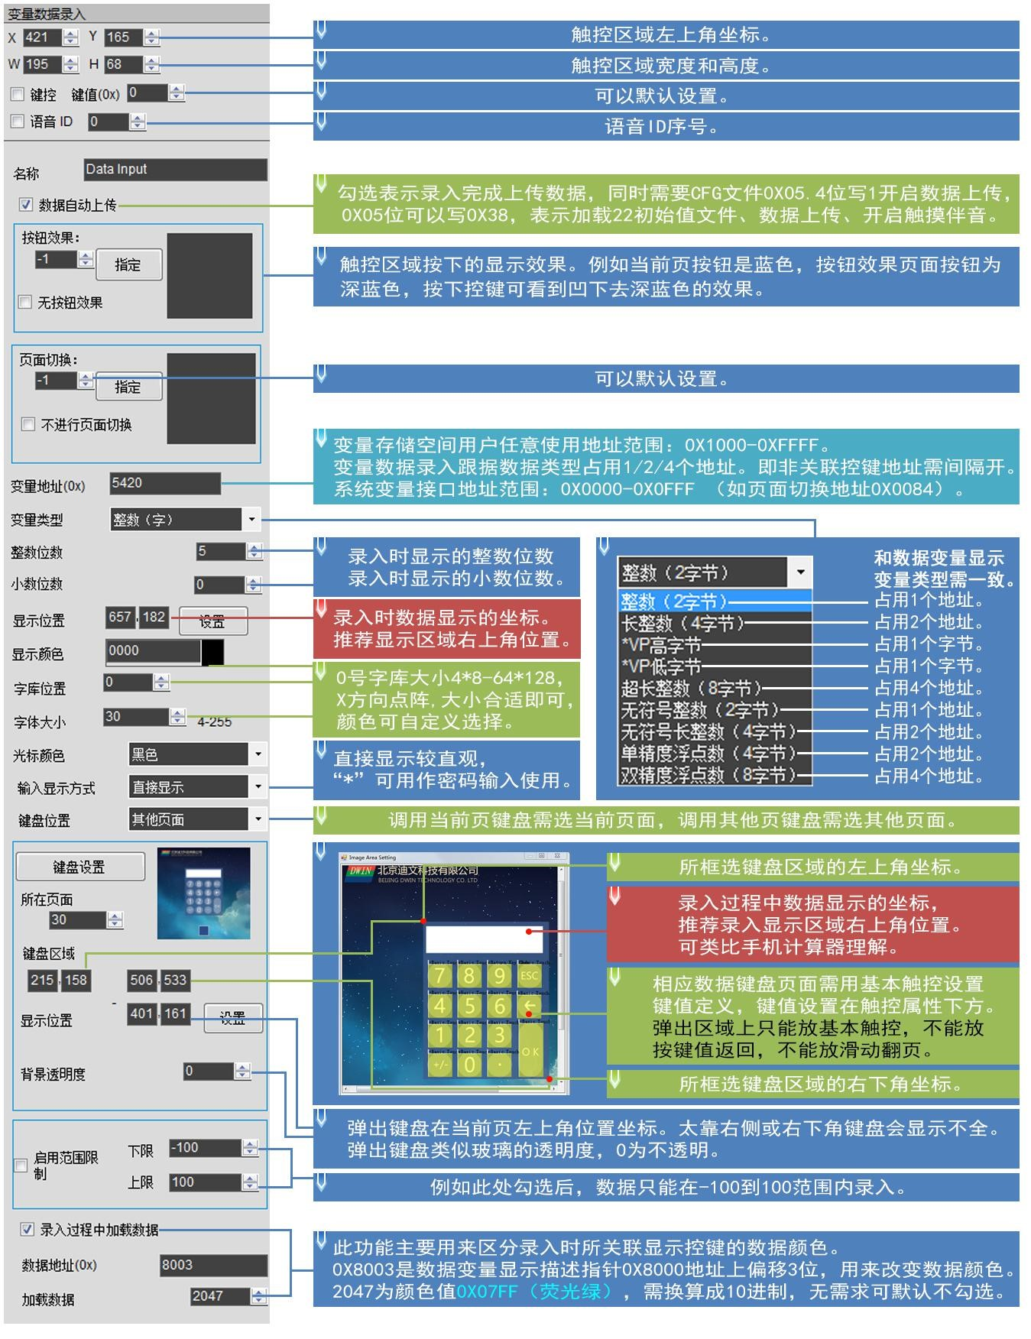

Figure **6.1 Description of** variable data entry software settings.

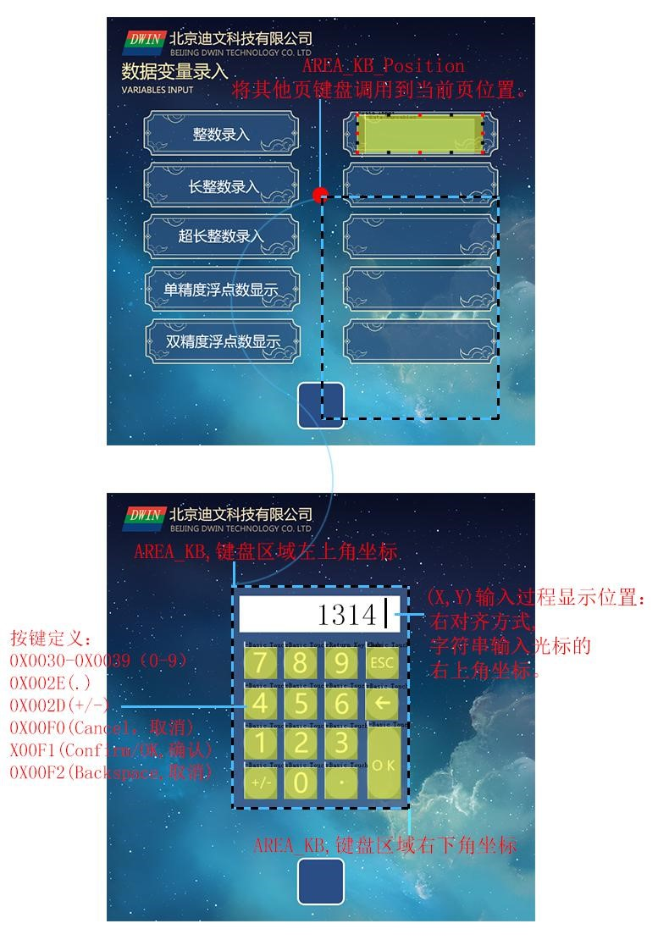

Figure **6.2 Variable** data entry software sets keyboard coordinate settings.

## **6.3** Pop-up menu.

#### **6.3.1** Pop-up menu instruction storage format.

The pop-up menu selection function clicks the key code that triggers a pop-up menu and returns the menu item, and the drop-down menu can also use this instruction. Valid key code during input:0x0000-0x00FF,where 0x00FF is canceled (i.e. no parameters are selected to return directly). Only basic touch keys can be used on pop-up menus.

Its instruction storage format is shown in the table. Pop-up menu transparency can be set.

Table 6.4 Pop-up menu instruction storage format.

|  |  |  |  |
| --- | --- | --- | --- |
| Address. | Defined. | The length of the data. | Description. |
| **0x00** | Pic_ID | 2 | 页面 ID |
| **0x02** | TP_Area | 8 | 触控按钮区域:(xs,Ys），（xe,Ye） |
| **0x0A** | Pic_Next | 2 | The target switch page,0xFF, means no page switching. |
| **0x0C** | Pic_On | 2 | The button presses the page where the effect map islocated, and 0xFF indicates that there is no button press effect. |
| **0x0E** | TP_Code | 2 | The key code selected by the 0xFE01 pop-up menu. |
| **0x10** | 0xFE | 1 | 0xFE |
| **ox11** | *VP | 2 | Variable address pointer, the data returned has VP_Mode decision. |
| **0x13** | VP_Mode | 1 | 0x00=把 0x00**键码写入 VP 字地址（整数型）；  0x01=把 0x**键码写入 VP 字地址的高字节地址（VP_H）；  0x02=把 0x**键码写入 VP 自地址的低字节地址（VP_L）；  0x10-0x1F:把**键码低位(1bit)变量并写入 VP 字址的指定位(0x10 修改 VP.0,0x1F 修改 VP.F) |
| **0x14** | Pic_Menu | 2 | The picture location of the pop-up menu. |
| **0x16** | Area_Menu | 8 | D.单区域:左上角坐标,xs,Ys)，右下坐标(xe,Ye. |
| **0x1E** | Menu_Position_x | 2 | The menu displays the x top left corner x coordinates of the current page. |
| **0x20** | 0xFE | 1 | 0xFE |
| **0x21** | Menu_Position_Y | 2 | The menu displays Y coordinates in the upper left corner of the current page. |
| **0x23** | Translucent | 1 | Pop-up menu picture background transparency settings. Range 00 to 0xFF . |
| **0x24** | NULL | 12 | 写 0x00 |

#### **6.3.2** Pop-up menu software settings.

Open the DGUS software and click on the touch keys on the page to pop up the menu. Next, select an area with the mouse box to set up the feature in the menu on the right.

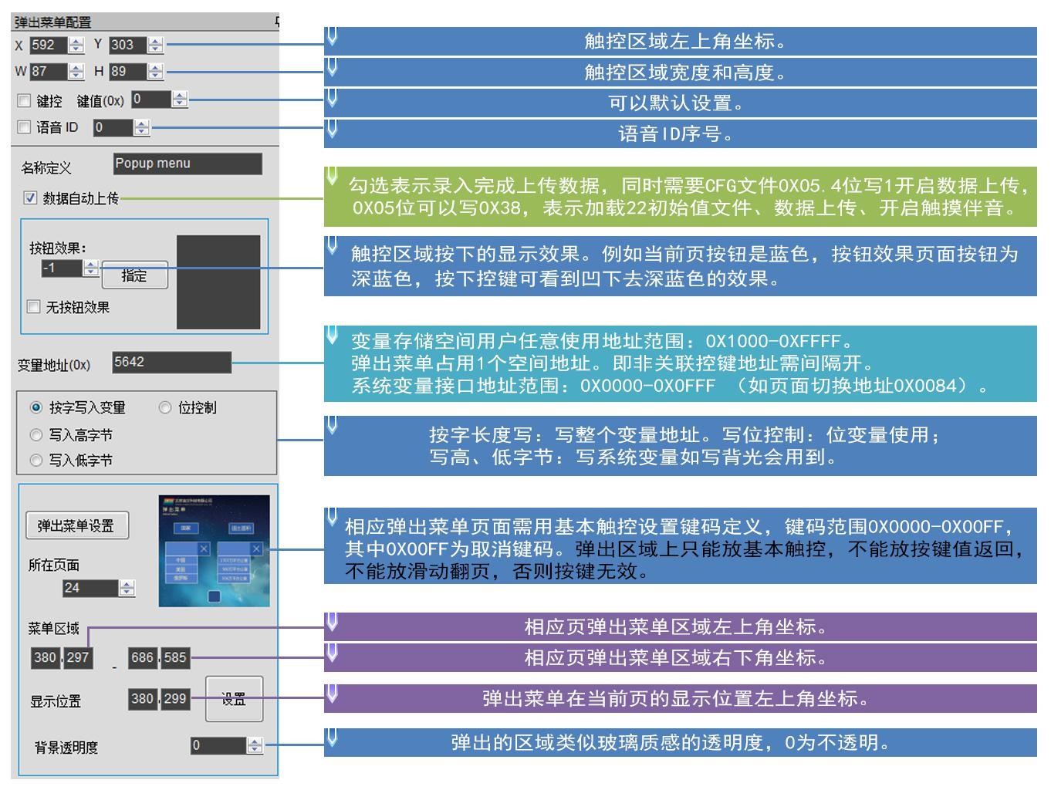

Figure **6.3 Pop-up** menu software setup instructions.

As shown in thefigure, 中国 the basic touch key code 俄罗斯 ” 上的基本触控键码（(0x0000-0x00FE)on 美国 "China", "United States" and "Russia" click will be returned to the variable address pointed to by the pop-up menu key,"x" cancellation 取消按钮键码设置为 button key code is set to 0x00FF, thevalue will not be returned when clicked and the menu will be ”“ ）点击后将返回给弹出菜单控键所指向的变量地址，exited.

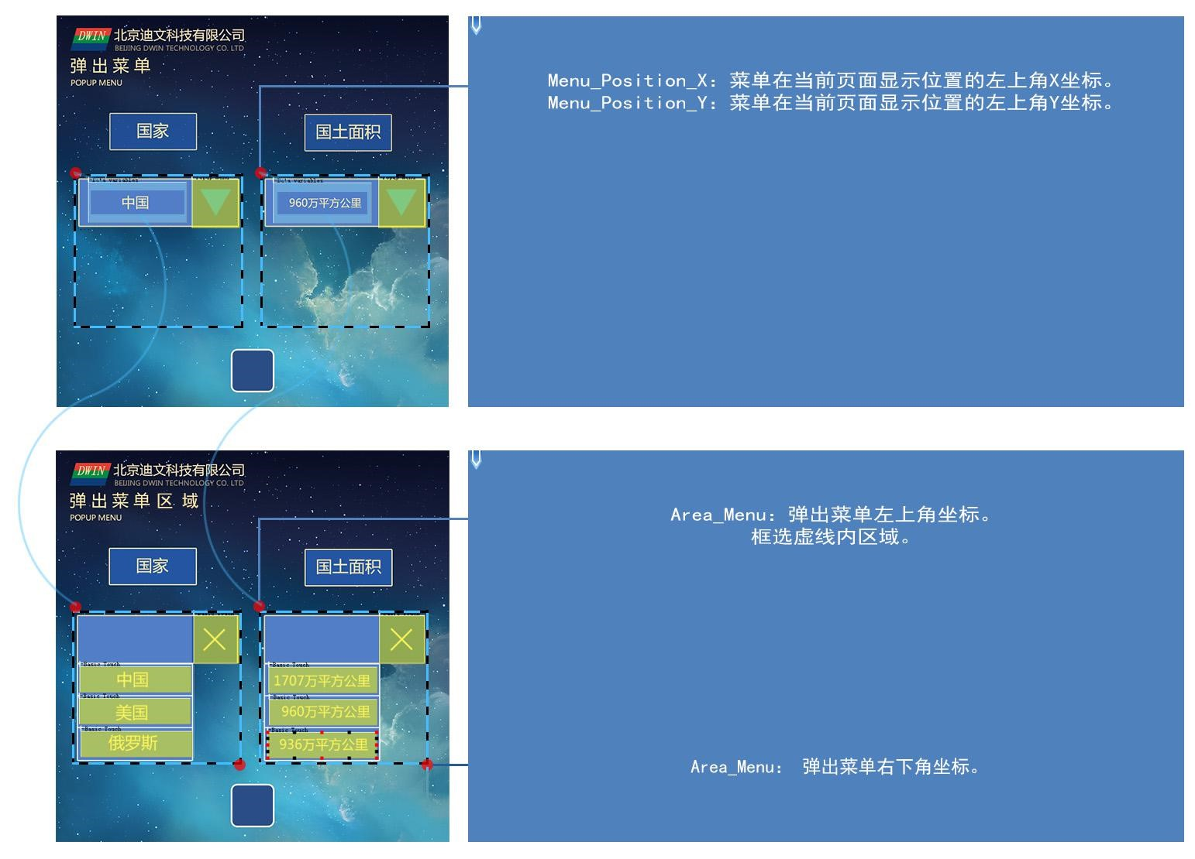

Figure **6.4 Pop-up** menu pop-up area illustration.

## **6.4** Incremental adjustment .

#### **6.4.1** Incremental adjustment instruction storage format.

Incremental adjustment is used to adjust the data value, click the button to the specified variable to perform the operation of the s/- , you can set the step length and upper and lower limits.

Table 6.5 incremental adjustment instruction storage format.

|  |  |  |  |
| --- | --- | --- | --- |
| Address. | Defined. | The length of the data. | Description. |
| **0x00** | Pic_ID | 2 | 页面 ID |
| **0x02** | TP_Area | 8 | 触控按钮区域:(xs,Ys),）,(car,Ye)） （ |
| **0x0A** | Pic_Next | 2 | The target switch page, which must be 0xFF,indicates that no page switch is made. |
| **0x0C** | Pic_On | 2 | The button presses the page where the effect map islocated, and 0xFF indicates that there is no button press effect. |
| **0x0E** | TP_Code | 2 | 0xFE02 |
| **0x10** | 0xFE | 1 | 0xFE |
| **0x11** | *VP | 2 | Variable address pointer, the return data is determined by VP_Mode of . |
| **0x13** | VP_Mode | 1 | 0x00=调节 VP 字地址（整型数）；  0x01）； - Adjusts the high-byte address ofthe VP word address(1 byte without a symbol, VP_H);VP_H  0x02）； - Adjusts the low-byte addressof the VP word address(1 byte is unsigned, VP_L);VP_L  0x10-0x1F:对 VP 字地址的指定位(0x10 对应 VP.0,0x1F 对应 VP.F)进行调节置为 调节围必须置为 0-1☛ |
| **0x14** | Adj_Mode | 1 | 调节方式：0x00=-- 其它=++ |
| **0x15** | Return_Mode | 1 | Over-the-limit processing:0x00 - Stop (equal to threshold) Other - Cycle adjustment. |
| **0x16** | Adj_Step | 2 | Adjust step,0x0000-0x7FFF. |
| **0x18** | V_Min | 2 | 下限：2 字节整数（VP_Mode=0x01 或 0x02 时，仅低字节有效） |
| **0x1A** | V_Max | 2 | 上限：2 字节整数（VP_Mode=0x01 或 0x02 时，仅低字节有效） |
| **0x1C** | Key_Mode | 1 | 0x00:Continuous adjustment when pressing and holding the button;  0x01:Adjust the key only 1 time when you press and hold it. |
| **0x1D** | NULL | 3 | 写 0x00 |

#### **6.4.2** Incremental adjustment software settings.

In the DGUS software, click _ touch keys for incremental adjustment, then use the mouse box to select an area and set the feature in the menu on the right.

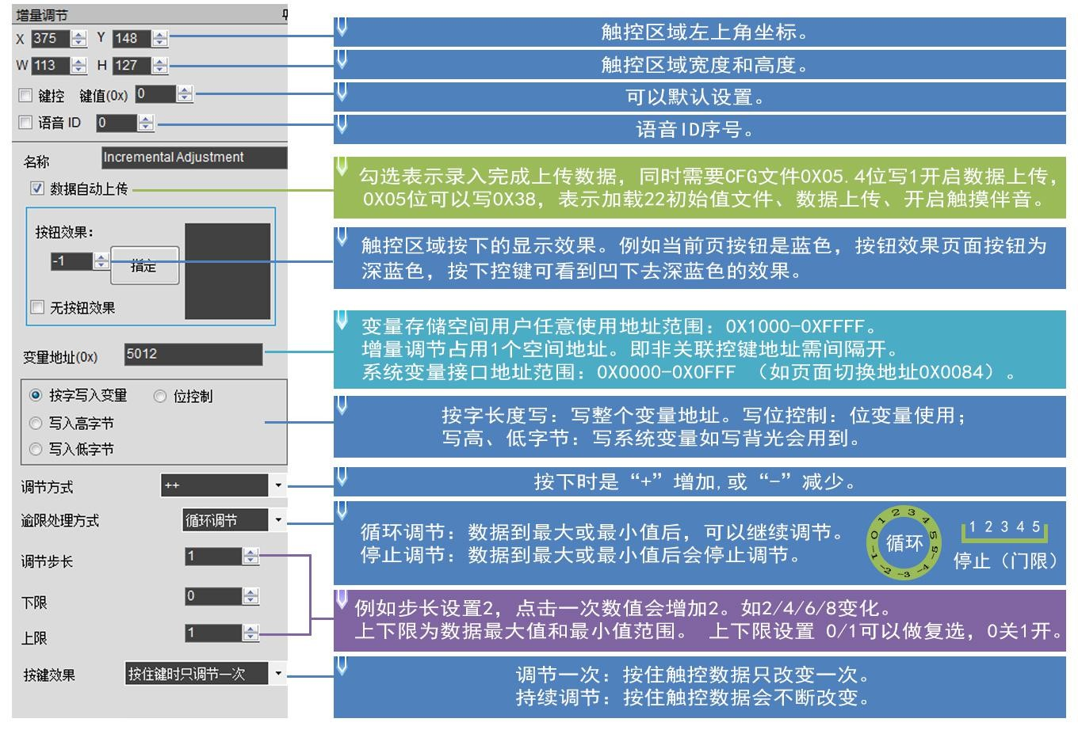

Figure **6.5 Description of** incremental adjustment software settings.

The adjustment range loop adjustment of the software setting 0-1 above can be combined with the icon control to achieve the following functions: buttonpress the display，再次按下显示图标 icon A, press the display icon B again,，类似 similar to the 开、关 "on, off" status “ display.

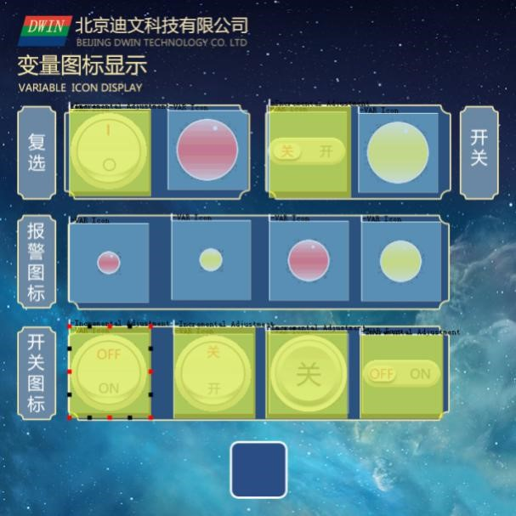

Figure **6.7 incremental** adjustment cycle adjustment.

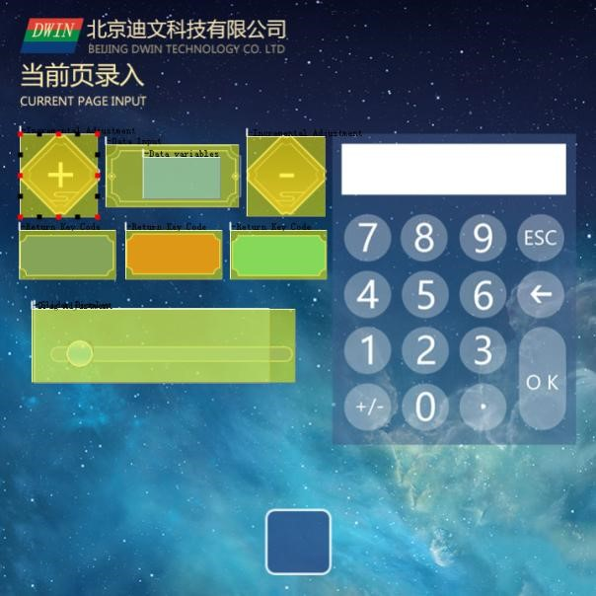

Figure **6.8 Incremental** adjustment control placement interface effect reference.

## **6.5** Drag adjustment .

#### **6.5.1** Drag adjustment instruction storage format .

Drag adjustment is used to drag the drag slider to achieve variable data entry, setting the scale range.

Table 6.6 Drag adjustment instruction storage format.

|  |  |  |  |
| --- | --- | --- | --- |
| Address. | Defined. | The length of the data. | Description. |
| **0x00** | Pic_ID | 2 | 页面 ID |
| **0x02** | TP_Area | 8 | 触控按钮区域:(xs,Ys），（xe,Ye） |
| **0x0A** | Pic_Next | 2 | The target switch page, which must be 0xFF,indicates that no page switch is made. |
| **0x0C** | Pic_On | 2 | The page on which the button presses the effect map must be 0xFF,indicating that there is no button press effect. |
| **0x0E** | TP_Code | 2 | 0xFE03 |
| **0x10** | 0xFE | 1 | 0xFE |
| **0x11** | *VP | 2 | Variable address pointer. |
| **0x13** | Adj_Mode | 1 | High 高 4bit defines the data return format : .  0x0*=调节 VP 字地址（整型数）；  0x1 s adjusts the high byte address of the VP ）； word address 字地址的高字节地址（(1 byte is unsigned,VP_H);  0x2 x - Adjusts the low-byte addressof the VP word address(1 byte unsigned,VP_L).  ☆低 4bit 定义了拖动方式：  0x*0=横向拖动；0x*1=纵向拖动。 |
| **0x14** | Area_Adj | 8 | 有效调节区域:(xs,Ys，(car,Ye),xe,Ye）必须和触控区域大致。 |
| **0x1C** | V_Begain | 2 | The return value corresponding to the starting position, the integer. |
| **0x1E** | V_End | 2 | The return value corresponding to the termination location, the integer. |

#### **6.5.2** Drag adjustment software settings.

In the DGUS software, click the _ touch key to drag the adjustment, select an area with the mouse box, and set the feature in the menu on the right. The advantage of drag adjustment is that it is intuitive, fast, and the parameters do not cross the line. When more precise drag entry is required, the variable data to which the drag adjustment is directed can be displayed with 数据变量显示 the Data Variable Display function (Figure 0.35).

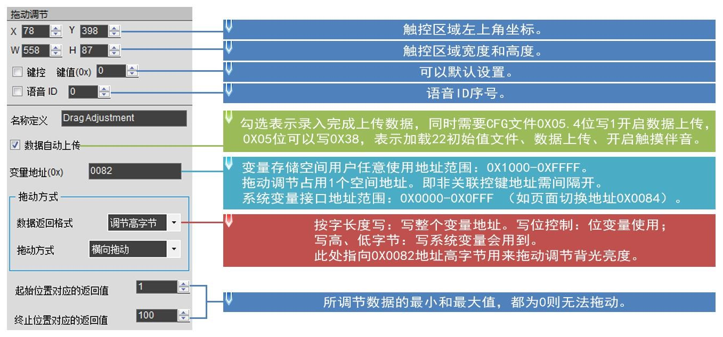

Figure **6.9 Description of** the drag adjustment software settings.

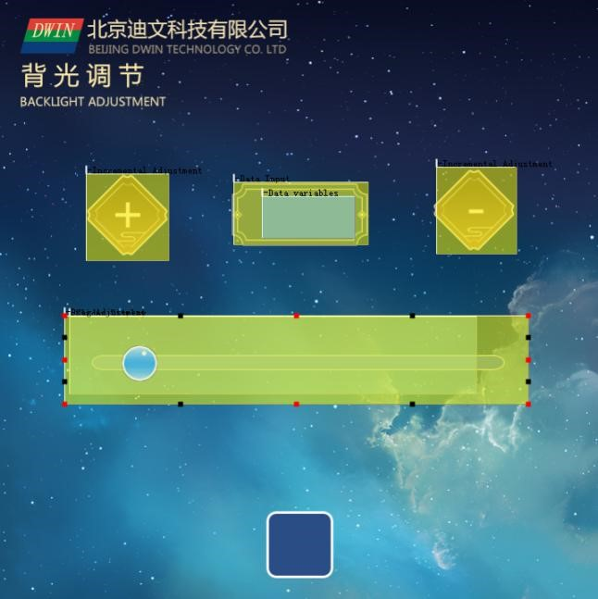

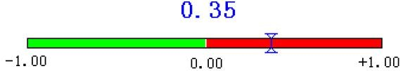

Figure **6.10 Drag** adjustment function effect.

## **6.6 The** key value returns .

#### **6.6.1 The key** returns the instruction storage format.

Key value return is used to click the key button, return the key value directly to the variable, support bit variable return.

Table 6.7 key values return the instruction storage format.

|  |  |  |  |
| --- | --- | --- | --- |
| Address. | Defined. | The length of the data. | Description. |
| **0x00** | Pic_ID | 2 | 页面 ID |
| **0x02** | TP_Area | 8 | 触控按钮区域(xs,Ys）（xe,Ye） |
| **0x0A** | Pic_Next | 2 | The target switch page,0xFF, means no page switching. |
| **0x0C** | pic_On | 2 | The button presses the page where the effect map islocated, and 0xFF indicates that there is no button press effect. |
| **0x0E** | TP_Code | 2 | 0xFE05 |
| **0x10** | 0xFE | 1 | 0xFE |
| **0x11** | *VP | 2 | Variable address pointer. |
| **0x13** | TP_Mode | 1 | 0x00 - The return key value is saved at the VP word address (integer number);  0x01 . . . returns a high byte address (the high-byte address ( the VP-word address)wherethe key value VP_H););  0x02 . . . returns a low byte of key value saved at the VP word address); 字地址的低字节地址（(VP_L);  0x10-0x1F:把返回键值的低位(1bit)写入）写入 VP 字地址的指定位(0x10 修改 VP.0,0x1F 修改 VP.F)☛ |
| **0x14** | Key_Code | 2 | Returns the key value. |
| **0x16** | NULL | 10 | 写 0x00。 |

#### **6.6.2 The button** returns the software settings.

In the DGUS development software, click the touch key to return, box the button area and set the button effect, page toggle, return key value, variable address, etc. to complete the configuration.

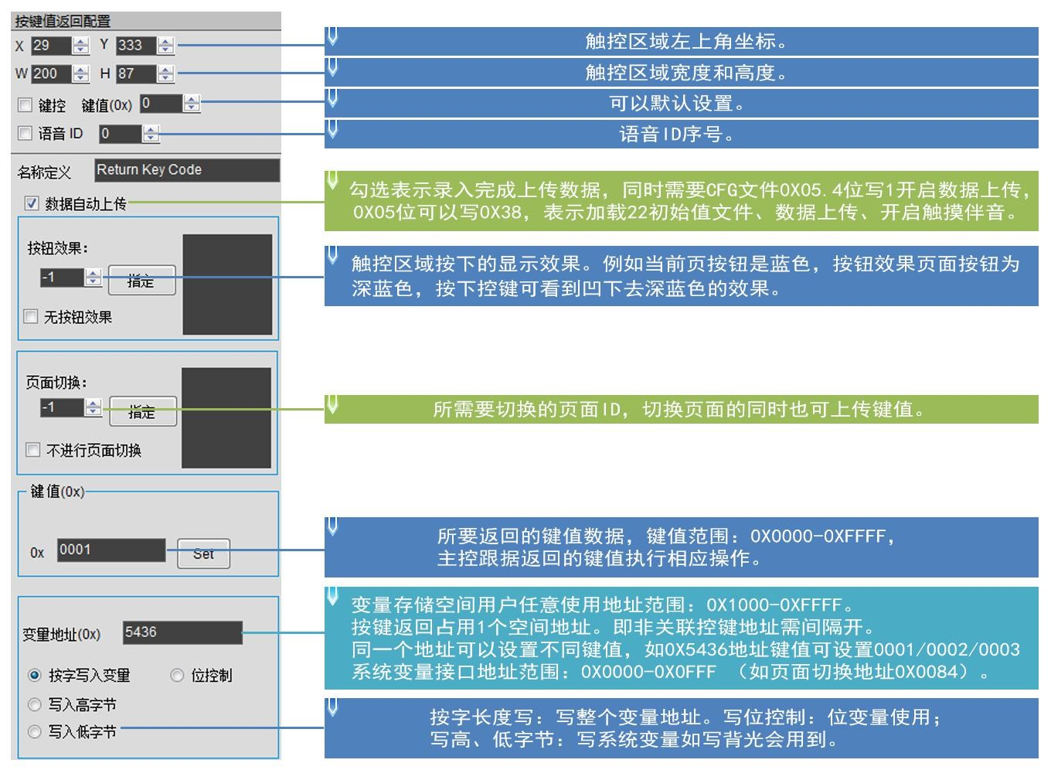

Figure **6.11 press to return** the software settings instructions.

Returns the data format: .

|  |  |  |  |  |  |
| --- | --- | --- | --- | --- | --- |
| 5AA5 | 06 | 83 | 5436 | 01 | 0001 |

含义：0x5A5A：帧头；

0x06:Data length;

###### 0x83:Read instructions; .

0x5436:Variable address;

0x01:The word length that returns the data;

0x0001：返回的 0001 键值。

## **6.7** Text entry.

Text entry contains ASCII and GBK 和 Chinese character text to enter text characters, the input process supports cursor movement, editing. You can set the inputstatus and entry length to be saved at the(VP-1)location. ASCII entry mode pop-up keyboard transparency can be set.

The input text keyboard keycode is shown in the table below: .

The key code is the key value that needs to be defined for the basic touch done on the keyboard. Two of the low bytes of the key code represent the normal key code, and the high byte represents the capital key code. For example, 0x61 corresponds to a,，0x41 corresponds to A,，and 0x31 corresponds to 1. At the same time, the key code definition of the text keyboard must be less than 0x80 (ASCII 码 code),，0x0D 键码录入会自动转换成 keycode entry is automatically converted to；0x0D 和 键码禁用 0x0A; 0xFF

Table 6.8 Text keyboard keycode.

|  |  |  |  |  |  |  |  |  |  |  |  |
| --- | --- | --- | --- | --- | --- | --- | --- | --- | --- | --- | --- |
| The key code. | Ordinary. | Capital. | The key code. | Ordinary. | Capital. | The key code. | Ordinary. | Capital. | The key code. | Ordinary. | Capital. |
| 0x7E60 | ` | ~ | 0x5171 | q | Q | 0x4161 | a | A | 0x5A7A | Z | Z |
| 0x2131 | 1 | ! | 0x5777 | w | W | 0x5373 | s | S | 0x5878 | x | x |
| 0x4032 | 2 | @ | 0x4565 | And | And | 0x4464 | D | D | 0x4363 | c | C |
| 0x2333 | 3 | # | 0x5272 | r | R | 0x4666 | f | F | 0x5676 | V | V |
| 0x2434 | 4 | $ | 0x5474 | t | T | 0x4767 | g | G | 0x4262 | b | B |
| 0x2535 | 5 | % | 0x5979 | And | And | 0x4868 | h | H | 0x4E6E | N | N |
| 0x5E36 | 6 | ^ | 0x5575 | u | U | 0x4A6A | J | J | 0x4D6D | m | M |
| 0x2637 | 7 | & | 0x4969 | i | I | 0x4B6B | k | K | 0x3C2C | , | < |
| 0x2A38 | 8 | * | 0x4F6F | The | The | 0x4C6C | L | L | 0x3E2E | . | > |
| 0x2839 | 9 | ( | 0x5070 | p | P | 0x3A3B | ; | : | 0x3F2F | / | ? |
| 0x2930 | 0 | ) | 0x7B5B | [ | { | 0x2227 | ‘ | “ | 0x2020 | SP | SP |
| 0x5F2D | - | _ | 0x7D5D | ] | } | 0x0D0D | Enter | Enter |  |  |  |
| 0x2B30 | = | + | 0x7C5C | \ | | |  |  |  |  |  |  |

Keyboard function keycode definition table: .

Table 6.9 Keyboard function keycode definition.

|  |  |  |
| --- | --- | --- |
| The key code. | Defined. | Description. |
| **0x00F0** | Cancel | Un-entry returns without affecting variable data. |
| **0x00F1** | Return | Confirm the entry return, and the entry text is saved to the specified variable location. |
| **0x00F2** | Backspace | Remove one character forward (back) . |
| **0x00F3** | Delete | Remove one character back. |
| **0x00F4** | CapsLock | Capital lock. If enabled, the corresponding button must define the effect of the button press. |
| **0x00F7** | Left | The cursor movesGBK one character forward; |
| **0x00F8** | Right | The cursor movesGBK one character back; |

#### **6.7.1 ASCII** text entry.

**6.7.1.1 ASCII** Text Entry Instruction Storage Format.

ASCII text entry is used to “ 文本显示 enter 可关联 文本录入 软件，点击基本触控 _ 文本录入，用鼠标框选一个区域，即可在右侧的菜单中对该功能进行设置 ASCII 字符，打开 characters, open the DGUS software, click on the basic touch s text entry, use the mouse box to select an area, you can set the function in the menu on the right,"ASCII textentry" can be associated with "text display" key, in order to display the entered characters. Devine's pre-installed library 字库包含了 of 0-word contains all ASCII code characters for the 4x8-64x128 点阵的所有 ASCII dot matrix. ASCII or GBK Chinese character text is entered in text characters, and the input process supports cursor movement and editing. You can set the inputstatus and entry length to be saved at the(VP-1)location. ASCII entry mode pop-up keyboard transparency can be set.

Table 6.10ASCII Text Entry Instruction Storage Format.

|  |  |  |  |
| --- | --- | --- | --- |
| Address. | Defined. | The length of the data. | Description. |
| **0x00** | Pic_ID | 2 | 页面 ID |
| **0x02** | TP_Area | 8 | 触控按钮区域:(xs,Ys),）,(car,Ye)） （ |
| **0x0A** | Pic_Next | 2 | The target switch page,0xFF, indicates that there is no button press effect. |
| **0x0C** | Pic_On | 2 | The button presses the page where the effect map islocated, and 0xFF indicates that there is no pressing effect. |
| **0x0E** | TP_Code | 2 | 0xFE06(i.e. the touch code for text entry). |
| **0x10** | 0xFE | 1 | 0xFE |
| **0x11** | *VP | 2 | Variable address pointer. |
| **0x13** | VP_Len_Max | 1 | The maximum length of the text variable, the number of words(Word),the range is 0x01-0x7B;  When the text is saved to the specified address, 0xFFFF 作为结束符；录入的文本变量实际可能占用的最大变量空间 is automatically added as the ending character VP_Len_Max at the end of the text; |
| **0x14** | Scan_Mode | 1 | Enter mode control:0x00 s re-entry, 重新录入，0x01 s open the original text and modify it. |
| **0x15** | Lib_ID | 1 | Displays the location of the ASCII word library to be used,0x00 - the default word library. |
| **0x16** | Font_Hor | 1 | Font size,number of dot matrixes in the x direction. |
| **0x17** | Font_Ver | 1 | Font size, number of dot matrixes in theY direction (whenusing the default wordlibrary, the number of dots in the Y direction must be twice the number of dots in the x direction). |
| **0x18** | Cusor_Color | 1 | Cursor color,0x00 s black, others s white. |
| **0x19** | Color | 2 | The text shows the color. |
| **0x1B** | Scan_Area_Start | 4 | The incoming text shows the upper-left coordinates(xs, Ys) of thearea. |
| **0x1F** | Scan_Return_Mod and | 1 |  |
| **0x20** | 0xFE | 1 | 0xFE |
| **0x21** | Scan_Area_End | 4 | Enter the coordinates(xe, Ye)in the lower right corner of thetext area. |
| **0x25** | KB_Source | 1 | Keyboard page location selection:0x00 - Keyboard is on the = current page; |
| **0x26** | PIC_KB | 2 | The page on which the keyboard is located (when the keyboard is not valid for the current page). |
| **0x28** | Area_KB | 8 | 键盘所在页面时的键盘区域坐标:(xs,Ys),）,(car,Ye)） （  (The keyboard is not valid for the current page). |
| **0x30** | 0xFE | 1 | 0xFE |
| **0x31** | AREA_KB_Positi on | 4 | When the keyboard is not on the current page, the keyboard displays the coordinates in the upper-left corner of the location. |
| **0x35** | Display_EN | 1 | 0x00 - The input process is displayed normally; ；  0x01 - The input process is displayed as a """"""""""""""""""""""""""""""""""""""""""， 用于密码输入 |
| **0x36** | Translucent | 1 | Pop up the picture background transparency settings for the keyboard area. Range 00 to 0xFF . |
| **0x37** | NULL | 9 | 写 0x00 |

**6.7.1.2 ASCII** Text Entry Software Settings Instructions.

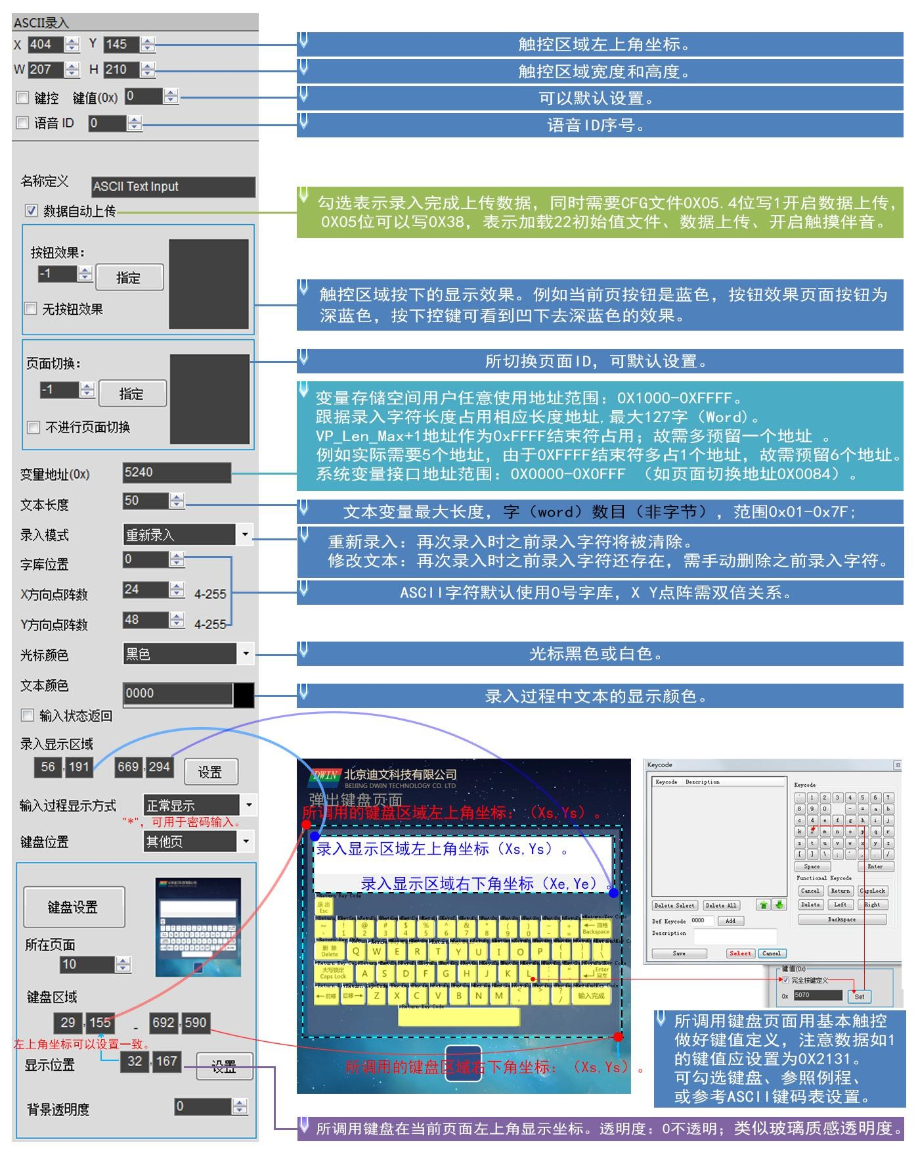

Figure **6.12 Description of** text software settings.

#### **6.7.2 GBK** 汉字录入

GBK Chinese character entry is used to enter Chinese character text, open the DGUS 软件，点击基本触控 software, click on the basic touch _GBK input, ，use the mouse box to select an area, you can set the function in the menu 可关联 “ 文本显示 on theright,"GBK 汉字录入 Chinese character entry" can be associated with "text display" key, in order to display the input characters.

**6.7.2.1 GBK** Chinese character entry instruction storage format.

Table 6.11GBK Chinese character entry instruction storage format.

|  |  |  |  |
| --- | --- | --- | --- |
| Address. | Defined. | The length of the data. | Description. |
| **0x00** | Pic_ID | 2 | 页面 ID |
| **0x02** | TP_Area | 8 | 触控按钮区域:(,(xe,Yexs,Ys)）） |
| **0x0A** | Pix_Next | 2 | The target switch page,0xFF, means no page switching. |
| **0x0C** | Pic_On | 2 | The button presses the page where the effect map islocated, and 0xFF indicates that there is no button press effect. |
| **0x0E** | TP_Code | 2 | 0xFE06(i.e. the touch code for text entry). |
| **0x10** | 0xFE | 1 | 0xFE |
| **0x11** | *VP | 2 | Variable address pointer. |
| **0x13** | VP_Len_Max | 1 | The maximum length of the text variable, the number of words(word),）数目，0x01-0x7B;  When the text is saved to the pointer address, 0xFFFF 作为结束符；录入的文本变量实际可能占用的最大变量空间为：is automatically added as the ending characterVP_Len_Max at the end of the text; |
| **0x14** | Scan_Mode | 1 | Entry mode control:0x00 s0x01= re-entry; 重新录入； |
| **0x15** | Lib_GBK1 | 1 | 汉字字符显示使用的 GBK 字库 ID，ASCII 字符默认使用 0x00 字库。 |
| **0x16** | Lib_GBK2 | 1 | The GBK word library ID used to display chinese characters during entry. |
| **0x17** | Font_Scale1 | 1 | Lib_GBK1 font size, the number of dot matrixes. |
| **0x18** | Font_Scale2 | 1 | Lib_GBK2 font size, number of dot matrixes. |
| **0x19** | Cusor_Color | 1 | Cursor color,0x00 s black, others s white. |
| **0x1A** | Color0 | 2 | The display color of the entered text. |
| **0x1C** | Color1 | 2 | The display color Chinese the entry process. |
| **0x1E** | PY_Disp_Mode | 1 | During the entry process, Pinyin prompts and corresponding Chinese characters are displayed in the following way: .   * 0x00- Pinyin prompts are displayed above, the corresponding Chinese characters are displayed on another line below, Pinyin prompts and Kanjis are displayed left-aligned, with a line spacing ofScan_Dis. * 0x01 - Pinyin prompts are displayed on the left, and the corresponding Chinese characters are displayed on the right;   The Chinese character prompt starts with the x position as:Scan1_Area_Start, 3x.Font_Scale2,Scan_Dis. |
| **0x1F** | Scan_Return_Mode | 1 | 0xAA - Save the inputend tag and the length of the valid data at the location of . .. (VP-1).  （(VP-1)high byte,input end mark:0x5A indicates end of input,0x00 means input is still in.  (（VP-1 )low bytes, valid input data length, byte units.  0xFF- does not return the input end tag and data length. |
| **0x20** | 0xFE | 1 | 0xFE |
| **0x21** | Scan0_Area_Start | 4 | The incoming text shows the coordinates(xs, Ys) in the upper-left corner of the area. |
| **0x25** | Scan0_Area_End | 4 | The incoming text shows the coordinates(xe, Ye) in the lower right corner of the area. |
| **0x29** | Scan1_Area_Start | 4 | Pinyin prompt text displays the coordinates of the upper-left corner of the area during entry. |
| **0x2D** | Scan_Dis | 1 | During entry, the spacing is displayed for each Chinese character. Each line displays a maximum of 8 characters. |
| **0x2E** | 0x00 | 1 | 0x00 |
| **0x2F** | KB_Source | 1 | Keyboard page location selection:0x00 - Keyboard is on the = current page; |
| **0x30** | 0xFE | 1 | 0xFE |
| **0x31** | PIC_KB | 2 | The page ID where the keyboard is located. (Only if the keyboard is not valid for the current page). |
| **0x33** | Area_KB | 8 | 键盘所在页面的键盘区域坐标:(xe,Yexs,Y ;(s）；（ |
| **0x3B** | Area_KB_Position | 4 | When the keyboard is not on the current page, the keyboard displays the top-left coordinates on the current page. |
| **0x3F** | Scan_Mode | 1 | 0x02 - Pinyin input method.  0x03 - Note input method (traditional input in Taiwan). |

Note:

* Pinyin "bd" is entered for all GBK encoded full-angle punctuation marks.
* Devine's pre-installed library of 0s contains all ASCII code characters for the 4x8-64x128 点阵的所有 ASCII dot matrix.
* The key code (low byte) of the phonetic input method is defined in Table 7.8 (the phonetic input method is mainly used in Taiwan).

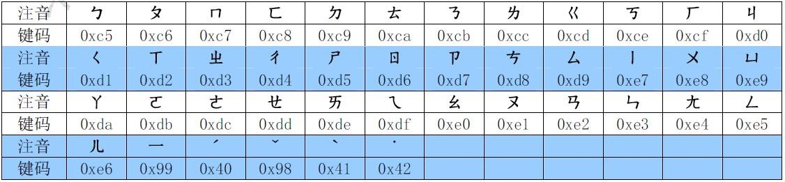

Figure **6.13 Description of** keycode settings for the phonetic input method.

**6.7.2.2 GBK** Chinese character entry software setup instructions.

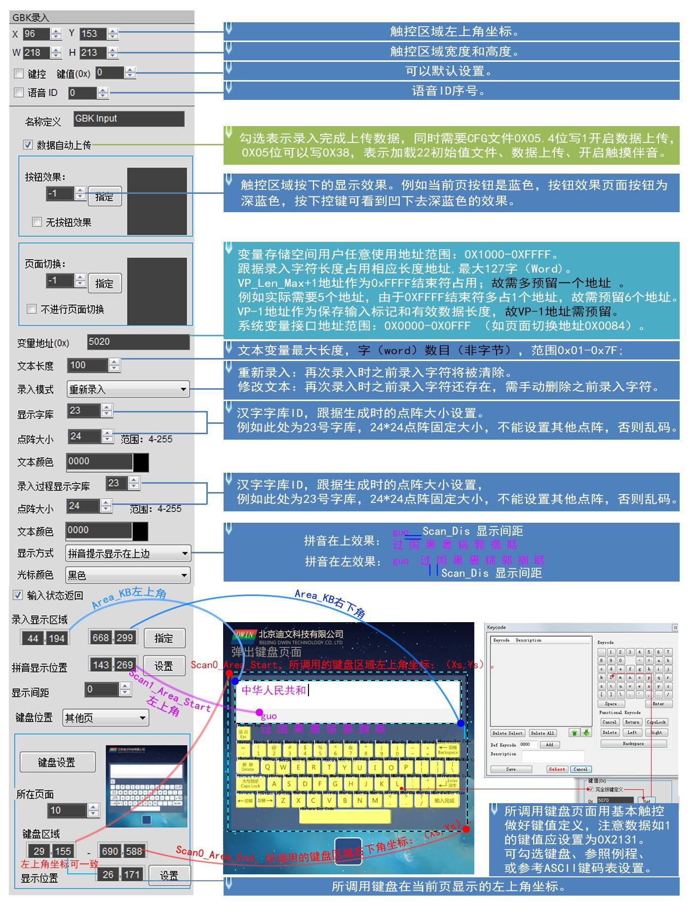

Figure **6.14 GBK Chinese** character entry software settings description.

## **6.8 Touch** screen press status data returns .

Press state data return has the bottom press, continuous press, release three states, click on the touch screen, according to the provisions to return data to variables.

#### **6.8.1 Touch** screen press status data returns instruction storage format.

The touch screen press state synchronization data return function clicks on the touch screen and returns the data to the variable or serial port according to the regulations.

T5L_DGUS II 屏只有 01 模式，用 01 模式功能取代 DGUS1 的 02 模式，新功能增加了：帧头+数据长度+83 和 VP 地址+长度+DATA，PC 软件中设置两处即可：VP1S 是设置可以用 22 文件初始化文件中地址，VP1T 指的 83 指令后面的 VP 地址。

Table 6.12 Touch screen press status data returns instruction storage format.

|  |  |  |  |
| --- | --- | --- | --- |
| Address. | Defined. | The length of the data. | Description. |
| **0x00** | Pic_ID | 2 | 页面 ID |
| **0x02** | TP_Area | 8 | 触控按钮区域:(Xs,Ys）（Xe,Ye） |
| **0x0A** | Pic_Next | 2 | The target switch page,0xFF, means no page switching. |
| **0x0C** | Pic_On | 2 | The button presses the page where the effect map islocated, and 0xFF indicates that there is no button press effect. |
| **0x0E** | TP_Code | 2 | 0xFE08 |
| **0x10** | 0xFE | 1 | 0xFE |
| **0x11** | TP_On_Mode | 1 | The first time the touch screen is pressed down, the data return mode: .  0x00 - No data is returned.  0x01 - Read the LEN2 length data that 指向的 the VP2S points 长度数据按 to is sent to the serial port in the DGUS serial protocol format. *VP2S  2。 |
| **0x12** | VP1S | 2 | The first time the touch screen is pressed, the address of the data is read. |
| **0x14** | VP1T | 2 | The address at which the data is written the first time the touch screen is pressed. |
| **0x16** | 0x00 | 1 | 0x00 |
| **0x17** | LEN1 | 1 | Returns the length of the data, the number of bytes. TP_On_Mode0x01, 时，LEN1 must be even. |
| **0x18** | 0xFE | 1 | 0xFE |
| **0x19** | TP_On_Continue_Mode | 1 | After the touch screen is pressed down for the first time, the data return mode: .  0x00 - No data is returned.  0x01 - Read the LEN2 length data that 指向的 the VP2S points 长度数据按 to is sent to the serial port in the DGUS serial protocol format. *VP2S  2。 |
| **0x1A** | VP2S | 2 | The address at which the data is read while the touch screen is continuously pressed. |
| **0x1C** | VP2T | 2 | The address at which the data is written while the touch screen is continuously pressed. |
| **0x1E** | 0x00 | 1 | 0x00 |
| **0x1F** | LEN2 | 1 | Returns the length of the data, the number of bytes. TP_On_Continue_Mode0x01, 时，LEN2 must be even. |
| **0x20** | 0xFE | 1 | 0xFE |
| **0x21** | TP_OFF_Mode | 1 | When the touch screen is released, the data return mode: .  0x00 - No data is returned.  0x01 - Read the LEN2 length data that 指向的 the VP2S points 长度数据按 to is sent to the serial port in the DGUS serial protocol format. *VP2S  2。 |
| **0x22** | VP3S | 2 | The address at which the data is read when the touch screen is released. |
| **0x24** | VP3T | 2 | The address at which the data is written when the touch screen is released. |
| **0x26** | 0x00 | 1 | 0x00 |
| **0x27** | LEN3 | 1 | Returns the length of the data, the number of bytes. TP_OFF_Mode0x01, 时，LEN3 must be even. |
| **0x28** | 0x00 | 8 | Reserved, write 0x00. |

The 3 states of touch screen press are shown in Figure 7.9. 所示

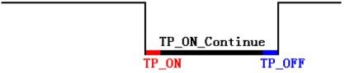

Figure **6.15 3** states in which the touch screen **is** pressed.

#### **6.8.2 Touch** screen press status data returns software settings.

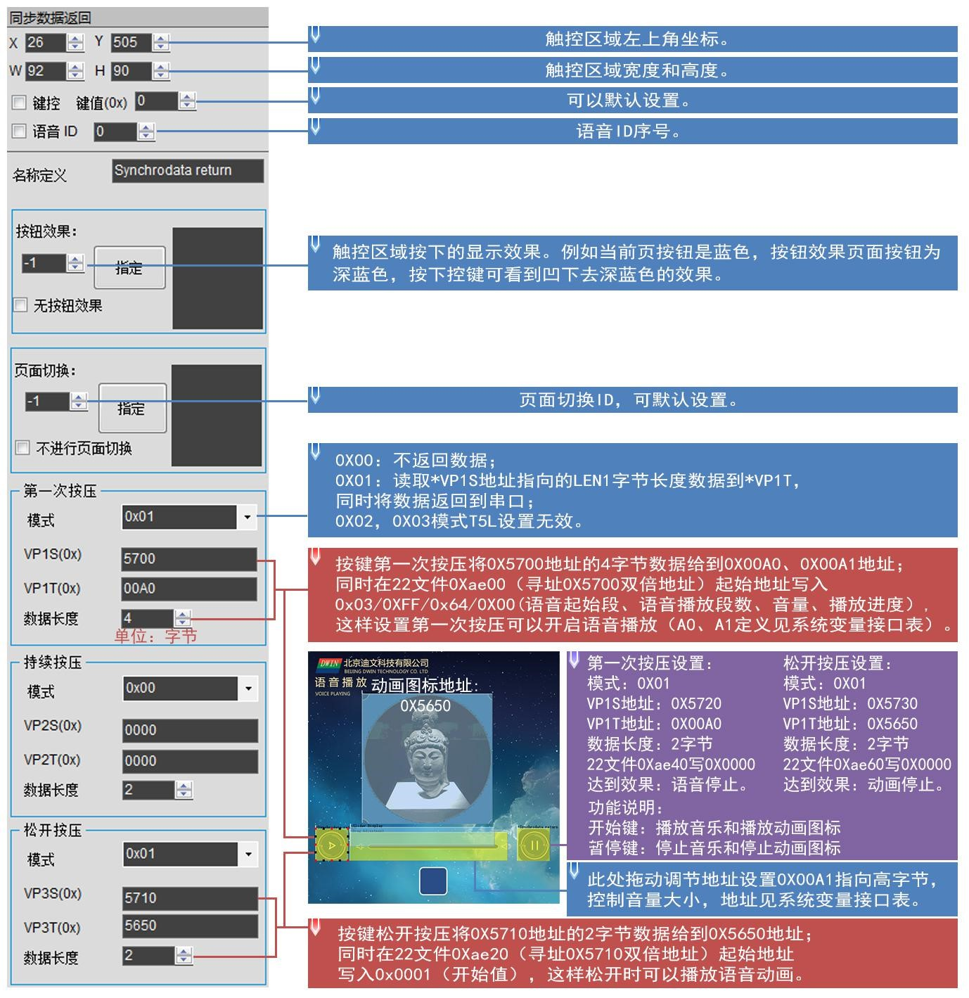

Figure **6.15 The touch** screen press status data returns the software settings instructions.

## **6.9** Slide (gesture) to adjust .

Sliding gesture adjustment slides the touch screen in the direction of the specified area X-axis or Y-axis, returning relative adjustment values in real time. With the data window indicating the display variable, dynamic vertical scrolling can be achieved.

#### **6.9.1** Slide (gesture) to adjust the instruction storage format.

Table 6.13 Slide (gesture) to adjust the instruction storage format.

|  |  |  |  |
| --- | --- | --- | --- |
| Address. | The length of the data. |  | Description. |
| **0x00** | 1 | Fixed value 0xFE. |  |
| **0x01** | 2 | The variable address. |  |
| **0x03** | 1 | Drag horizontally / vertically . |  |
| **0x04** | 1 | Set sensitivity. |  |

#### **6.9.2 Slide** (gesture) to adjust the software settings instructions.

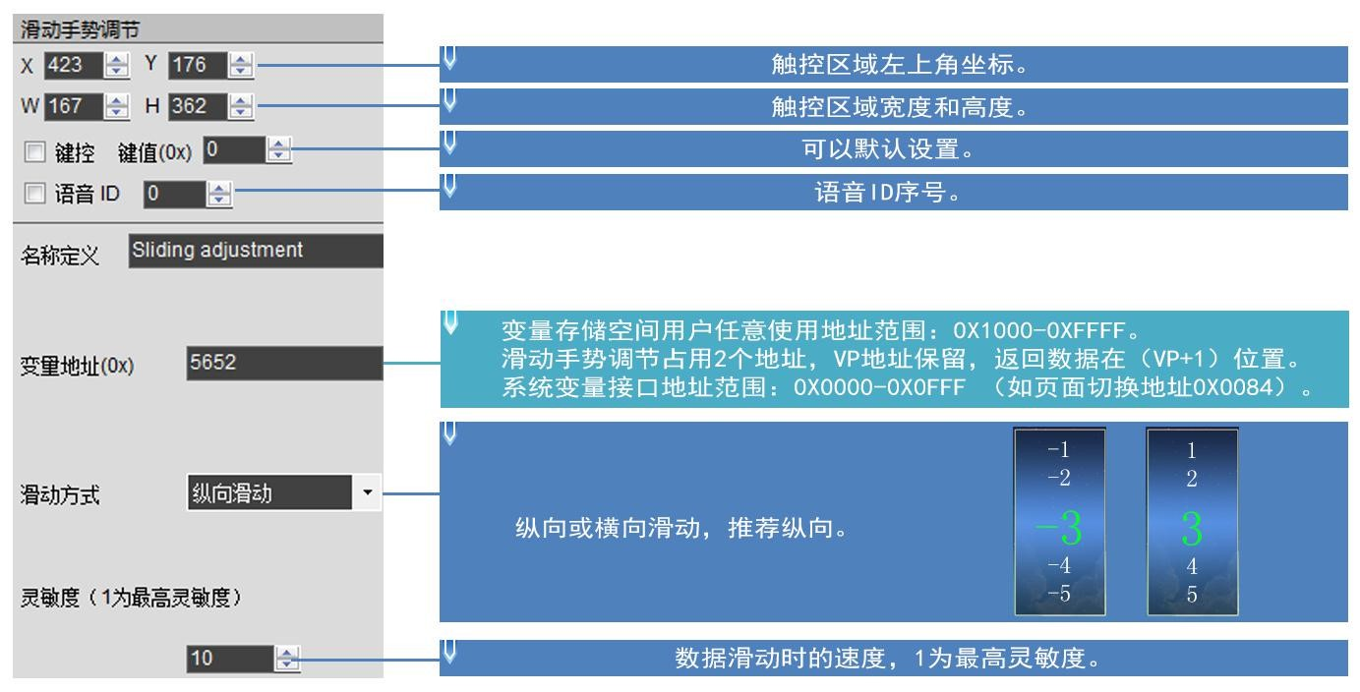

Figure **6.16 Slide** (gesture) to adjust the software settings instructions.

## **6.10** Swipe (gesture) to turn the page.

Slide the touch screen in the X-axis direction according to the specified area for dynamic page drag. You can set the target and area of the page switch, and the variable display of the current page will follow the drag. If you have other touch buttons on the slide page at the same time, and you need the entire page, including drag and drop touch buttons, to gesture to turn the page, you must set the touch priority of the swipe gesture page turn to the highest.

#### **6.10.1** Slide (gesture) page-turning instruction storage format.

Table 6.14 Slide (gesture) page-turning instruction storage format.

|  |  |  |  |
| --- | --- | --- | --- |
| Address. | Defined. | The length of the data. | Description. |
| **0x00** | FE | 1 |  |
| **0x01** | The previous page. | 2 | Turn the page ID of the previous page. |
| **0x03** | The 1st page. | 2 | The last page ID of the page. |
| **0x05** | And 坐标 | 4 | The Y coordinates in the upper-right and lower-right corners of the sliding area. |
| **0x09** | Page-turning sensitivity. | 1 | Distance. |
| **0x0A** | 0X00 | 1 | 00 |
| **0x0B** | Page-turning sensitivity. | 1 | Time. |
| **0x0C** | 0X00 | 4 | 00 |
| **0x10** | The current page. | 2 | The current number of pages. |

#### **6.10.2 Slide** (gesture) page-turning software settings instructions.

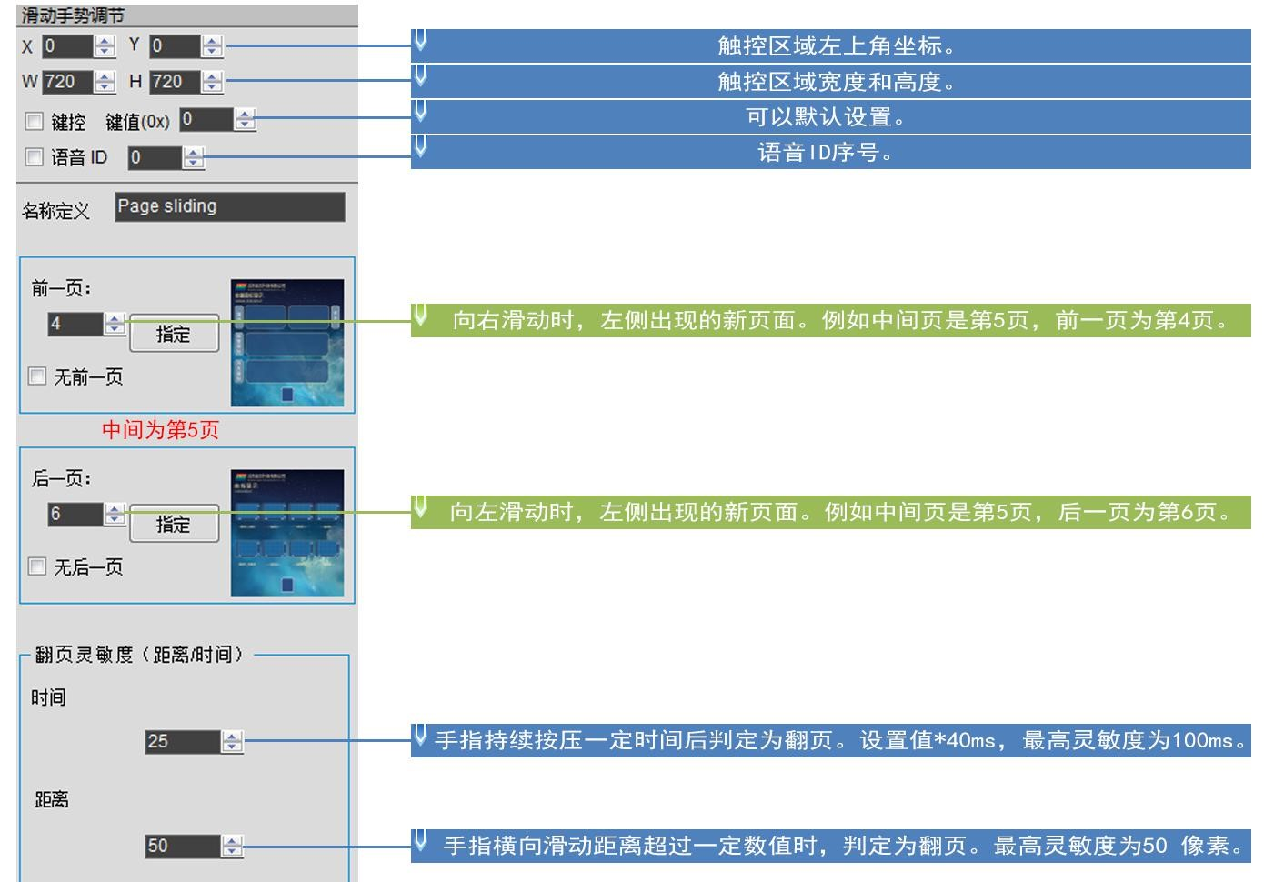

Figure **6.18 Slide** (gesture) page-turning software settings instructions.

## **6.11** Slide icon selection .

#### **6.11.1 Slide** icon to select the instruction storage format.

Sliding icon selection with icon page panning(JPEG icon panning display) enables icon page swipe selection. The benefits of this feature: smoother page switching than a slide screen, and a feature that can be ported directly on any screen above the window resolution, making the next set easier.

How to use:

1. Rank the icons you need (program or menu index) on a "huge" 巨大 ” 的 JPEG image 图片上（(T5L1 不超过 no more than 252KB,，T5L2 不超过 no more than 764KB;resolution is notrequired).
2. Define the touch of a virtual page for this "picture" (with the meaning of a pop-up keyboard).
3. By placing a window on the page you want to use, you can slide and select with a touch screen (or serial write VP2 position integer values for movement).

#### **6.11.2 Slide the** icon to select the software settings instructions.

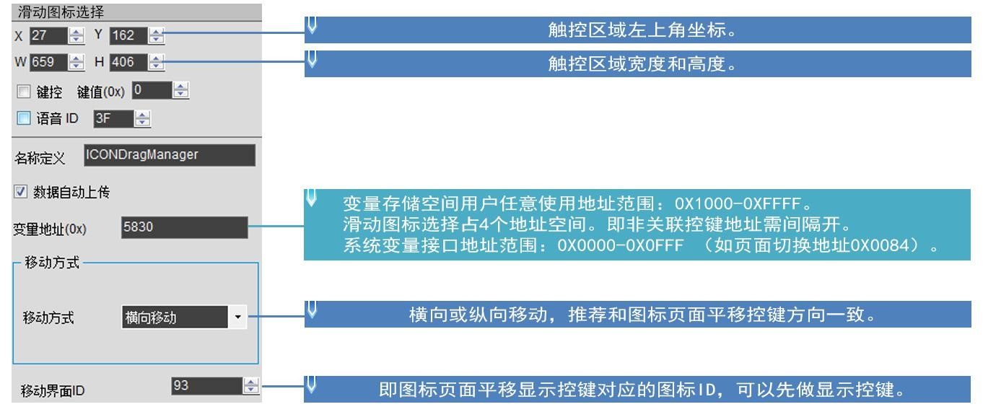

Figure **6.19 Slide the** icon to select the settings description.

# Chapter 7 shows the variable configuration function**(14.BIN)**description.

The display variable profile is stored in the word library space and consists of N variable 条按照页面配置的变量指令组成，每条变量指令固定占用 instructions configured by the page, each of which takes up 32 bytes of storage space. Fixed allocation of ）变量存储空间，即每页最多可设置 或 2KB, 或 4KB, or 8KB、(0x0800,、0x1000, or 或 0x2000)variable storage space per page,、 i.e. up to 64,（128, or 255 variables per page. The display variable profile is up to 2MB,，即最多可配置 i.e. up to 1024 张页面 ，（pages can be 变量模式下为 张页面、configured 变量模式下为 (512 pages in 128 variable mode and256 pages in 255 variable mode).

Because less than 2MB of variable 变量配置空间，所以 configuration space is used in real-world applications, 1 中固定划分出 个 256KB 子空间做为 subspace is fixed in 或 、 16MBFLASH 、as 14.BIN profile space, i.e. 配置文件空间，即在每页固定分配 up to a maximum of 2KB,4KB, or 或 8KB(64,128, or 255 variables) variable storage space per page. （ 128 pages 变量模式下为 (64 pages in 张页面（128 variable mode and32 pages in 255 variable mode). And the data variable display space is 128Kbytes. For variables of the same type, the lower the storage location, the higher its display priority.

Display variables(14.BIN)）可由 can be generated by DGUS-organized software, with applications that match touch variables, associated variable addresses, modify 22 file information, 文件信息、使用描述指针、通过串口或 use description pointers, and implement complex display variable combinations through serial or DWIN OS access.

A display variable configuration instruction consists of six parts: ： .

Table **7.1 shows** the composition of an instruction.

|  |  |  |  |
| --- | --- | --- | --- |
| Serial number. | Defined. | The length of the data (bytes). | Description. |
| **1** | 0x5A | 1 | Fixed. |
| **2** | Type | 1 | The type of variable. |
| **3** | *SP | 2 | The variable description file is loaded from Flash and stored as an address pointer to the data store. |
| **4** | Len_Dsc | 2 | The word length of the variable description. |
| **5** | *VP | 2 | Variable address 0x0000-0xFFFF,some variables that do not need to specifyan address, write 0x0000. |
| **6** | Description | N | The variable describes the contents. |

## **7.1 Display** variable function at a glance.

Note: ： .

* VP refers to where the user variable storage space is stored (pointer).
* Setting a variable description pointer during PC configuration software development stores the display variable configuration information in the user variable space to which the variable description pointer points.

The application can be accessed by serial or DWIN OS, dynamically turning variable configuration information on, off, or modifying, enabling complex display variable combination capabilities.

Table **7.2 shows** a list of variable compositions.

|  |  |  |  |  |
| --- | --- | --- | --- | --- |
| Serial number. | The function code. | Function. | The length of the data.  (Word) | Description. |
| **01** | 0x00 | The variable icon is displayed. | 1 | Displays a set of ICON icons linearly in the range of changes for a data variable, and automatically switches the icons as the variables change. More for fine dashboard, progress bar display.  Supports background overlays and transparency settings. |
| **02** | 0x01 | The animation icon is displayed. | 2 | A fixed-value data variable corresponds to three different icon indication states: do not display, display a fixed icon, display an animation icon. Alarm alerts for variables.  变量占 2 个字位置，（VP+1）位置保留；图标ID 不能超过255（0xFF）。  Supports background overlays and transparency settings to set the animation speed. |
| **03** | 0x02 | The slider scale indicates. | 1 | The range of changes in a data variable corresponds to the change in the display position of an icon (slider).  More instructions for levels, dials, and schedules.  Supports background overlays and transparency settings. |
| **04** | 0x03 | Art word variables are displayed. | 1/2/4 | Replace the word library with an ICON icon to display variable data.  Supports background overlays and transparency settings. |
| **05** | 0x04 | The picture is animated. | No. | Play a set of full-screen pictures at the specified speed. More for power-on interfaces or screensavers. |
| **06** | 0x05 | The icon rotates to show. | 1 | The range of change of a data variable is linearly corresponding to the angle data, and then an ICON icon is rotated according to the corresponding angle data and displayed. More for pointer dashboard display. |
| **07** | 0x06 | The bit variable icon is displayed. | 3 | The）的 0/1 状态对应 state of eachbit (bit)of a data variable corresponds to two of the eight different display scenarios, with an ICON icon (or icon animation) corresponding to the 种不同显示方案中的两种，用 display.  Mostly used for switching status displays, such as fan operation (animation), stop (still icon). |
| **08** | 0X07 | The JPEG icon pans to show . | 4 | Pan the JPEG icon page beyond the screen resolution up and down the screen window or left and right.  With the 0x0C touch variable, you can make the icon swipe selection.  The background filter strength can be set. |
| **09** | 0x10 | Data variables are displayed. | 1/2/4 | Display a data variable in a specified format (integer, integer, with units) in Arabic numerals of the specified font and size. |
| **10** | 0x11 | The text is displayed. | 最大 2K | Display the string in the specified text box display area in the specified format (as determined by the selection library). |
| **11** | 0x12_00 | The text format RTC shows . | No. | The Gregorian RTC is displayed in text in a user-edited RTC format. |
| **12** | 0x12_01 | The dial format RTC shows . | No. | Rotate the ICON icon and display the Gregorian RTC as a pointer dial. |
| **13** | 0x13 | HEX data shows . | Maximum 8. | Display variable data in byte HEX interval user-specified ASCII characters.  More for timing displays, such as displaying 0x1234 as 12:34. |
| **14** | 0x14 | The text scrolls. | No. | Rolls the text stored in the variable space on the screen in the specified area of the screen. |
| **15** | 0x15 | The data window indicates. | 2 | Displays the data variables in a specified display window and highlights the selected values.  Combined with touch screen swipes or incremental adjustments, the data can be scrolled. It is also possible for DWIN OS to control the adjustment speed.  The variable occupies 2 word positions, and the(VP-1)position is 个字位置 preserved. |
| **16** | 0x20 | Real-time curve (trend chart). | 2K per channel. | Display real-time curves (trend charts) based on curve buffer data to automatically match.  You can specify the display area, the center axis coordinates, the display scale (zoom in/out), 缩小 and set the curve direction. |
| **17** | 0x21_01 | Drawings and points. |  | 置点(x,y,color) |
| **18** | 0x21_02 | Drawings _ - Endpoints are connected. |  | 端点连线（color,(x0,y0), (xn,yn)） |

|  |  |  |  |  |
| --- | --- | --- | --- | --- |
| **19** | 0x21_03 | Drawing - Rectangle. | The user definition. | Displays rectangles, colors and positions, and sizes are controllable. |
| **20** | 0x21_04 | Drawing - Rectangular fill. |  | Fill the specified rectangular area, fill the color and position, size can be controlled. |
| **21** | 0x21_06 | Drawings - Picture copy sticky. |  | Copy an area from the specified picture and paste it to the current display page. |
| **22** | 0x21_07 | The drawing _ICON displayed by the icon. |  | Icon icons are displayed, and the icon library can be selected. |
| **23** | 0x21_09 | The drawing is displayed by the spectrum. |  | Depending on the variable data, the spectrum (vertical line), line color, position can be controlled. |
| **24** | 0x21_0D | 绘图_矩形域xOR |  | XOR operations are performed on the specified rectangular field bitmap data in the specified color, mostly for highlighting. |
| **25** | 0x24 | Area roll screen. | 1 | The contents of the specified area are moved in a loop, and the direction of movement can be set.  Dynamic running effects such as flowcharts, progress bars, etc. for simple implementation of the on-screen surface. Variables are occupied by the system and users do not use . |
| **26** | 0x25 | QR code display. | Up to 259. | Displays a QR code graphic on the screen based on the specified content. |
| **27** | 0x26 | The adjustment area shows the brightness. | 1 | Adjusts the display brightness of the specified display area to highlight or fade the background display. |

## **7.2** Icon variable.

#### **7.2.1 The** variable icon shows .

**7.2.1.1 The** variable icon shows the instruction storage format.

The function of the variable icon display is to linearly correspond the range of changes of a data variable to a set of ICON icons, and when the variable changes, the icon automatically switches accordingly. More for fine dashboard, progress bar display. This display function is usually used in conjunction with incremental adjustment and digital entry. Its instruction storage format is shown.

Table **7.3 The variable** icon shows the instruction storage format.

|  |  |  |  |
| --- | --- | --- | --- |
| **The** SP describes the pointer offset. | Defined. | The length of the data.  **(**字节**)** | Description. |
| **0x00** | *VP | 2 | Variable pointer, variable in integer format. |
| **0x01** | (x,y) | 4 | Where the variables are displayed, and where the icon coordinates in the upper-left corner. |
| **0x03** | V_Min | 2 | The lower limit of the variable does not appear between the boundaries. |
| **0x04** | V_Max | 2 | The upper limit of the variable does not appear between the boundaries. |
| **0x05** | Icon_Min | 2 | V_Min the corresponding icon ID. |
| **0x06** | Icon_Max | 2 | V_Max the corresponding icon ID. |
| **0x07:H** | Icon_Lib | 1 | Where the icon library is stored. |
| **0x07:L** | Mode | 1 | ICON display mode,0x00 s transparent (no background), others s display icon background. |

**7.2.1.2 The variable** icon displays a description of the software settings.

In the DGUS development software, click on the Display Keys and Variables icon to display, and then the box selects the display area and completes the configuration of the feature.

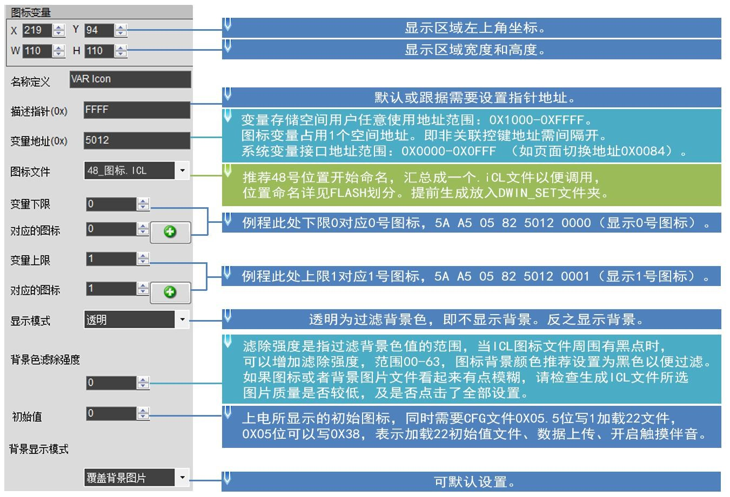

Figure **7.1 The variable** icon shows a description of the software settings.

**7.2.1.3 The** variable icon shows an example of an application instruction.

(1) Displays the icon for the lower limit of 0. 0

|  |  |  |  |  |
| --- | --- | --- | --- | --- |
| 5A A5 | 05 | 82 | 5012 | 0000 |

含义：0x5AA5:帧头；0x05:数据长度；0x82:写指令；0x5012:变量地址；0x0000:显示下限0所对应图标。

②显示上限1对应图标 5A A5 05 82 5012 0001

含义：0x5AA5:帧头；0x05:数据长度；0x82:写指令；0x5012:变量地址；0x0001:显示上限1所对应图标。

(3) The upper and lower limits are not displayed.

5A A5 05 82 5010 0002

Meaning: This instruction hides the icon,and 0002 is the over-limit.

(4) Describes pointer hiding, moving icons.

Hiding and moving positions requires the use of a description pointer, which uses a detailed explanation to see the description pointer instruction section of the data variable display.

#### **7.2.2 The** animation icon shows .

**7.2.2.1 The** animation icon shows the instruction storage format.

The animation icon corresponds to a fixed-value data variable with three different icon indication states: no display, no fixed icon, display animation icon. More alarm alerts for variables. Variables occupy 2-word positions, ，（(VP1)locations are reserved for auxiliary animation displayfunctions, and serial instructions may not participate in address access. Icons or animations are V_Stop variables V_Start not equal to or not. Supports background overlays and transparency settings to set the animation speed. Its instruction storage format is shown in the table.

Table **7.4 The animation** icon shows the instruction storage format.

|  |  |  |  |
| --- | --- | --- | --- |
| **The** SP describes the pointer offset. | Defined. | The length of the data.  **(**字节**)** | Description. |
| **0x00** | *VP | 2 | The initial icon variable pointer, the variable is a double word, the low word is retained, the high word has no sign number.  (0x0000-0xFFFF) User data control animation icon display. |
| **0x01** | (x,y) | 4 | Where the variables are displayed, and where the icon coordinates in the upper-left corner. |
| **0x03** | Reset_ICON_En | 2 | 0x0000: When stopped, the starting value of the animation icon is not reset (the animation icon displays 到 an arbitrary value between ICON_Start and ICON_End.  0x0001: When stopped, reset the starting value of the animation icon (the animation icon display will be pinned from .  ICON_Start starts to show). |
| **0x04** | V_Stop | 2 | A fixed icon is displayed when the variable is at this value. |
| **0x05** | V_Start | 2 | The animation icon is automatically displayed when the variable is the value. |
| **0x06** | ICON_Stop | 2 | The icon is V_Stop when the variable is a variable. |
| **0x07** | ICON_Start | 2 | When the variable V_Start value, the icon is automatically ICON_Start from ICON_End to the computer to animate. |
| **0x08** | ICON_End | 2 |
| **0x09:H** | ICON_Lib | 1 | Where the icon library is stored. |
| **0x09:L** | Mode | 1 | ICON显示模式，0x00=透明。 |

**7.2.2.2 The animation** icon displays instructions for the software settings.

In the DGUS development software, click the _ Display Keys and animation icon display, then box the display area and complete the configuration of the feature. Where the stop value and the stop icon represent the fixed icon that is displayed when the variable is the value. The start value represents the trigger value that starts displaying the animation icon, and the start and end icons are the range of icon animation loops when the variable is the start value.

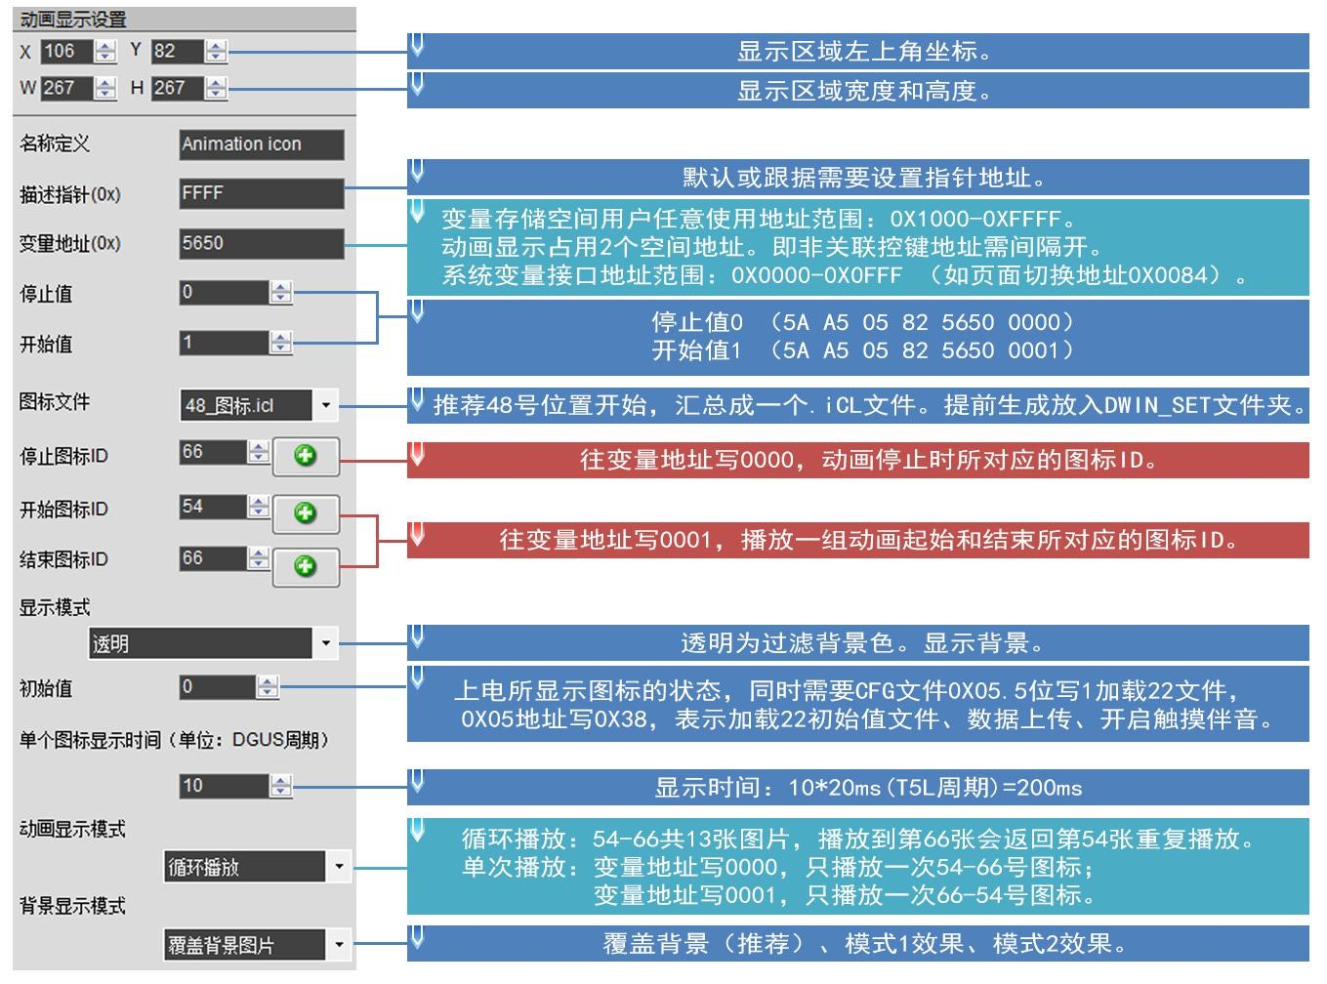

Figure **7.2 The variable** animation icon shows instructions for software settings.

**7.2.2.3** Examples of variable icon application instructions.

(1) Turn on animation and loop the mode.

|  |  |  |  |  |
| --- | --- | --- | --- | --- |
| 5A A5 | 05 | 82 | 5650 | 0001 |

含义：5A A5帧头；05数据长度；82写指令；6540变量地址；0001写入开始动画值设置值1。

(2) Stop the animation and loop the playback mode.

5AA5 05 82 5650 0000

(3) Sequential animation, single playback mode.

5AA5 05 82 5430 0001 Animation display mode needs to be set to single playback.

(4) Reverse animation, single playback mode.

5AA5 05 82 6540 0000 Animation display mode needs to be set to single playback.

(5) Hiding, moving, changing the animation icon serial number Hiding, moving position, etc. need to be used to describe the pointer, description of the use of the pointer can be seen in the data variable display instruction section.

**7.2.2.4** Animated icon display effect.

The animation loop shows the set of icons used.

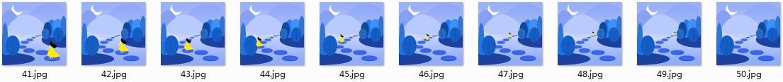

Figure **7.2 The** animation icon shows the effect.

#### **7.2.3** Slider scale indication .

**7.2.3.1** Slider scale indicates the instruction storage format.

The slider scale indicates a change in the display position of an icon (slider) corresponding to the range of changes in a data variable. Mostly used for levels, dials, schedule indications. Supports background overlays and transparency settings. Its instruction storage format is shown in the table.

Table **7.5 The** slider scale indicates the instruction storage format.

|  |  |  |  |
| --- | --- | --- | --- |
| **The** SP describes the pointer offset. | Defined. | The length of the data.  **(**字节**)** | Description. |
| **0x00** | *VP | 2 | Variable pointer, the variable format is determined by VP_Data_Mode of . |
| **0x01** | V_Begain | 2 | The variable value that corresponds to the starting scale. |
| **0x02** | V_End | 2 | The variable value that corresponds to the termination scale. |
| **0x03** | x_Begain | 2 | Start scale coordinates (portrait Y coordinates). |
| **0x04** | x_End | 2 | The stop scale coordinates (portrait Y coordinates). ） |
| **0x05** | ICON_ID | 2 | The icon ID of the scale slider. |
| **0x06** | And | 2 | The scale indicates the location of the Y coordinates displayed by the icon (longitudinal as x coordinates). 坐标 |
| **0x07:H** | x_adj | 1 | The scale indicates the x-coordinate forward offset (portrait Y-coordinate) that the icon displays. 坐标  0x00-0xFF |
| **0x07:L** | Mode | 1 | Scale mode:0x00 - Landscape tick bar 0x01 - Portrait scale bar. |
| **0x08:H** | ICON_Lib | 1 | Where the icon library is stored. |
| **0x08:L** | ICON_Mode | 1 | ICON display mode,0x00 s transparent (no background), others s display icon background. |
| **0x09:H** | VP_Data_Mode | 1 | 0x00：*VP指向一个整型变量  0x01: . ..VP points to a high byte address for an integer variable.  0x02: .. .VP points to a low-byte address for an integer variable. |

**7.2.3.2** Slider scale indicates software setup instructions.

In the DGUS development software, click show _ keys and slide the scale indication, then box the area and complete the configuration of the feature. The slider scale indication is the display function, the drag adjustment is the control function, and together the two can realize the function of dragging the slider icon to change the variable value.

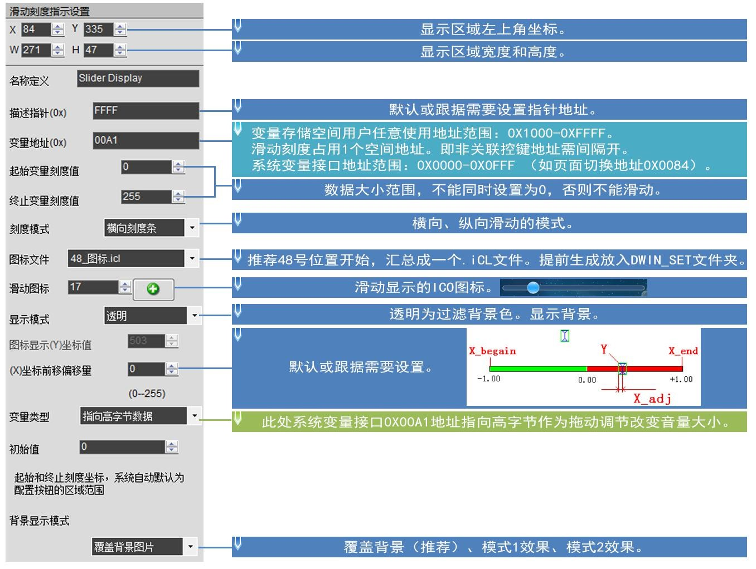

Figure **7.3 The slider** scale indicates the software setup instructions.

**7.2.3.3 The** slider scale indicates an example of applying instructions.

The 0x82 instruction writes data to the variable address that conforms to the set variable type. Example:5AA5 05 82 00A1 000A.

**7.2.3.4** The slider scale indicates the display effect.



Figure **7.4 The** slider scale indicates the software setup description.

#### **7.2.4 Art** word variable display.

**7.2.4.1** Art word variable instruction storage format.

The Art Word Variable Display feature replaces 功能与图标变量显示功能类似 the word library with an ICON icon to display variable data, similar to the icon variable display feature, with background overlays and transparency settings. Its instruction storage format is shown in the table.

Table **7.6 Picture** animation shows the instruction storage format.

|  |  |  |  |
| --- | --- | --- | --- |
| **The** SP describes the pointer offset. | Defined. | The length of the data.  **(**字节**)** | Description. |
| **0x00** | *VP | 2 | The variable pointer. |
| **0x01** | (X,Y) | 4 | Start display position: .  Left-alignment mode, which displays the upper-left coordinates of the string, and right-alignment mode, which shows the upper-right coordinates of the string. |
| **0x03** | ICON0 | 2 | 0 对应的 ICON_ID，排列顺序为 0123456789… 。 |
| **0x04:H** | ICON_Lib | 1 | ICON library location. |
| **0x04:L** | ICON_Mode | 1 | ICON display mode,0x00 - Transparent other - Display background. |
| **0x05:H** | The number of integers. | 1 | The number of integers displayed. |
| **0x05:L** | The scale. | 1 | The number of scales displayed. |
| **0x06:H** | The variable data type. | 1 | 0x00=整数（2 字节），范围-32768 到 32767  0x01=长整数（4 字节），范围-2147483648 到 2147483647  0x02 sVP high bytes, no sign number, range 0 to 255.  0x03 sVP low bytes, no sign number, range 0 to 255.  0x04= 超 长 整 数 （ 8 字 节 ） ， 范 围 -9223372036854775808 到  9223372036854775807  0x05=无符号整数（2 字节），范围 0 到 65535  0x06=无符号长整数（4 字节），范围 0 到 4294967295 |
| **0x06:L** | Alignment mode. | 1 | 0x00=左对齐 0x01=右对齐 |

**7.2.4.2 Art** Word Variable Software Settings Description.

In the DGUS development software, click _ Show Keys to display the Art Word variable, then box the area and complete the configuration of the feature.

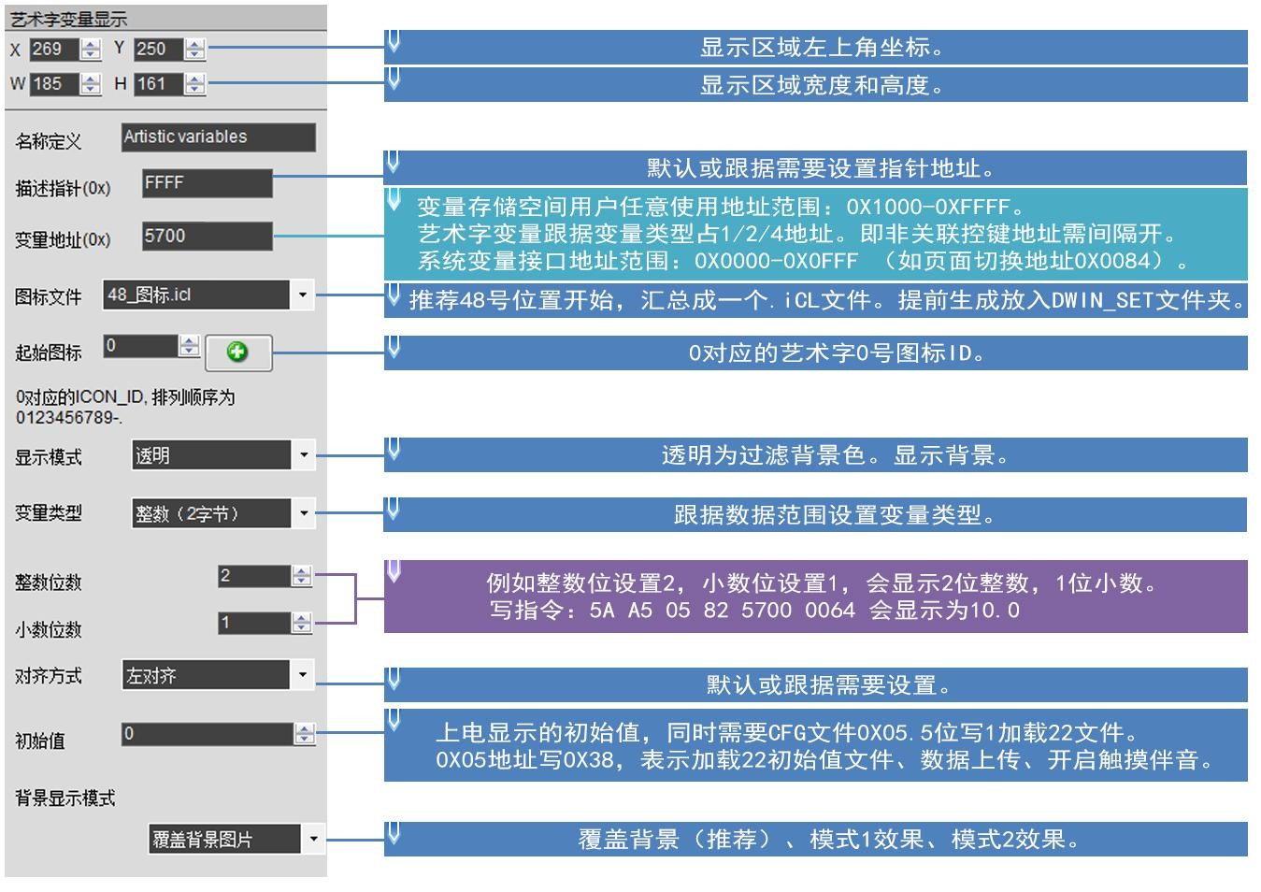

Figure **7.4 Description of** the art word variable software settings.

**7.2.4.3** Examples of art word variable application instructions.

|  |  |
| --- | --- |
| 5700 | 0002 |

5AA5 05 82

含义：0x5AA5 帧头；0x05 数据长度；0x82 写指令；

0x 5700:Variable address;

0x 0002：显示数据 2。

**7.2.4.4 Art** word variable display effect.

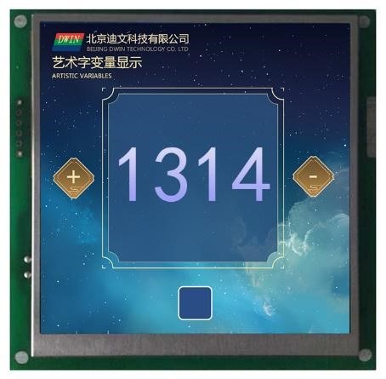

Figure **7.4 Description of** the art word variable software settings.

#### **7.2.5** Picture animation.

**7.2.5.1** Picture animation instruction storage format.

The picture animation feature is to play a set of full-screen pictures at a specified speed. Mostly used for power-on interfaces or screensavers. Its instruction storage format is shown in the table.

Table **7.7 Picture** animation shows the instruction storage format.

|  |  |  |  |
| --- | --- | --- | --- |
| **The** SP describes the pointer offset. | Defined. | The length of the data.  **(**字节**)** | Description. |
| **0x00** | 0x0000 | 2 | Fixed value 0x0000. |
| **0x01** | Pic_Begain | 2 | The starting icon position. |
| **0x02** | Pic_End | 2 | The location of the termination icon. |
| **0x03:H** | Frame_Time | 1 | A frame (a picture) shows the time in 8ms. |

**7.2.5.2** Description of the animation software settings for the picture.

In the DGUS development software, click _ show keys and picture animation to select the area in the specified page box and complete the configuration of the feature. This function does not require a button trigger, the area can be arbitrarily boxed, guaranteed to be on the specified page.

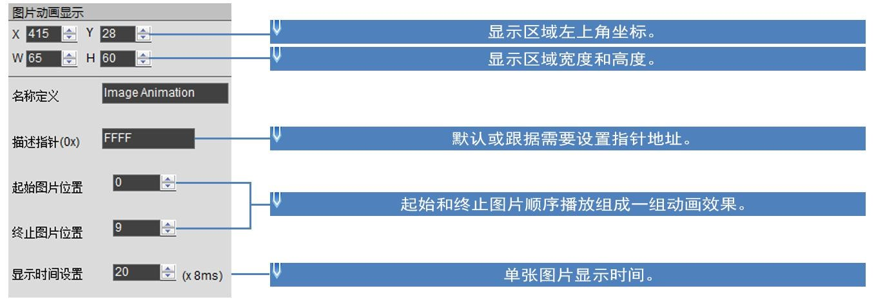

Figure **7.5 Picture** animation settings description.

**7.2.5.3** Examples of image animation application instructions.

|  |  |  |  |
| --- | --- | --- | --- |
| 0084 | 5A | 01 | 0000 |

5AA5 07 82

含义：0x5AA5 帧头；0x07 数据长度；0x82 写指令；

###### 0x 0084: System variable interface address, which is afixed switch page address; ；

0x 5A01:Fixed. A high byte 0x5A means that page processing is initiated once, theCPU is zeroed out, a 低字节 low byte 0x01 means a page switch, the picture specified by the picture store is displayed to the current background page, and a list of system variable interfaces is visible.

0x 0000:Page ID,the page number to switch.

**7.2.5.4** Picture animation effect.

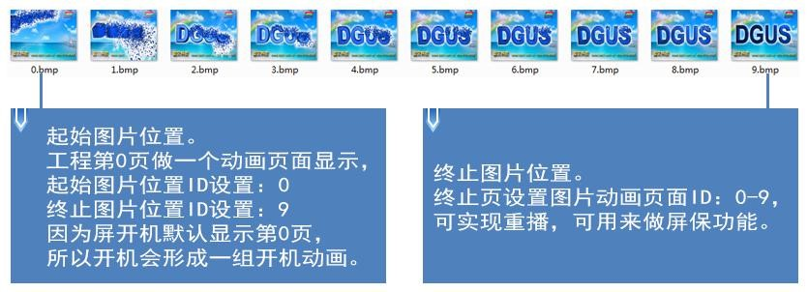

Figure **7.6 The** picture animation shows the effect.

#### **7.2.6 Icon** rotation indicates the display.

**7.2.6.1** Icon rotation instruction storage format.

The icon rotation indication function is to rotate a data variable's range of changes linearly corresponding to the angle data, and then rotate an ICON icon according to the corresponding angle data to display. More for pointer dashboard display. Its instruction storage format is shown in the table.

Table **7.8 icon rotation** indicates the instruction storage format.

|  |  |  |  |
| --- | --- | --- | --- |
| **The** SP describes the pointer offset. | Defined. | The length of the data.  **(**字节**)** | Description. |
| **0x00** | *VP | 2 | Variable pointer, the variable pattern is determined by VP_Mode . |
| **0x01** | ICON_ID | 2 | The specified icon ID. |
| **0x02** | ICON_xc | 2 | Rotating center position on ICON icon:x coordinates. |
| **0x03** | ICON_Yc | 2 | Rotating center position on ICON icon:Y coordinates. |
| **0x04** | xc | 2 | ICON is displayed to the rotating center of the current screen:x coordinates. |
| **0x05** | Yc | 2 | ICON is displayed to the rotating center of the current screen:Y coordinates. |
| **0x06** | V_Begain | 2 | The variable value corresponding to the starting rotation angle, the number of integers, does not appear between the boundaries. |
| **0x07** | V_End | 2 | The variable value corresponding to the angle of termination rotation, the number of integers, is not displayed between the boundaries. |
| **0x08** | AL_Begai n | 2 | 起始旋转角度，0-720（0x000-0x2D0），单位 0.5°。 |
| **0x09** | AL_End | 2 | 终止旋转角度，0-720（0x000-0x2D0），单位 0.5°。 |
| **0x0A:H** | VP_Mode | 1 | 0x00：*VP 指向一个整型变量。  0x01: sVPpoints to high-byte data for an integer variable.  0x02: sVPpoints to a low byte of data for an integer variable. |
| **0x0A:L** | Lib_ID | 1 | ICON 图标库 ID。 |
| **0x0B** | Mode | 1 | ICON display mode,0x00 s transparent (no chart background is displayed) others s display icon background. |

In the DGUS development software, click show keys _ and icon rotation instructions, then box the area and complete the configuration of the feature. Icon rotation indication is the display function, rotation adjustment is the control function, the two can be combined to achieve the function of rotating slider icons to change the value of variables. This function can also be used separately for dashboard display, where there is no need to rotate the mate of the adjustment function. When used with rotation adjustment, the rotation adjustment box selection should be consistent with the vant range indicated by the icon rotation, so that the slider drags with the finger effect. Rotation is always assumed to be ，即 “ clockwise, i.e. ” AL_End must be greater than AL_Begin,，若 and if AL_End is less than AL_Begin, the system AL_Beginwill automatically add 360 degrees.

**7.2.6.2 Icon** rotation software settings instructions.

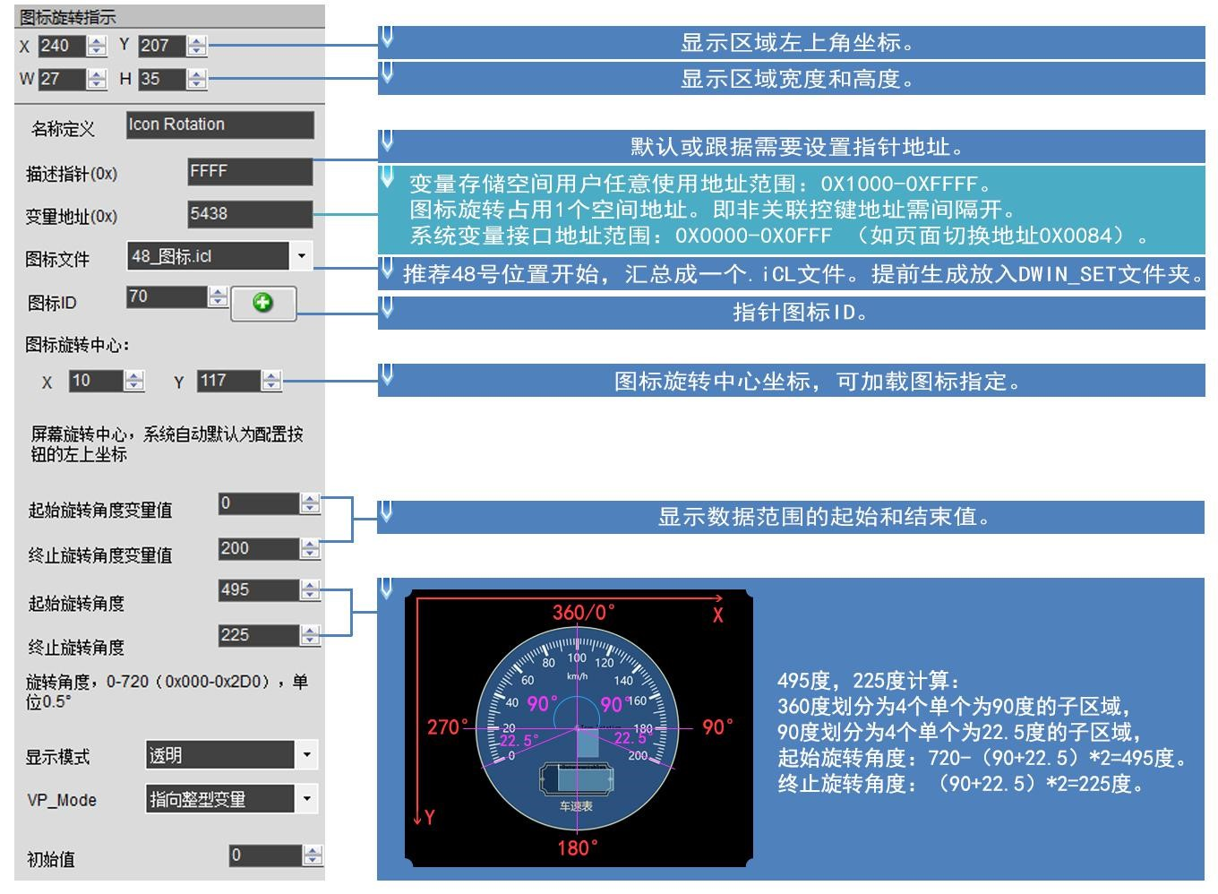

Figure **7.8 Icon** spins the software settings description.

**7.2.6.3** Example of an icon rotation application instruction.

|  |  |
| --- | --- |
| 5438 | 0000 |

5AA5 05 82

含义：0x5AA5 帧头；0x05 数据长度；0x82 写指令；0x5438 变量地址；0x0000 数据 0；图标指针指向表盘 0 度。

5AA5 05 82

|  |  |
| --- | --- |
| 5438 | 0064 |

含义：0x5AA5 帧头；0x05 数据长度；0x82 写指令；0x5438 变量地址；0x0064 数据 100；图标指针指向 100 度。

5AA5 05 82

|  |  |
| --- | --- |
| 5438 | 00C8 |

含义：0x5AA5 帧头；0x05 数据长度；0x82 写指令；0x5438 变量地址；0x00C8 数据 200；图标指针指向 200 度。

#### **The 7.2.7-bit** variable icon shows .

**7.2.7.1** bit variable icon instruction storage format.

The bit variable icon display function is to match the）的 0/1 状态对应 state of each bit(bit)of a data variable to two of the eight 种不同显示方案中的两种，用 different display schemes, with the ICON icon (or icon animation) corresponding to the display. Mostly used for switching status displays, such as fan operation (animation), ）、 stop (still icon). Its instruction storage format is shown in the table.

Table **7.9 bit** variable icon instruction storage format.

|  |  |  |  |
| --- | --- | --- | --- |
| **The** SP describes the pointer offset. | Defined. | The length of the data.  **(**字节**)** | Description. |
| **0x00** | *VP | 2 | Bit variable pointer, word variable. |
| **0x01** | *VP_AUx | 2 | Auxiliary variable pointer, double word, user software can not be accessed. |
| **0x02** | Act_Bit_Set | 2 | 值为 1 的 bit 位置说明*VP 对应位置需要显示。 |
| **0x03:H** | Display_Mode | 1 | Define the display mode: .   |  |  |  | | --- | --- | --- | | Display_  Mode | 位变量(bit)值 |  | | 0 | 1 | | 0x00 | ICONS | ICONS | | 0x01 | ICONS | Does not display. | | 0x02 | ICONS | ICONS-ICONOE 动画 | | 0x03 | Does not display. | ICONS | | 0x04 | Does not display. | ICONS-ICONOE 动画 | | 0x05 | ICON0S-ICON0E 动画 | ICONS | | 0x06 | ICON0S-ICON0E 动画 | Does not display. | | 0x07 | ICON0S-ICON0E 动画 | ICONS-ICONOE 动画 |   For example, Display_Modeset to s2,then: .  The ICONS icon is displayed when a bit of the variable corresponding to the VP is 0. 图标 |
| **0x03:L** | Move_Mode | 1 | Bitmap icons are arranged in the following way: .  0x00=x++，Act_Bit_Set 指定的不显示 bit 不保留位；  0x01-Y++,Act_Bit_Set 指定的不显示 bit 不保留位置  0x02=x++，Act_Bit_Set 指定的不显示 bit 保留 DIS_MOV 位置  0x03-Y++,Act_Bit_Set 指定的不显示 bit 保留 DIS_MOV 位置 |
| **0x04:H** | Icon_Mode | 1 | ICON 显示模式：0x00=透明 0x01=不透明 |
| **0x04:L** | Icon_Lib | 1 | Where the icon library is stored. |
| **0x05** | ICON0S | 2 | Animation mode is notdisplayed, bit_0 icon ID shows animation mode, andbit_0the icon animation starting ID position. |
| **0x06** | ICON0E | 2 | The animation mode isdisplayed, bit_0 the end ID position of the icon animation. |
| **0x07** | ICON1S | 2 | Animation mode is notdisplayed, bit_1 icon ID shows animation mode, bit_1the icon animation start ID position. |
| **0x08** | ICON1E | 2 | The animation mode isdisplayed, bit_1 the end ID position of the icon animation. |
| **0x09** | (x,y) | 4 | The starting bit variable shows the position, with the upper-left coordinate position of the icon. |
| **0x0B** | DIS_MOV | 2 | The next icon coordinate moves the coordinate interval. |
| **0x0C** | Keep. | 2 | 写 0x00 |

**7.2.7.2** Bit Variable Icon Software Settings Description.

In the DGUS development software, click the display key and bit variable icon display button. Then use the mouse box to select an area to set the feature in the menu on the right. As shown in the figure.

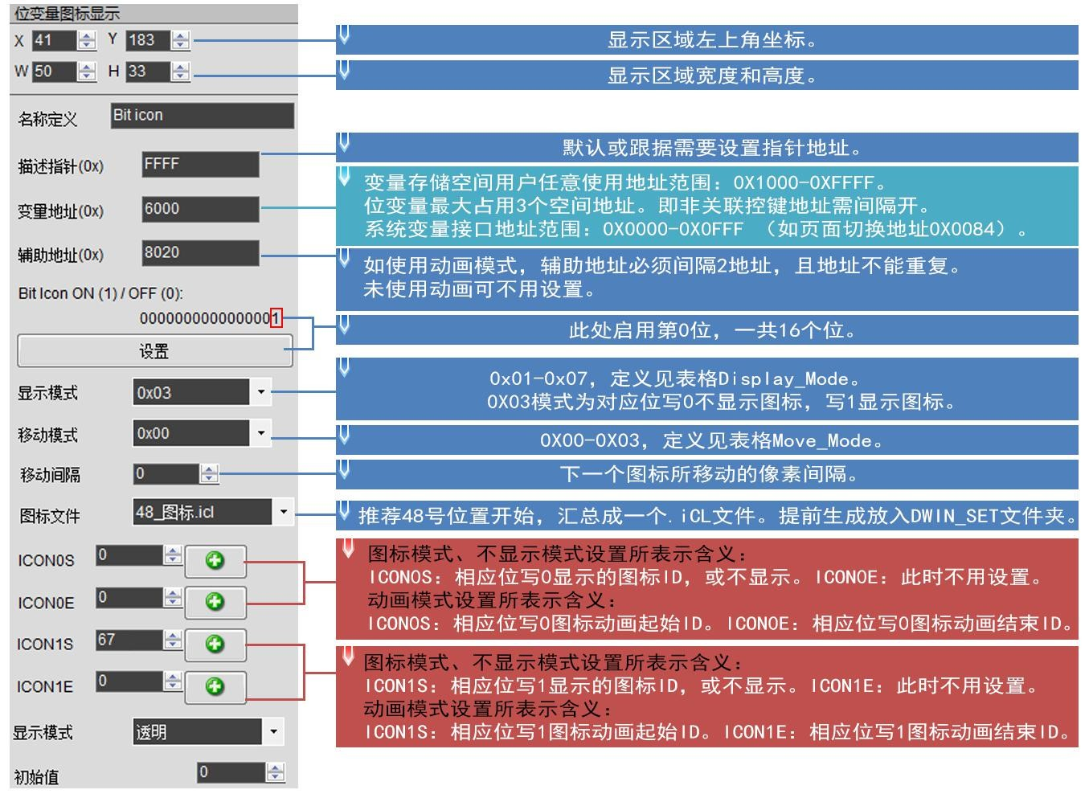

Figure **7.9 Bit** Variable Icon Software Settings Description.

**7.2.7.3 bit** variable icon application instruction example.

(1)16 bits fully open.

|  |  |  |  |  |
| --- | --- | --- | --- | --- |
| 5AA5 | 05 | 82 | 6000 | FFFF |

含义：0x5A 0xA5：帧头；

###### 0x 05：数据长度；

0x 82：写指令；

0x 6000：变量地址；

FFFF0x FFFF:1111 1111 1111 1111 1111 x 16 位写 2002 , 即ffff fff!

(2)16-bit full pass.

|  |  |
| --- | --- |
| 6000 | 0000 |

5AA5 05 82 含义：0x5A 0xA5：帧头； 0x 05：数据长度；

0x 82:Write instructions;

0x 6000：变量地址；

0x0000:16 个位全部写 0。

③开启第 0 位和第 3 位

5AA5 05 82 6000 0009

含义：0x5A 0xA5：帧头； 0x 05：数据长度；

0x 82:Write instructions;

0x 6000:Variable address;

0x 0009：第 0 位和第 3 位写 1，0000 0000 0000 1001 即为 0x0009。

**The 7.2.7.4-bit** variable icon shows the effect.

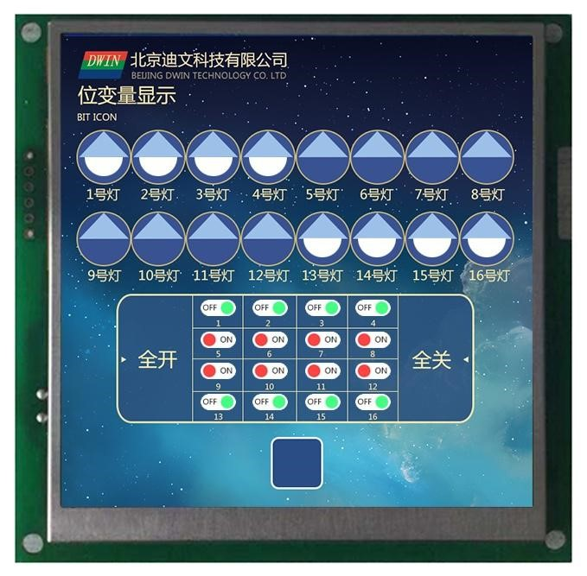

Figure **7.10 bit** variables show the effect.

#### **7.2.8 JPEG** icon translation display.

**7.2.8.1 JPEG** icon translation instruction storage format.

Pan the JPEG icon page beyond the screen resolution up and down the screen window or left and right. With sliding icon selection, you can achieve icon swipe selection. The background filter strength can be set.

**7.2.8.2 JPEG** icon translation software settings instructions.

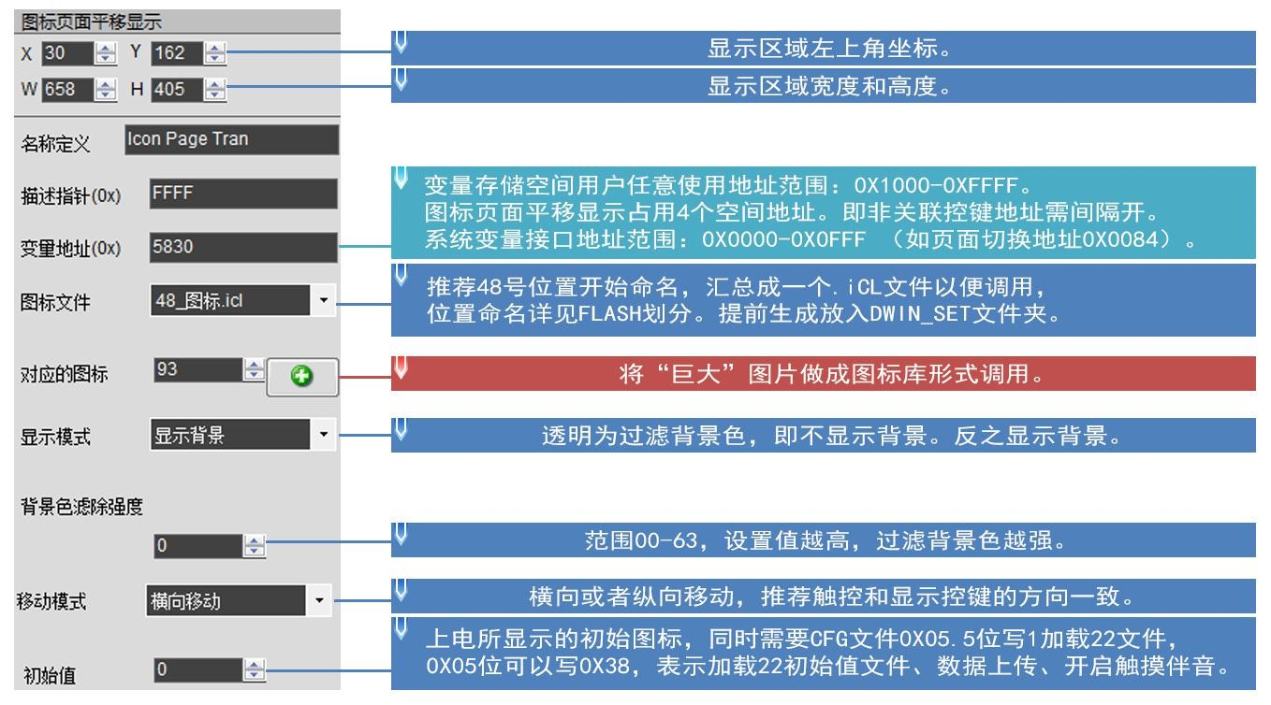

Figure **7.11 Description of** the icon translation software settings.

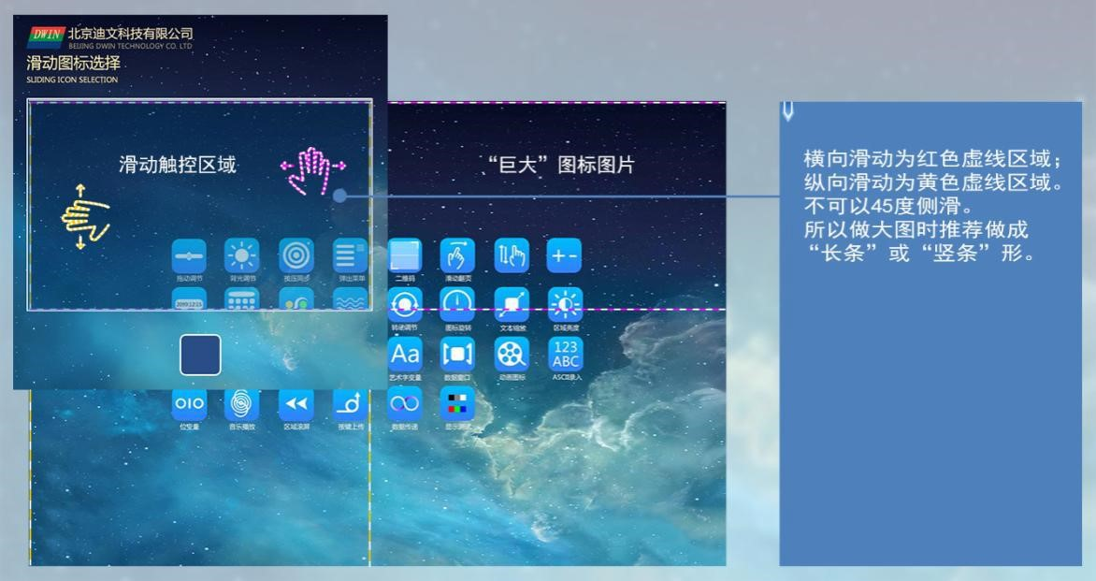

Figure **7.12** Icon Translation Effect Map.

## **7.3** Text variable .

#### **7.3.1 Data** variables are displayed.

**7.3.1.1** Data variable instruction storage format.

The data variable display function is to display a data variable in the specified format (integer, scale, with AICII units) in the specified font and size of the Arabic numerals, the instruction storage format is shown in the table.

Table **7.9 Data** variables show the instruction storage format.

|  |  |  |  |
| --- | --- | --- | --- |
| **The** SP describes the pointer offset. | Defined. | The length of the data.  **(**字节**)** | Description. |
| **0x00** | *VP | 2 | The variable pointer. |
| **0x01** | X,Y | 4 | The starting display position, showing the coordinates in the upper left corner of the string. |
| **0x03** | COLOR | 2 | Displays the color. |
| **0x04:H** | Lib_ID | 1 | ASCII word library location. |
| **0x04:L** | The font size. | 1 | Character x direction dot matrix. |
| **0x05:H** | Alignment. | 1 | 0x00=左对齐 0x01=右对齐 0x02=居中 |
| **0x05:L** | The number of integers. | 1 | Displays integer bits. The sum of integers and scales cannot exceed 20. |
| **0x06:H** | The scale. | 1 | Displays integer bits. The sum of integers and scales cannot exceed 20. |
| **0x06:L** | The variable data type. | 1 | 0x00=整数（2 字节），范围为-32768 到 32767  0x01=长整数（4 字节），范围为-2147483648 到 2147483647  0x02 sVP high bytes, no sign number, range 0 to 255.  0x03 sVP low bytes, no sign number, range 0 to 255.  0x04= 超长整数（ 8 字节），范围为 -9223372036854775808 到  9223372036854775807  0x05=无符号整数（2 字节），范围为 0 到 65535  0x06=无符号长整数（4 字节），范围为 0 到 4294967295 |
| **0x07:H** | Len_unit | 1 | Variable units (fixed strings) show length,and 0x00 indicates that no units are displayed. |
| **0x07:L** | String_Unit | Max11 | Unit string,ASCII encoding. |

**7.3.1.2 Description** of data variable software settings.

In the DGUS development software, click the display control Data 数据变量显示 Variable Display,， then box the display area and configure the functionality in the settings menu on the right.

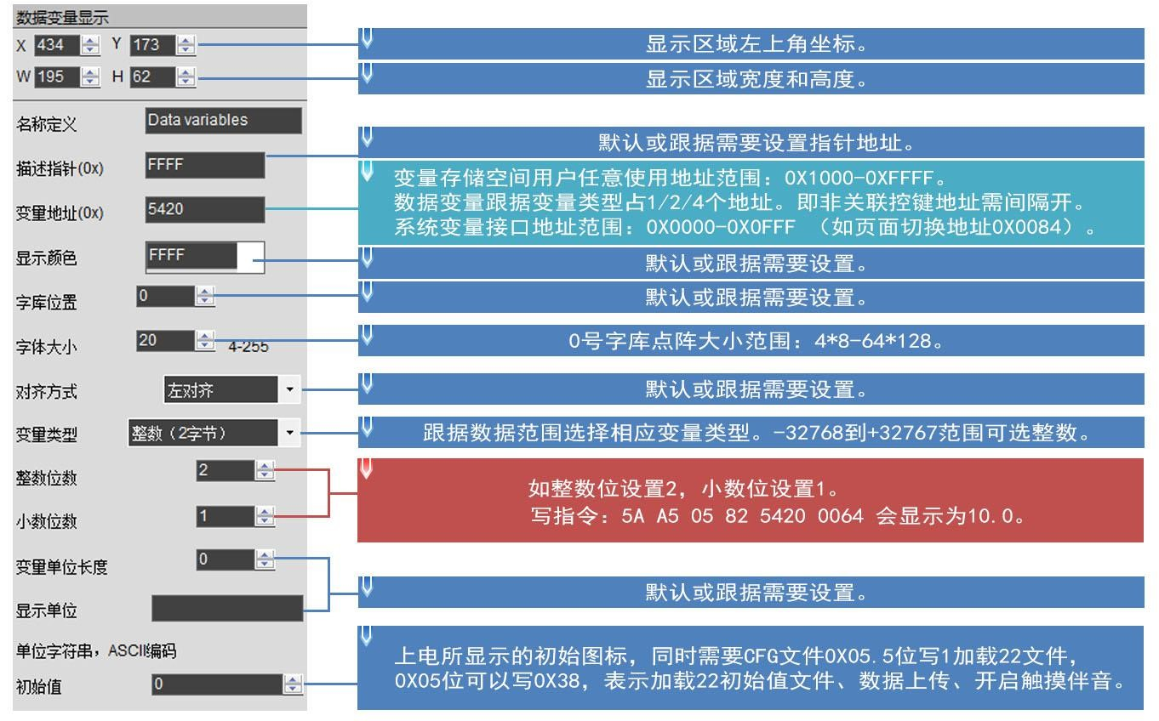

Figure **7.11 Description of** data variable software settings.

**7.3.1.3** Examples of data variable application instructions.

Variable address range 0x1000-0xFFFF,instruction data are in 16-step format.

1. Displays integer data 100.

|  |  |  |  |  |
| --- | --- | --- | --- | --- |
| 5AA5 | 05 | 82 | 5420 | 0064 |

含义：0x5A 0xA5：帧头；

0x 05：数据长度，为 82 53 00 00 64 这 5 个字节；

0x 82：写指令；

0x 5420：变量地址；

0x 0064：数据 100。 整数范围：-32768 到 32767，占 2 字节。

1. An instruction displays 3 data at the same time, and the address must be continuous.

|  |  |
| --- | --- |
| 5300 | 0064 0063 0062 |

5AA5 09 82

含义：0x5A 0xA5 固定帧头；0x09 数据长度,表示 0x09 后面包含数据的字节个数；0x82 写指令；

0x 5300 变量地址；

0x 0064 数据 100（映射 0x5300 地址）；

0x0063 数据 99（映射 0x5301 地址）； 0x0062 数据 98（映射 0x5302 地址）。

1. Displays long integer data 100.

|  |  |
| --- | --- |
| 5422 | 0000 0064 |

5AA5 07 82

含义：0x5A 0xA5 固定帧头；0x07 数据长度；0x82 写指令；

0x 5422 变量地址；

0x 0000 0064 长整数数据 100。 长整数范围-2147473648 到 2147483647，占 4 字节，字节不够的位补 00。

1. Displays the extra-long integer data 100.

|  |  |
| --- | --- |
| 5424 | 0000 0000 0000 0064 |

5AA5 0B 82

含义：0x5A 0xA5 固定帧头；0x0B 数据长度；0x82 写指令；

0x 5424 变量地址；

0x 0000 0000 0000 0064 数据 100。 超长整数范围：-9223372036854775808 到 9223372036854775807，占 8 字节，不够的位补 00。

1. Displays single-precision floating-point data 99.

|  |  |
| --- | --- |
| 5428 | 42C6 0000 |

5AA5 07 82

含义：0x5A 0x A5 帧头；0x07 数据长度；0x82 写指令；

0x 5428 变量地址；

0x 42C6 0000 single-precision floating-point 99,which can be converted by the floating-point conversion tool.

1. Double float data 99 is displayed.

|  |  |
| --- | --- |
| 4058 | C000 0000 0000 |

5AA5 0B 82 542B

含义：0x5AA5 帧头；0x0B 数据长度；0x82 写指令；

0x 542B 变量地址；

0x4058 C000 0000 0000 double floating-point 99, convertibleby the floating-point tool.

1. Displays integer type data -100.

|  |  |
| --- | --- |
| 5300 | FF9C |

5AA5 05 82

含义：0x5A 0xA5 固定帧头；0x05 数据长度；0x82 指令；

0x 5300 变量地址；

0x FF9C negative 100. A complement to a negative number: the sign bit is 1,the remaining bit is the original code of the absolute value of that number isreversed by bit, and then the entire number is added 1. If you enter -200,，会返回 you will return 5AA5 06 83 68 20 01 FF 38,，返回的数据 and the returned data 0xFF38 will 就是录入的数据 be the incoming data -200.

1. Displays 2-bit counts.

Sending 5AA5 05 82 5300 0064 will show 1.00. The software data variable display key sets the integer to 1,，小数位为 the integer to 2,clickSave, build, and then bring the 14.BIN display file down to the screen. (9 )Change the color of thedata.

|  |  |
| --- | --- |
| 9003 | F800 |

5AA5 05 82

含义：0x5AA5 帧头；0x05 数据长度；0x82 写指令；

0x 9003 represents a description pointer offset of 3 bits; ；

0x F800 颜色代码。

Directive 0x9000 is the underlying address 是描述指针的基础地址，所有属性偏移都在该地址基础上进行，此处 that describes the pointer, and all property offsets are based on that address, where the 0x9000 address is not fixed.

0x9003 为 is 0x9000 describes 描述指针地址基础上偏移 the meaning of offset 3 addresses on the basis of the pointer address, the offset 偏移地址详见数据变量显示指令存储格式表中 address is detailed in the data variable display instruction storage format table SP describes 描述指针偏移量 the pointer offset, where the property is red vertical column can be used to offset tochange the data properties, 0x03 address is used to change the data ，其中属性标红竖列都可以用来偏移改变数据属性， color.

Changing the properties of a property box requires the use of description pointers, such as coordinates, colors, word library locations, integers, scales, font sizes, dot matrix.

and so on.

1. Change the coordinates of the data.

|  |  |
| --- | --- |
| 9001 | 0064 0064 |

5AA5 07 82

含义：0x5AA5 固定帧头；0x 07 数据长度；0x 82 写指令；

0x 9001: represents a 基础上偏移 1-bit offset based on the description pointer 0x 9000; 位；偏移地址详见数据变量显示指令存储格式表中 SP 描述指针偏移量 ；

0x 0064 0064:数据偏移到（100,100）坐标点。

1. Change the font size.

|  |  |  |
| --- | --- | --- |
| 9004 | 00 | 28 |

5AA5 05 82

含义：0x 5AA5 固定帧头；0x 05 数据长度；0x 82 写指令；

0x 9004: represents a 4-bit offset based on the description pointer 0x 9000; 4 位；

0x 0028:高字节 0x 00 为 0 号字库位置，写 0x 00 即可，低字节 0x 28 为字体大小。

1. Change the integer to 3 bits.

|  |  |  |
| --- | --- | --- |
| 9005 | 00 | 03 |

5AA5 05 82

含义：0x 5AA5 固定帧头；0x 05 数据长度；0x 82 写指令；

0x 9005:表示描述指针 0x 9000 基础上偏移 5 位；

0x 0003:高字节 0x 00 为左对齐，低字节 0x 03 为整数位数。

1. Change the scale to 2 digits.

|  |  |  |
| --- | --- | --- |
| 9006 | 02 | 00 |

5AA5 05 82

含义：0x 5AA5 固定帧头；0x 05 数据长度；0x 82 写指令；

0x 9006:表示描述指针 0x 9000 基础上偏移 6 位；

0x 0200: High bytes 高字节 0x 02 are scales, and low bytes 0x00 indicates that the data type is integer.

1. Power-up does not display data 0, hide data 0.

Set the variable address to 0x 5300 andthe pointer address to 0x 9000.

Method one: Hide.

|  |  |
| --- | --- |
| 9000 | FF00 |

Hidden data variable display:5AA5 05 82.

含义：0x 5AA5 固定帧头；0x 05 数据长度；0x 82 写指令；

0x 9000 描述指针；

0x FF00 将数据隐藏。

|  |  |
| --- | --- |
| 9000 | 5300 |

Hidden data:5AA5 05 82.

含义：0x 5AA5 固定帧头；0x 05 数据长度；0x 82 写指令；

0x 9000: represents a description pointer; ；

0x 5300: is the variable address.

Change the data value again:5AA5 05 82 5300 0062 .

含义： 0x 5AA5 固定帧头；0x 05 数据长度；0x 82 写指令；

0x 5300 变量地址；

0x 0062 显示数据 98。

Method 2: Change the coordinate position with the description pointer.

|  |  |
| --- | --- |
| 9001 | 02D0 02D0 |

5AA5 07 82

含义：0x 5AA5 固定帧头；0x 07 数据长度；0x 82 写指令；

0x 9001:描述指针 0x 9000 基础上偏移 1 位；

0x 02D0 02D0:（720,720）坐标点。

Do not display with the help of cross-border. For example, if the resolution screen of 720 x 720, change the display coordinates of the upperleft display to (720 x 720)to hide between the boundaries, and move the normal display back to the original 分辨率屏，将左上显示显示坐标改成（coordinates.

**7.3.1.4 Data** variable display effect.

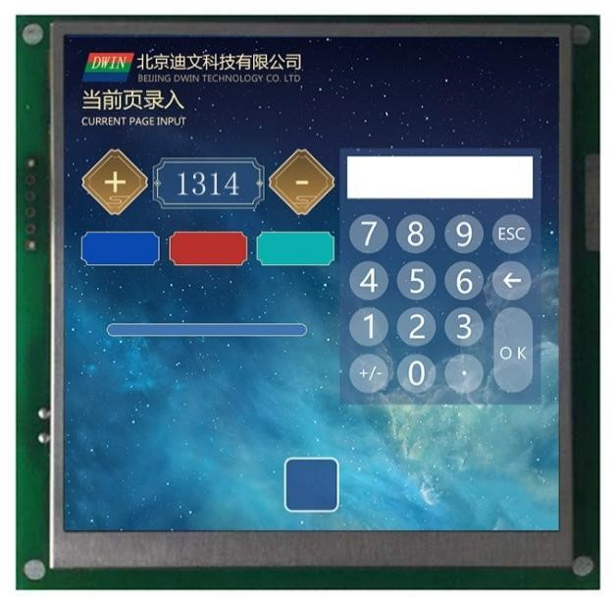

Figure **7.12 The effect of** the data variable display.

#### **7.3.2 Text** display .

**7.3.2.1** Text display instruction storage format.

The text display feature is to display strings in the specified format (as determined by the selection library) in the specified text box display area. This feature is typically used in conjunction with the text entry feature. Its instruction storage format is shown in the table.

Table **7.10 Text** display instruction storage format.

|  |  |  |  |
| --- | --- | --- | --- |
| **The** SP describes the pointer offset. | Defined. | The length of the data.  **(**字节**)** | Description. |
| **0x00** | *VP | 2 | The text pointer. |
| **0x01** | (X,Y) | 4 | The starting display position, showing the coordinates in the upper left corner of the string. |
| **0x03** | Color | 2 | Displays the color of the text. |
| **0x04** | (xs,Ys)(xe,Ye) | 8 | The text box. |
| **0x08** | Text_Length | 2 | The number of bytes is displayed and will no longer be displayed when 0xFFFF,、0x0000 is encountered, or is displayed at the end of the text box. |
| **0x09:H** | Font0_ID | 1 | The library position used by 时的 ASII characters encoded as 0x01-0x04. 字符使用的字库位置 |
| **0x09:L** | Font1_ID | 1 | 编码方式为 0x00、0x05，以及 0x01-0x04 时的非 ASCII 字符使用的字库位置。 |
| **0x0A:H** | Font_x_Dots | 1 | 字体 x 方向点阵数（0x01-0x04 模式，ASCII 字符的 x 方向点阵数按照 x/2 计算）。 |
| **0x0A:L** | Font_Y_Dots | 1 | The number of dots in the font Y direction. |
| **0x0B:H** | Encode_Mode | 1 | .7 defines whether the character spacing displayed by the text is adjusted automatically; ；  The .7-0 character spacing is automatically adjusted;  The .7-1 character spacing is not automatically adjusted, and the character width is fixed to the set number of dots.  .6-.0 defines how text is encoded: ： .  0=8bit 编码 1=GB2312 内码 2=GBK 3=BIG5 4=SJIS 5=UNICODE |
| **0x0B:L** | HOR_Dis | 1 | Character horizontal interval. |
| **0x0C:H** | VER_Dis | 1 | The vertical interval between characters. |
| **0x0C:L** | Undefined. | 1 | 写 0x00。 |

**7.3.2.2 Text** displays instructions for software settings.

In the DGUS development software, click the Display Keys and Text Display button, select the display area with the mouse box, and then configure the feature in the settings menu on the right. The number of dots in the font Y direction must be even. The DGUS screen is pre-installed with a library of 0-word, 字库，包含 containing all ASCII characters for a 4x8-6x128 点阵的所有 dot matrix.

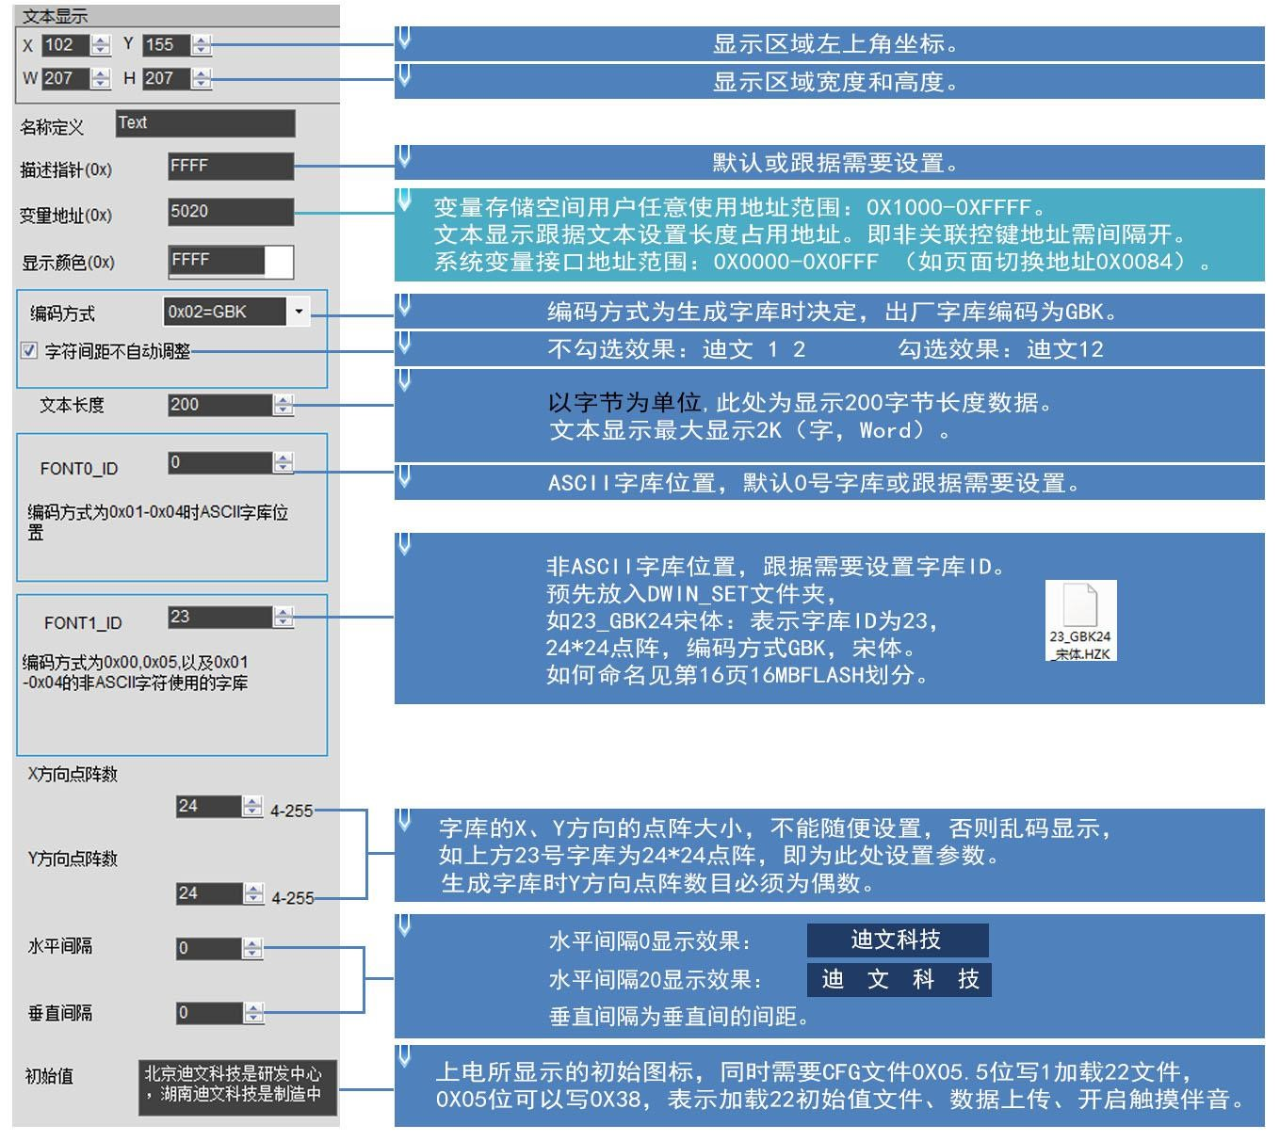

Figure **7.13 This shows** instructions for software setup.

**7.3.2.3 Text** shows examples of application instructions.

(1)显示"12AB" 北

|  |  |  |  |  |
| --- | --- | --- | --- | --- |
| 5A A5 | 09 | 82 | 5020 | B1B1 3132 4142 |

含义：0x5A A5:帧头；

0x 09:数据长度；

0x 82:写指令；

0x 5020:变量地址；

0x B1B1:“北”字的ASCII码；

0x 3132：“12”的ASCII码；

0x 4142“AB”的ASCII码。 ASCII码可由ASCII转换工具转换。

(2) Line-by-line display.

|  |  |
| --- | --- |
| 5023 | 0D0A |

5A A5 05 82

含义：0x 5A A5帧头；0x 05数据长度；0x 82写指令；

###### 0x 8073 is displayed in new lines starting with this address; ；

0x 0D0A换行的ASCII码，可由ASCII转换工具转换。

(3) Empty the text display.

|  |  |
| --- | --- |
| 5020 | 2020 2020 |

5A A5 07 82

含义：0x 5A A5帧头；0x 07数据长度；0x 82写指令；

0x 5020:变量地址；

0x 20: Space ASCII code, 码，2020 clears data for an address. The data for 2 addresses is purged from the 5020 2 address.

(4) Change the color of the text.

|  |  |
| --- | --- |
| 8803 | F800 |

5A A5 05 82

含义：0x 5A A5帧头；0x 05数据长度；0x 82写指令；

0x 8803: Description 描述指针偏移量；描述指针的使用见 pointer：描述指针 0x 8000 基础地址上偏移 offset 3 bits change color on the underlying address, offset address is detailed 位改变颜色；偏移地址详见文本显示指令存储格式表中 in the text display instruction store format table SP describes pointer offset, description of the use of pointers see 7.3.1 data variable display section.

0x F800：颜色值。

(5) Hide the text display.

Method one: Hide.

|  |  |
| --- | --- |
| 8800 | FF00 |

5A A5 05 82

含义：0x 5A A5帧头；0x 05数据长度；0x 82写指令；

0x 8800：描述指针； 0x FF00：隐藏文本。

|  |  |
| --- | --- |
| 8800 | 8070 |

Hidden display:5A A5 05 82.

含义：0x 5A A5帧头；0x 05数据长度；0x 82写指令；

0x 8800：描述指针；

0x 8070：变量地址。

Method two: Modify the coordinates.

|  |  |
| --- | --- |
| 8801 | 02D0 02D0 |

5A A5 07 82

含义：0x 5A A5帧头；0x 05数据长度；0x 82写指令；

0x 8801: 720,720）坐标点，越界移到看不到的地方 Describes the pointer 0x 8000 underlying 基础地址上偏移 address offset 1 bit to change the display coordinate :(s; ：（

Hide and display: .

|  |  |
| --- | --- |
| 8801 | 0064 0064 |

5A A5 07 82

含义：0x 5A A5帧头；0x 05数据长度；0x 82写指令；

0x 8801: Describes a 1-bit shift on the pointer：描述指针 0x 8000 基础地址上偏移 1 base address :(100,100to change the display coordinates; ）坐标点，越界移到能看到的地方

Method three: The display length is changed to 0000.

|  |  |
| --- | --- |
| 8808 | 0000 |

5A A5 05 82

含义：0x 5A A5帧头；0x 05数据长度；0x 82写指令；

0x 8808 describes the pointer 0x 8000 基础地址上偏移 on the base address offset 8 bits to change the display byte length;

|  |  |
| --- | --- |
| 8808 | 0064 |

0x 0000显示0字节数据。 隐藏后显示：5A A5 05 82

含义：0x 5A A5帧头；0x 05数据长度；0x 82写指令；

0x 8808 describes the pointer 0x 8000 基础地址上偏移 on the base address offset 8 bits to change the display byte length;

0x 0064显示100字节数据。

**7.3.2.4** Text display effect.

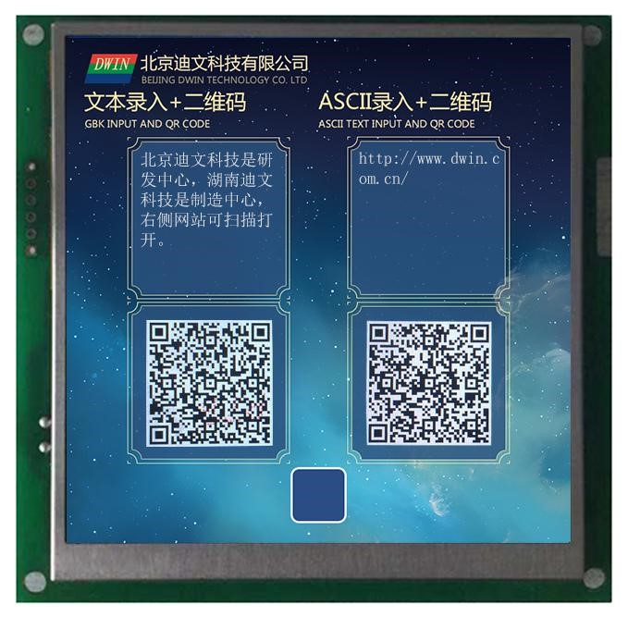

Figure **7.14 The text** shows the effect.

#### **7.3.3** The data window indicates .

**7.3.3.1** Data window instruction storage format.

The data window indication is to display the data variables in a specified display window and highlight the selected values. Combined with touch screen swipes or incremental adjustments, the data can be scrolled. It is also possible for DWIN OS to control the adjustment speed. The variable occupies 2 word positions, and the(VP-1)position is 个字位置 preserved.

Table **7.11 The data window** indicates the display instruction storage format.

|  |  |  |  |
| --- | --- | --- | --- |
| **The** SP describes the pointer offset. | Defined. | The length of the data.  **(**字节**)** | Description. |
| **0x00** | *VP | 2 | Variable pointer, variable is double word, low word retention, high word is integer data -32768 to .32767. |
| **0x01** | The lower limit of the data. | 2 | The lower limit of the data. |
| **0x02** | The upper limit of the data. | 2 | The upper limit of the data. |
| **0x03:H** | The number of integers. | 1 | The number of integers. |
| **0x03L** | The scale. | 1 | The scale. |
| **0x04:H** | The number of data. | 1 | Displays the total number of data. |
| **0x04L** | Display mode. | 1 | 0x01=显示无效 0 0x02=显示正数+号 0x04= 越界后掉头 |
| **0x05** | (x,y) | 4 | The position of the center point coordinates that the variable displays. |
| **0x07** | Adjust the step length. | 2 | Adjust the step length. |
| **0x08:H** | The font size. | 1 | The data x direction point size is not selected. |
| **0x08:L** | The font size. | 1 | The data Y direction point size is not selected. |
| **0x09** | The font color. | 2 | The data color is not selected. |
| **0x0A:H** | The font size. | 1 | Check the data x direction point size. |
| **0x0A:L** | The font size. | 1 | Check the size of the data Y direction point. |
| **0x0B** | The font color. | 2 | Check the data color. |
| **0x0C** | 0000 |  | Hold, write 0000. |

**7.3.3.2 Description** of the software setup for the data window.

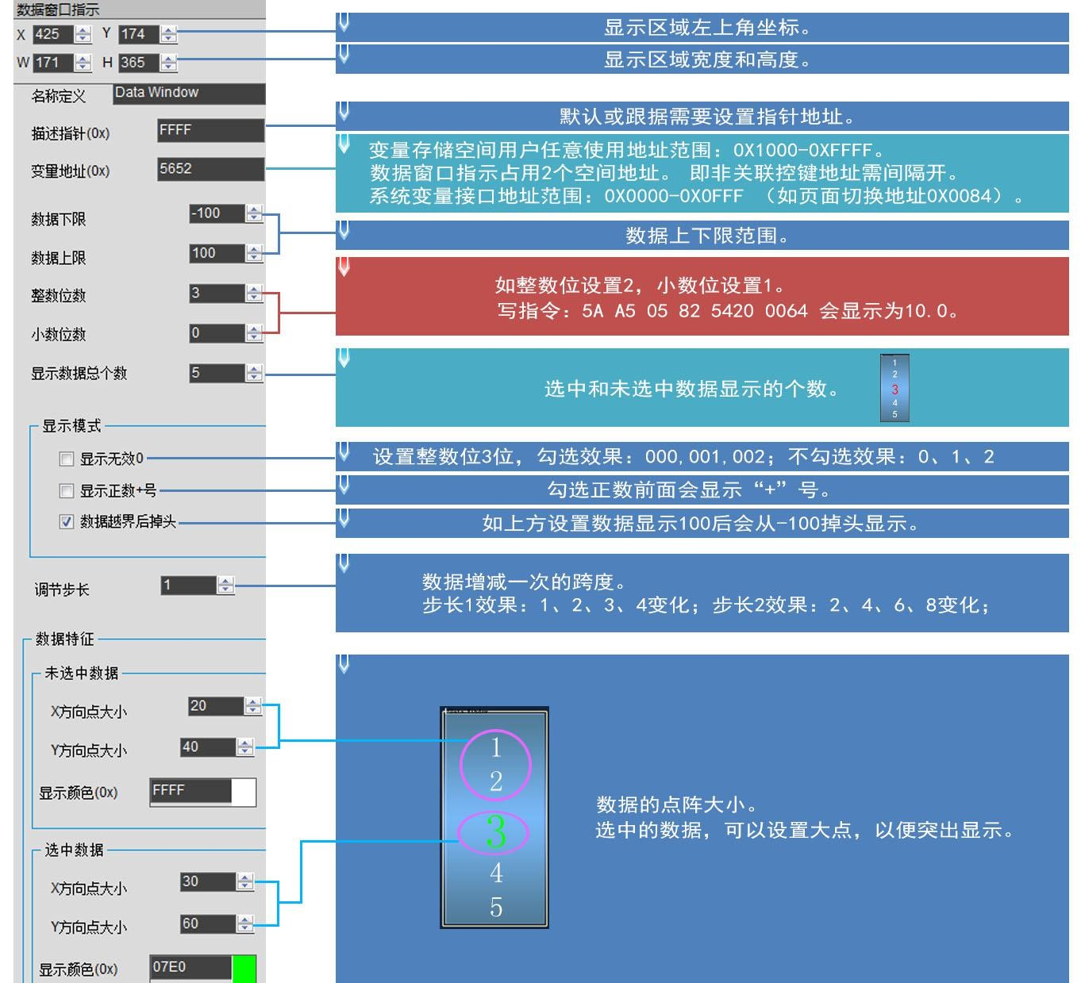

Figure **7.16 Description of** the data window software settings.

**7.3.3.3** Examples of data window application instructions.

|  |  |
| --- | --- |
| 5652 | 0064 |

5AA5 05 82

说明：0x5AA5 帧头；0x05 数据长度；0x82 写指令；

0x5652：变量地址；

0x0064:Write data 100 to the variable address.

**7.3.3.4** The data window displays.

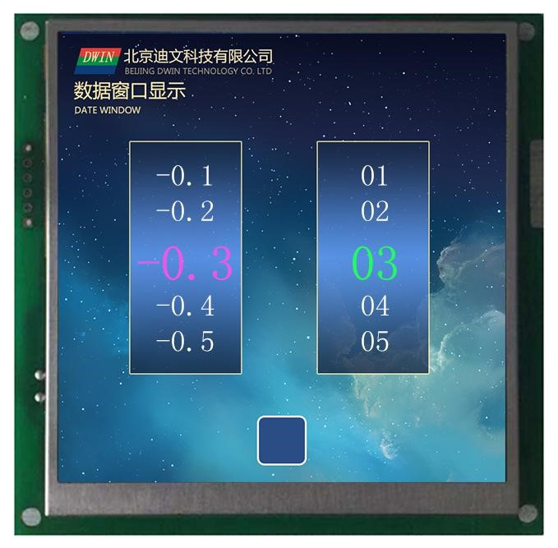

Figure **7.17 The** data window shows the effect.

### **7.3.4RTC** 显示

**7.3.4.1** 文本 **RTC** 显示

**7.3.4.1.1** Text **RTC display** instruction storage format.

The text clock display function is to display the Gregorian RTC in text in a format edited by the user. The instruction storage format is shown in the table.

Table **7.12 Text** clock displays the instruction storage format.

|  |  |  |  |
| --- | --- | --- | --- |
| **The** SP describes the pointer offset. | Defined. | The length of the data.  **(**字节**)** | Description. |
| **0x00** | 0x0000 | 2 | 写 0x0000 |
| **0x01** | (x,Y) | 4 | Displays the location, showing the coordinates in the upper left corner of the string. |
| **0x03** | Color | 2 | Word library color. |
| **0x04:H** | Lib_ID | 1 | The position of the word library. |
| **0x04:L** | The font size. | 1 | x Directional dot matrix. |
| **0x05** | String_Code | MAx16 | Encoding strings, consisting of RTC encoding and ASCII characters.  Suppose the current time is Wednesday, 2012-05-02 12:00:00, then .  Y-M-D H:Q:S 0x00显示为将显示为2012-05-02 12:00:00  M-D W H:Q 0x00 将显示为 05-02 WED 12:00 |

The RTC encoding is shown in the table.

表 **7.13 RCT** 编码

|  |  |  |
| --- | --- | --- |
| Description. | Coding. | The display format. |
| 公历**_**年 | And | 2000-2099 |
| 公历**_**月 | M | 01-12 |
| 公历**_**日 | D | 01-31 |
| Gregorian **calendar . .** . hours. | H | 00-23 |
| **Gregorian calendar** . | Q | 00-59 |
| 公历**_**秒 | S | 00-59 |
| The **Gregorian calendar is** the week. | W | SUN MON TUE WED THU FRI SAT |
| The encoding ends. | 0x00 |  |

**7.3.4.1.2 Text RTC displays instructions** for software settings. 文本

In the DGUS development software, _ 文本 click on the display key - text RTC display, then use the mouse box to select the display range, and in the right side of the settings menu for word library, time format and other configurations to achieve the display of the text clock. The time can be modified by the RTC setup function or by using serial instructions.

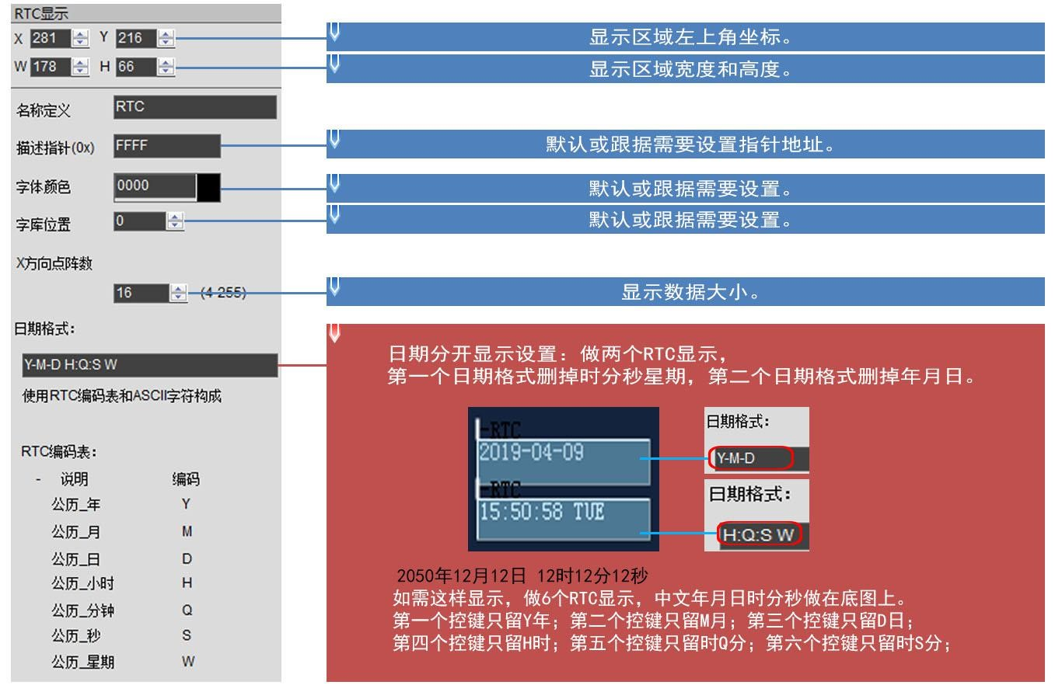

Figure **7.18 Text** RTC **shows instructions** for software settings.

**7.3.4.1.3** Text **RTC** display effect.

RTC hardware support is required to display .

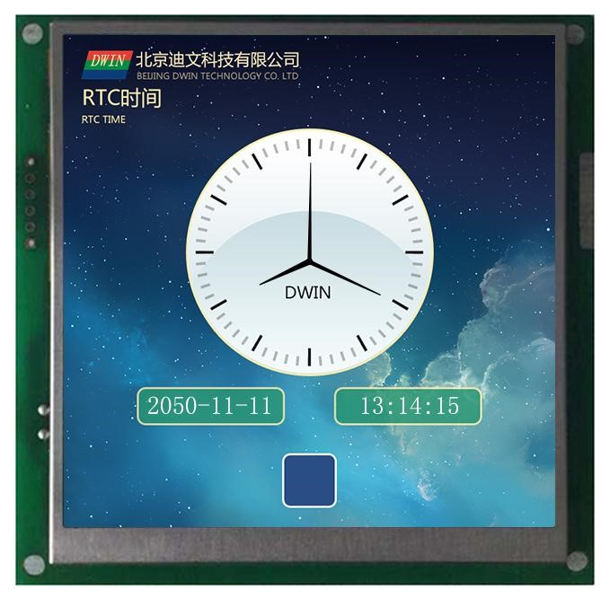

图 **7.19** 文本 **RTC** 显示效果

**7.3.4.2** 表盘格式 **RTC** 显示

**7.3.4.2.1** Dial format **RTC** instruction storage format.

The dial clock display function uses the ICON icon rotation to display the Gregorian RTC by means of a pointer dial. Its instruction storage format is shown in the table.

Table **7.14 The** dial clock displays the instruction storage format.

|  |  |  |  |
| --- | --- | --- | --- |
| **The** SP describes the pointer offset. | Defined. | The length of the data.  **(**字节**)** | Description. |
| **0x00** | 0x0001 | 2 | 写 0x0001 |
| **0x01** | (x,Y) | 4 | The center of the pointer to the clock dial. |
| **0x03** | Icon_Hour | 2 | 指针 ICON 的 ID，0xFFFF 表示时针不显示。 |
| **0x04** | Icon_Hour_Central | 4 | The rotation center position of the hour hand ICON. |
| **0x06** | Icon_Minute | 2 | 分针 ICON 的 ID，0xFFFF 表示分针不显示。 |
| **0x07** | Icon_Minute_Central | 4 | The rotating center position of the minute hand ICON. |
| **0x09** | Icon_Second | 2 | 秒针 ICON 的 ID，0xFFFF 表示秒针不显示。 |
| **0x0A** | Icon_Second_Central | 4 | The rotating center position of the second-hand ICON. |
| **0x0C:H** | Icon_Lib | 1 | The ICON library file ID where the pointer icon is located. |
| **0x0C:L** | Undefined. | 1 | 写 0x00 |

**7.3.5.2.2** Table format **RTC software** setup instructions.

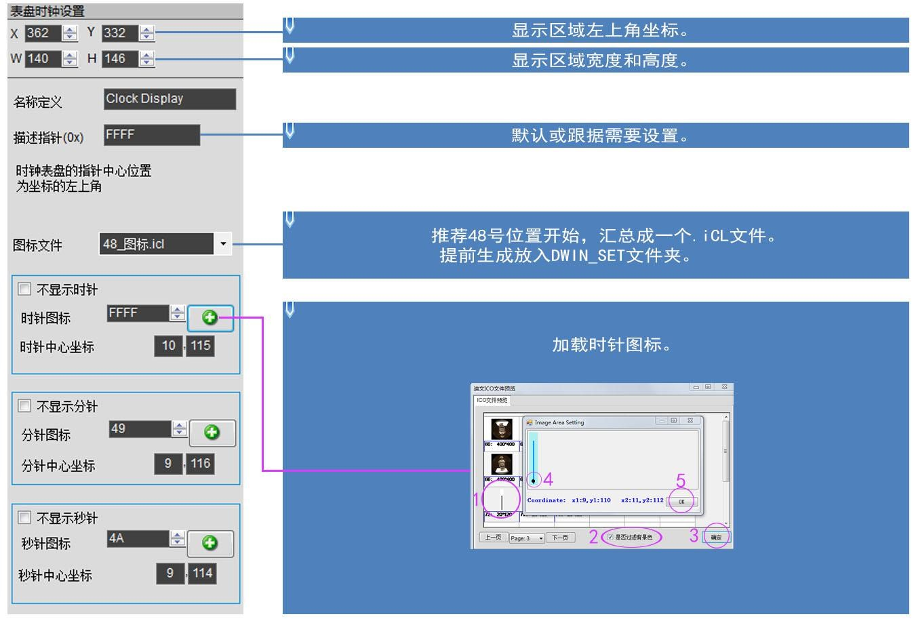

Figure **7.20 Description** of the **RTC software setup for** the dial format.

**7.3.4.2.1** Table format **RTC application** instruction example.

显示时间 2050 年 10 月 1 日 11 时 12 分 13 秒

|  |  |  |
| --- | --- | --- |
| 009C | 5AA5 | 32 0A 01 0B 0C 0D |

5AA5 0B 82

含义：0x5AA5 帧头；0x0B 数据长度；0x82 写指令；

0x009C: Variable：变量地址；该地址固定，不能自定义详见系统变量接口表 0x9C 地址定义 address;

###### 0x5AA5:Start the RTC setting once, and the system variable interface table 0x9C address definition can be seen in detail; ；

0x32 年，0x0A 月，0x01 日，0x0B 时，0x0C 分，0x0D 秒。

**7.3.4.2.4** Dial format **RTC** display effect.

RTC hardware support is required to display .



### **7.3.5HEX** variable display .

**7.3.5.1 HEX** variable instruction storage format.

The HEX data display feature is to display variable data at byte HEX intervals between user-specified ASCII characters. Mostly used for timing displays, such as showing 1234 as 12:34. Its instruction storage format is shown in the table.

Table **7.15 HeX variable display** instruction storage format.

|  |  |  |  |
| --- | --- | --- | --- |
| **The** SP describes the pointer offset. | Defined. | The length of the data.  **(**字节**)** | Description. |
| **0x00** | 0x0001 | 2 | 写 0x0001 |
| **0x01** | (X,Y) | 4 | The center of the pointer to the clock dial. |
| **0x03** | Icon_Hour | 2 | 指针 ICON 的 ID，0xFFFF 表示时针不显示。 |
| **0x04** | Icon_Hour_Central | 4 | The rotation center position of the hour hand ICON. |
| **0x06** | Icon_Minute | 2 | 分针 ICON 的 ID，0xFFFF 表示分针不显示。 |
| **0x07** | Icon_Minute_Central | 4 | The rotating center position of the minute hand ICON. |
| **0x09** | Icon_Second | 2 | 秒针 ICON 的 ID，0xFFFF 表示秒针不显示。 |
| **0x0A** | Icon_Second_Central | 4 | The rotating center position of the second-hand ICON. |
| **0x0C:H** | Icon_Lib | 1 | The ICON library file ID where the pointer icon is located. |
| **0x0C:L** | Undefined. | 1 | 写 0x00 |

**7.3.5.2 HEX** variable software setup instructions.

Encoding strings are used to combine variable data into the format that the customer needs to display. After each BCD code is displayed, an ASCII character is removed sequentially into the encoding string to be displayed at intervals. 0x00 means invalid, this character is not displayed, and the two BCD codes are connected together. 0x0D indicates that the line is displayed.

As shown in the following illustration, suppose you enter "::::",click on theconversion,and the 16-step data is 3A3A3A. Assuming the variable is 0x01210224,the finaloutput is displayed as 01:21:02:24.

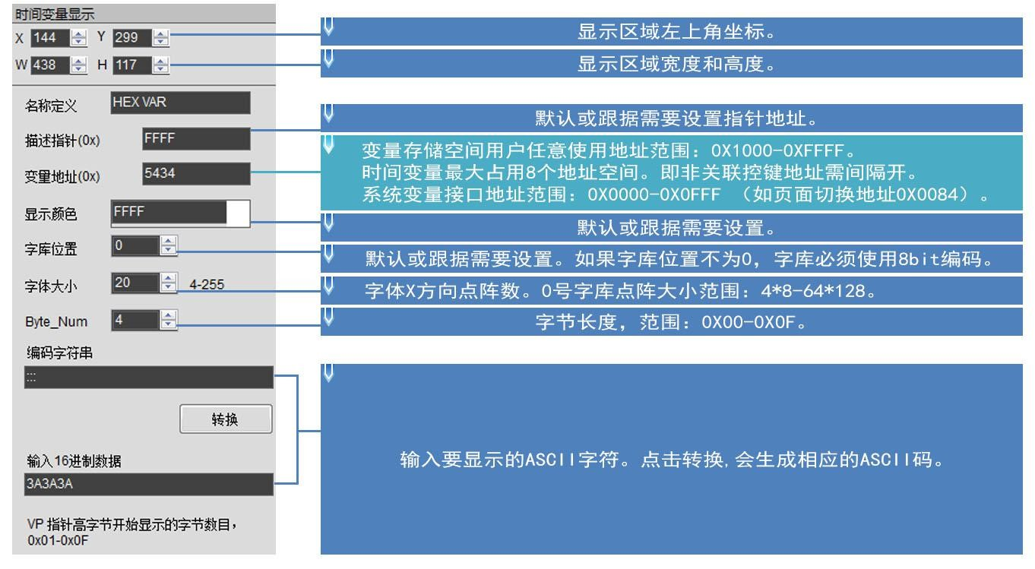

Figure **7.22 Description of hex** variable software settings.

**Examples of 7.3.5.3 HEX** variable application instructions.

|  |
| --- |
| 10 11 12 13 |

5AA5 07 82 5434

含义：0x5AA5 帧头；0x07 数据长度；0x82 写指令；0x5434 变量地址； 0x10 11 12 13 ：BCD 码。 发什么数据就显示什么数据，不用再转换成 16 进制。  **7.3.5.4 HEX** 变量显示效果

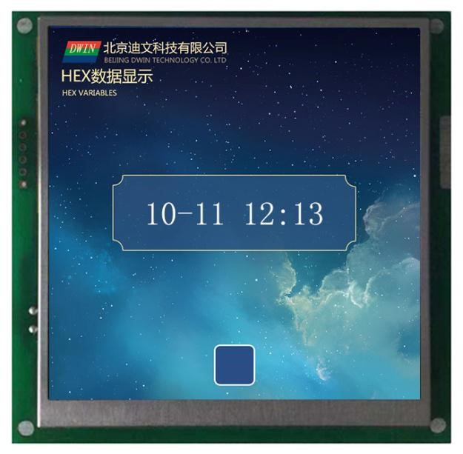

Figure **7.23 HEX shows** the effect.

## **7.4 Graphic** variable .

#### **7.4.1** Real-time curve (trend chart) shows .

**7.4.1.1** Real-time curve instruction storage format.

The real-time curve (trend chart) display function is combined with the 0x84 instruction to write curve buffer data to automatically match the display real-time curve (trend chart). You can specify the display area, the center axis coordinates, and the display scale (zoom in/out) can be controlled. The instruction storage format for this feature is shown in the table.

Table **7.16 The** real-time curve (trend chart) shows the instruction storage format.

|  |  |  |  |
| --- | --- | --- | --- |
| **The** SP describes the pointer offset. | Defined. | The length of the data.  **(**字节**)** | Description. |
| **0x00** | 0x0000 | 2 | There is no definition. |
| **0x01** | xs,Ys xe,Ye | 8 | The upper-left coordinates(xs, Ys) of the curve windowand the lower-rightcoordinates (xe, Ye)are not）和右下角坐标（displayed if the curve crosses the boundary. |
| **0x05** | Y_Central | 2 | The position of the center axis of the curve. |
| **0x06** | VD_Central | 2 | The curve data value corresponding to the center axis is generally taken at half the size of the maximum and minimum values of the data. |
| **0x07** | Color | 2 | The color of the curve. |
| **0x08** | MUL_Y | 2 | 纵轴放大倍数，单位是 1/256，0x0000-0x7FFF。 |
| **0x09:H** | CHANEL | 1 | Data source channel,0x00-0x07. |
| **0x09:L** | Dis_HOR | 1 | 横轴间隔，0x01-0xFF。 |

**7.4.1.2 Real-time** curve refers to the software setup instructions.

In the DGUS development software, _ click show keys and dynamic curves, then use the mouse box to select the display range, and in the right-hand settings menu to configure the curve color, data source channels, etc. to achieve this function.

If you need to display curved lines that are thick, you can place multiple curve variables that pan up anddown (Y-axis) in the same location and reference the same data source access. That is, CtrlC,、CtrlV copy a set curve box, click on the copied curve box to hold down the keyboard's up and down moving keys, move up and down a pixel can be, the more times the curve is thicker, other settings do not need to change.

Note: Use examples of configuration instructions for touch buttons: ： .

If you store the variable description in a data storage space (*SP sPS-specified storage location), .

Combined with incremental touch, adjust the low-byte access position of .0x09 to achieve automatic scaling of curves without user code intervention. ；

Combined with drag +0x05 修改 touch, adjusting the Y_Central value of the Y_Central allows the curve to move up and down without user code intervention.

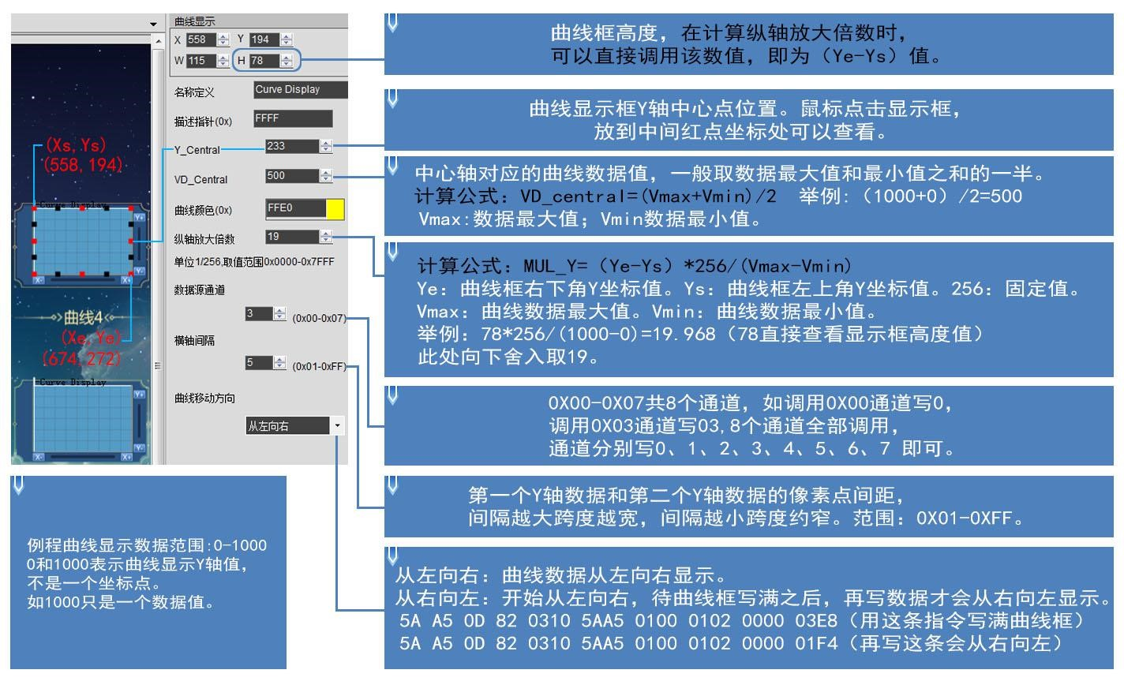

Figure **7.24 The real-time** curve refers to the description of the software setup.

**7.4.1.3 Real-time** curve refers to the application of instructions as an example.

Table **7.17 Real-time** curve system variable interface address definition.

|  |  |
| --- | --- |
| The system variable interface reads and writes the address. | Description. |
| **0x300-0x30F** | State feedback for 8 channel curve buffers (recommended ）， 每通道占 user read-only), 2 words per channel, storage pointer position 低字存储曲线缓冲区有效数据长度（(0x0000-0x07FF) for high-wordstorage curvedata, and effective data length for low-word storage curve buffer 个字，高字存储曲线数据的存储指针位置（(0x0000-0x0800).  Writing 0x0000 of the valid data length of the curve buffer will cause the curve not to be displayed.  Example:5AA5 05 82 0301 0000 Curve 0 channel does not display the curve and resumes if you rewrite the point value. |
| **0x310-0x311** | Curve buffer data write starts .  D3：D2：0x5AA5 启动一次曲线缓冲区数据写操作，CPU 操作完清零。  D1：数据块个数，0x01-0x08。  D0：未定义，写 0x00。 |
| **0x312-0x37F** | The block of data that needs to be written to the curve buffer is a 16bit unsigned number. A single block of data is defined as a data channel ID.  （0x00-0x07）+数据字长度（0x01-0x6E）+数据。 |

①0x00 通道显示数据 0 和 1000

|  |  |  |  |  |  |
| --- | --- | --- | --- | --- | --- |
| 0310 | 5AA5 | 0100 | 00 | 02 | 0000 03E8 |

5AA5 0D 82

含义： 0x5AA5 帧头；0x0D 数据字节长度；0x82 写指令；

0x0310: Curve buffer data write start, system variable hardware interface curve fixed address;

###### 0x5AA5: Start a curve buffer data write operation,cpu operation is cleared; ；

个字长度数据，即 0x0000，0x03E80x0100: 高字节 The number of high byte 0x01 曲线数据块个数即占用了几个通道，低字节未定义写 curve blocks occupies several channels, the low byte is not defined to write 高字节 0x00 表示 0 通道，低字节 0x02 表示数据字长度个数，此处为 2 0x00;； ；

0x0000: 为要显示的数据 0,0x03E8 for the data to be displayed is 1000 for the data to be displayed.

②0x06 通道显示数据 0 和 1000

|  |  |  |  |  |  |
| --- | --- | --- | --- | --- | --- |
| 0310 | 5AA5 | 0100 | 06 | 02 | 03E8 0000 |

5AA5 0D 82

③0x07 通道显示数据 0 和 1000：

|  |  |  |  |  |  |
| --- | --- | --- | --- | --- | --- |
| 0310 | 5AA5 | 0100 | 07 | 02 | 0000 03E8 |

5AA5 0D 82

④0x00 和 0x07 通道显示数据 0 和 1000

|  |  |  |  |  |  |  |  |  |
| --- | --- | --- | --- | --- | --- | --- | --- | --- |
| 0310 | 5AA5 | 0200 | 00 | 02 | 0000 03E8 | 07 | 02 | 0000 03E8 |

5AA5 12 82

含义：0x5AA5 帧头；0x12 数据字节长度；0x82 写指令；

0x0310:Curve buffer data write start, system variable hardware interface curve fixed address;

###### 0x5AA5:Start a curve buffer data write operation,CPU operation is cleared; ；

0x0200:High byte 0x02 is the number of blocks of data that consume several channels, if an instruction to write 8 channels the byte needs to 个通道该字节需改为 be changed to 08,lowbyte is not defined to write 0x00.

0x0002：高字节 0x00 表示 0 通道，低字节 0x02 表示数据字长度个数，即 0x0000，0x03E8 这两个数据；

0x0000: 0000 for the data to be：为要显示的数据 displayed, 0x03E8 for the data to be displayed 1000.

0x0702：高字节 0x07 表示 07 通道，低字节 0x02 为数据字长度个数，即 0x0000，0x03E8 这两个数据；

0x0000: 0000 for the data to be：为要显示的数据 displayed, 0x03E8 for the data to be displayed 1000.

The channels of the two curves are written separately from the length of the data word.

|  |  |  |  |  |  |  |  |  |
| --- | --- | --- | --- | --- | --- | --- | --- | --- |
| 0310 | 5AA5 | 0200 | 06 | 02 | 0000 03E8 | 07 | 02 | 03E8 0000 |

(5)The 0x06 和 and 0x07 通道显示两条交叉曲线且从右到左显示指令 channels display two cross curves and right-to-left instruction 1:：5AA5 12 82.

Meaning: Directive 1 is to form a cross-curve, where the maximum and minimum values of the two curves are set opposite so that the cross-display in the middle of the curve box sees the effect.

The cross curve is really two different channel curves, so you need to do two curve boxes to set the different channels.

|  |  |  |  |  |  |  |  |  |
| --- | --- | --- | --- | --- | --- | --- | --- | --- |
| 0310 | 5AA5 | 0200 | 06 | 02 | 0064 01F4 | 07 | 02 | 01F4 0064 |

指令 2：5AA5 12 82

Meaning: The software's right-to-left settings screen starts with a left-to-right display, waiting for the curve box to fill in and then writing instruction 2 beforeyou see the curve display from right toleft.

(6)0x00-0x078 channels are all displayed together.

5AA5 37 82 0310 5AA5 08000002 0000 03E8 0102 0000 03E80202 0000 03E8 0302 0000 03E80402 0000 03E80502

0000 03E80602 0000 03E80702 0000 03E8

The display 个通道，每个通道可以存放 of the T5DGUS curve 曲线 8 channels, with a total of 8 channels, each with a storage of 2048 words. ，

When dynamic curve display is enabled, a data buffer is established 开始，按照每通道 for each curve at 2Kwords per channel, starting at 0x1000. 为每条曲线建立数据缓冲区

CH0 缓冲区为 0x1000-0x17FF，CH1 缓冲区为 0x1800-0x1FFF， CH2 缓冲区为 0x2000-0x27FF，CH3 缓冲区为 0x2800-0x2FFF， CH4 缓冲区为 0x3000-0x37FF，CH5 缓冲区为 0x3800-0x3FFF， CH6 缓冲区为 0x4000-0x47FF，CH7 缓冲区为 0x4800-0x4FFF，

Curve buffers that are not used can be used as user variable areas. Users can also directly overwrite the curve buffer.

For example, directly override the variable address 5AA5 05 82 1000 0065... The value of the corresponding channel of the curve changes with it.

If the user needs to use 8 channels, the variable addresses and description pointers of the other display controls are used from the 0x5000 to 0xFFFF interval.

(7) Description pointers for real-time curves use illustration examples: ： .

The description pointer storage address format for this feature is shown as the red address of the table. Here are a few examples of common access instruction references: .

|  |  |  |
| --- | --- | --- |
| **The** SP describes the pointer offset. | The serial port sends a send instruction.  （示例的 **SP** 地址设置为 **0x8000**） | Instruction effect and application. |
| **0x05** | 5AA5 05 82 8005 0064 | Changes the position of the center axis of the curve (the curve moves up and down): moves up and down to the y coordinate point.  100 位置。 |
| **0x06** | 5AA5 05 82 8006 0064 | Change the range of the curve (curve vertical scaling): ）The value of the curve data corresponding to the center axis, typically half the size of the maximum and minimum values of the data. For example, change the instruction to 0'200 quantum here ，(display 需要配合 correctly after modifying the corresponding magnification with the 0x08 pointer address). ） |
| **0x07** | 5AA5 05 82 8007 F800 | The curve displays a color that changes red. |
| **0x08** | 5AA5 05 82 8008 00F0 | 修改纵轴放大倍数，单位是 1/256，0x0000-0x7FFF。 （需要与配合 0x06 指针使用） |
| **0x09:H** |  | Data source channel,0x00-0x07. |
| **0x09:L** | 5AA5 05 82 8009 0014 | Change the horizontal axis interval (curve horizontal scaling): ）：将 Displays the curve of the 00 通道的曲线显示横轴间隔为 channel at a horizontal axis interval of 0x14(range 0x01-0xFF). |

(8) The negative number of curves is displayed.

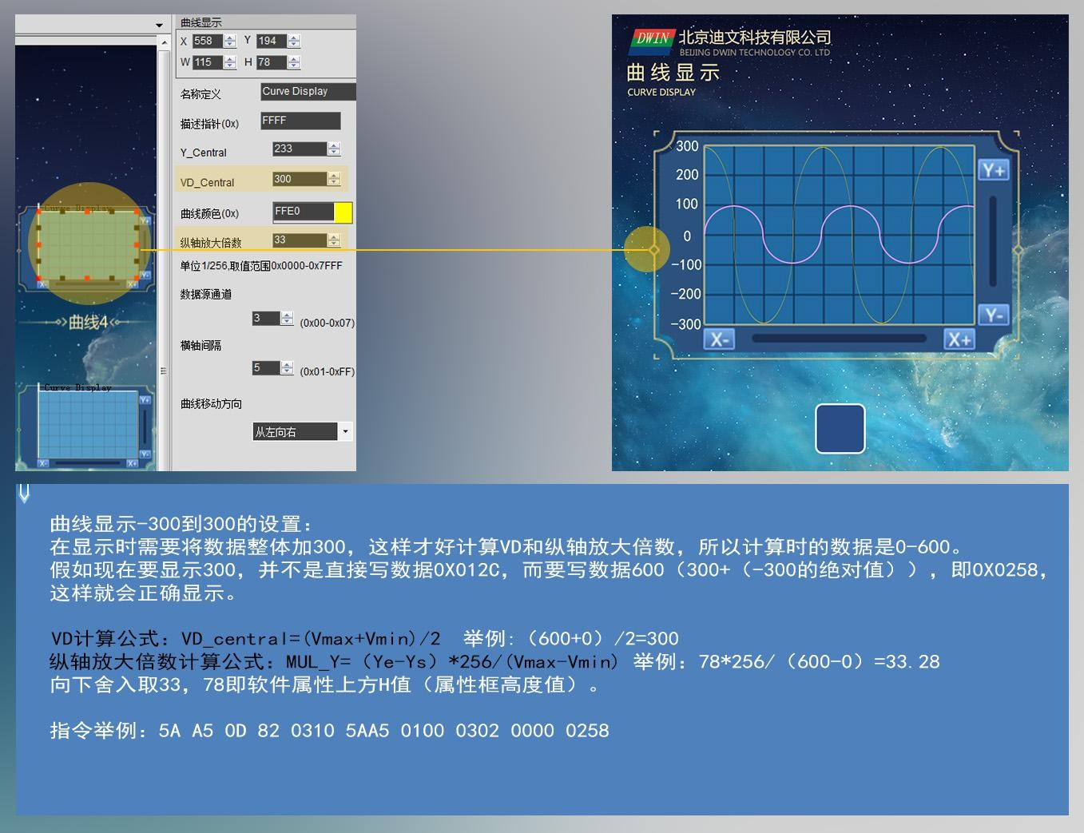

**7.4.1.4** Real-time curve display.

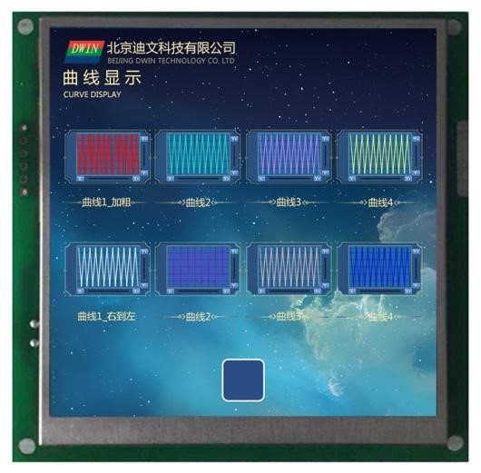

Figure **7.25 The** real-time curve shows the effect.

#### **7.4.2 Basic** graphical display .

**7.4.2.1 Basic** graphics instruction storage format.

The basic graphical display function is to define a "drawing 中定义一个 board" 绘图板 function in the display profile 14.BIN, while the specific drawing operation is ” 功能，而具体的绘图操作则由 determined by the contents of the variable memory that the VP points to. Users implement different drawing functions by changing the data in the variable memory. Its instruction storage format is shown in the table.

Table **7.18 Basic** graphics instruction storage format.

|  |  |  |  |
| --- | --- | --- | --- |
| **The** SP describes the pointer offset. | Defined. | The length of the data.  **(**字节**)** | Description. |
| **0x00** | *VP | 2 | Variable data pointer. |
| **0x01** | Area | 8 | The top-left and lower-right coordinates of the plot display area; That's only right.  0x0001-0x0005、0x0009、0x000A、0x000B 指令有效。 |
| **0x05:H** | Dashed_Line_En | 1 | 0x5A:Drawing instructions using segments(0x02,、0x03,、0x09,、0x0A instructions) display segments using dashed or dotted lines; ；  Other: Use the drawing instructions for segments to display segments with solid lines. |
| **0x05:L** | Dash_Set | 4 | 4 bytes are formatted in turn with dashed (dot dashed): ： .  The number of solid-line dots in paragraph 1, the number of dotted dots in the first segment, the number of solid-line dots in the second segment, and the number of dotted dots in the second segment.  比如，设置 0x10 0x04 0x10 0x04 将显示虚线；设置 0x10 0x04 0x02 0x04 将显示点划线。 |
| **0x07** | Undefined. | 13 | Reserved, write 0x00. |

The variable data format description that the variable data pointer (the variable storage space) points to is shown in the table.

Table **7.19 Description of** the variable data format to which the variable data pointer points.

|  |  |  |
| --- | --- | --- |
| Address. | Defined. | Description. |
| **VP** | CMD | Drawing instructions. |
| **VP+1** | Data_Pack_Num_Max | Maximum packet data: The wire instruction(0x0002),）, defined as the number of connected lines (vertest points -1);）； |
| **VP+2** | DATA_Pack | Data. |

The drawing instruction packet description is shown in the table.

Table **7.20 Drawing** instruction packet description.

|  |  |  |  |  |  |
| --- | --- | --- | --- | --- | --- |
| Instructions.  **(CMD)** | Operation. |  | Description of the drawing packet format (relative address and length units are**word).**）） | | |
| Relative address. | Length. | Defined. | Description. |
| **0x0001** | point. | 0x00 | 2 | (x,y) | The location of the point coordinates,x coordinates high bytes as a condition of judgment. |
| 0x02 | 1 | Color | The color of the dot. |
| **0x0002** | The endpoint is connected. | 0x00 | 1 | Color | The color of the line. |
| 0x01 | 2 | (x,y)0 | Front vertes 0 coordinates,x coordinates high bytes as a condition of judgment. |
| 0x03 | 2 | (x,y)1 | Front vertes 1 coordinates,x coordinates high bytes are the criteria for judging. |
| 0x01-2 | 2 | (x,y)n | Front vertes n coordinates,x coordinates high bytes as a condition of judgment. |
| **0x0003** | Rectangular. | 0x00 | 2 | (x,y)s | The upper-left coordinates of the rectangle box,with x-coordinate high bytes as the criterion for judging. |
| 0x02 | 2 | (x,y)e | The coordinates in the lower right corner of the rectangle box. |
|  |  | 0x04 | 1 | Color | The color of the rectangle. |
| **0x0004** | Rectangular domain fill. | 0x00 | 2 | (x,y)s | The upper-left coordinates of the rectangle box,with x-coordinate high bytes as the criterion for judging. |
| 0x02 | 2 | (x,y)e | The coordinates in the lower right corner of the rectangle box. |
| 0x04 | 1 | Color | Rectangular fields fill the color. |
| **0x0005** | The entire arc is displayed. | 0x00 | 2 | (x,y) | Round center coordinates,x coordinates high bytes as a condition of judgment. |
| 0x02 | 1 | Wheel | Radius. |
| 0x03 | 1 | Color | The color of the arc. |
| **0x0006** | The picture area is cut and pasted. | 0x00 | 1 | Pic_ID | Cut the page IDwherethe picture area is located; |
| 0x01 | 2 | (x,y)s | Cut the coordinates in the upper left corner of the picture area. |
| 0x03 | 2 | (x,y)e | Cut the coordinates in the lower right corner of the picture area. |
| 0x05 | 2 | (x,y) | Cut the top-left coordinates of the picture area pasted to the current page coordinate location. |
| **0x**07** | The ICON icon shows . | 0x00 | 2 | (x,y) | Displays the coordinate position,with x-coordinate high bytes as a condition of judgment. |
| 0x02 | 1 | ICON_ID | Icon ID, theicon library location is specified by the instruction high byte.  The icon is pinned to not display a background color. |
| **0x0008** | The area is filled. | 0x00 | 2 | (x,y) | Seed point coordinates,x coordinates high bytes as a condition of judgment. |
| 0x02 | 1 | Color | Fill the color. |
| **0x0009** | Spectrum display.  (vertical line). ） | 0x00 | 1 | Color0 | 把(x0,Y0s）(x0,Y0e）用 Color0 颜色连线，x0 高字节为判断条件。 |
| 0x01 | 3 | X0,Y0s,Y0e |  |
| **0x000D** | Rectangular domain xOR. | 0x00 | 2 | (x,y)s | The top-left coordinates of the rectangular field,with x-coordinate high bytes as the criterion for judging. |
| 0x02 | 2 | (x,y)e | The coordinates in the lower right corner of the rectangular field. |
| 0x04 | 1 | Color | The rectangular field does the color of xOR, and 0xFFFF performs an anti-color operation. |

Determining that the adjustment to 0xFF represents the end of the drawing operation,and 0xFE represents skipping (ignoring) the operation.

**7.4.2.2 Basic** graphics software setup instructions.

In the DGUS development software, 开发软件中，点击显示控键 click on the display keys , basic graphic display, then select the display area with the mouse box on the page where you want to display the artboard, define the variable address, etc. in the settings menu on the right, and finally use the serial instructions to achieve the drawing.

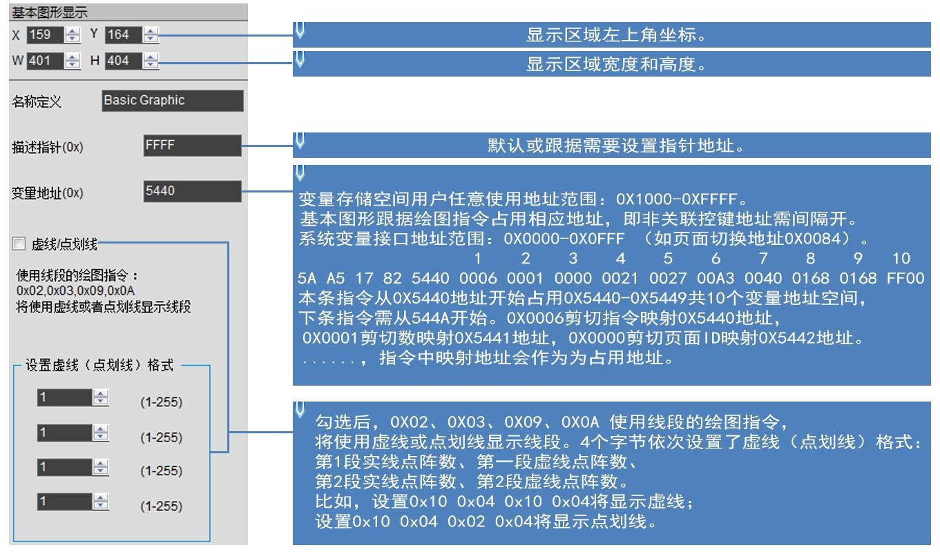

Figure **7.26 Description of basic** graphics software settings.

**7.4.2.3** Examples of basic graphics application instructions.

**7.4.2.3.1** Set point .

A red dot is displayed.

|  |  |  |  |
| --- | --- | --- | --- |
| 0001 | 0001 | 0168 0168 | F800 |

5A A5 0F 82 5440FF00

含义：0x5A A5帧头；0x0D数据长度；0x82写指令；0x5440变量地址；

0x 0001:画点；

0x 0001:点个数；

0x 0168:0168（360,360）坐标；

0x F800:颜色值；

The 0xFF00 drawing operation ends.

Two red dots are displayed.

|  |  |  |  |
| --- | --- | --- | --- |
| 0001 | 0002 | 0168 0168 F800 | 0169 0169 F800 |

5A A5 15 82 5440FF00

含义：0x5A A5帧头；0x15数据长度；0x82写指令；0x5440变量地址；

0x 0001:画点；

0x 0002:点个数；

0x 0168 0168:（360,360）坐标，0xF800颜色值；

0169 0169:（361,361）坐标，0xF800颜色值； FF00:绘图操作结束。

Three red dots are displayed.

|  |  |  |  |  |
| --- | --- | --- | --- | --- |
| 0001 | 0003 | 0168 0168 F800 | 0169 0169 F800 | 016A 016A F800 |

5A A5 19 82 5440FF00

含义：0x5A A5帧头；0x19数据长度；0x82写指令；0x5440变量地址；

0x 0001:画点；

0x 0003:点个数；

0x 0168 0168:（360,360）坐标；0x F800颜色值；

0x 0169 0169:（361,361）坐标，0x F800颜色值； 0x 016A 016A:（362,362）坐标，0x F800颜色值； 0x FF00:绘图操作结束。

**7.4.2.3.2 The** endpoint is connected to the two endpoints.

|  |  |  |  |  |
| --- | --- | --- | --- | --- |
| 0002 | 0001 | F800 | 00FC 0168 | 015E 0168 |

5A A5 13 82 5440FF00

含义：0x5A A5帧头；0x13数据长度；0x82写指令；0x5440变量地址；

0x 0002:画线段；

0x 0001:连线条数；

0x F800:颜色值；

0x 00FC 0168:（252,360）坐标；

0x 015E 0168:（(350,360)坐标;）坐标； 0x FF00:绘图操作结束。

The three endpoints are connected in line.

|  |  |  |  |  |  |
| --- | --- | --- | --- | --- | --- |
| 0002 | 0002 | F800 | 00FC 0168 | 015E 0168 | 015E 0136 |

5A A5 17 82 5440FF00

含义：0x5A A5帧头；0x17数据长度；0x82写指令；0x5440变量地址；

0x 0002:画线段；

0x 0002:连线条数；

0x F800:颜色值；

0x 00FC 0168:（252,360）坐标；

0x 015E 0168:（(350,360)坐标;）坐标；

0x 015E 0136:（(350,310)坐标;）坐标； 0x FF00绘图操作结束。

The four endpoints are connected in line.

|  |  |  |  |  |  |  |
| --- | --- | --- | --- | --- | --- | --- |
| 0002 | 0003 | F800 | 00FC 0168 | 015E 0168 | 015E 0136 | 0190 0136 |

5A A5 1B 82 5440FF00

含义：0x5A A5帧头；0x1B数据长度；0x82写指令；0x5440变量地址；

0x 0002:画线段；

0x 0003:连线条数；

0x F800:颜色值；

0x 00FC 0168:（252,360）坐标；

015E 0168:（(350,360)坐标;）坐标；

015E 0136:（(350,310)坐标;）坐标；

0x 0190 0136:（350,310）坐标； 0x FF00:绘图操作结束。

The five endpoints are connected in line.

|  |  |  |  |  |  |  |  |
| --- | --- | --- | --- | --- | --- | --- | --- |
| 0002 | 0004 | F800 | 00FC 0168 | 015E 0168 | 015E 0136 | 0190 0136 | 0190 0168 |

5A A5 1F 82 5440FF00

含义：0x5A A5帧头；0x1F数据长度；0x82写指令；0x5440变量地址；

0x 0002:画线段；

0x 0004:连线条数；

0x F800:颜色值；

0x 00FC 0168:（252,360）坐标；

0x 015E 0168:（(350,360)坐标;）坐标；

0x 015E 0136:（(350,310)坐标;）坐标；

0x 0190 0136:（350,310）坐标；

0x 0190 0168:（400,360）坐标； 0x FF00:绘图操作结束。

Six endpoints are connected in line.

|  |  |  |  |  |  |  |  |  |
| --- | --- | --- | --- | --- | --- | --- | --- | --- |
| 0002 | 0005 | F800 | 00FC 0168 | 015E 0168 | 015E 0136 | 0190 0136 | 0190 0168 | 01C2 0168 |

5A A5 23 82 5440FF00

含义：0x5A A5帧头；0x23数据长度；0x82写指令；0x5440变量地址；

0x 0002:画线段；

0x 0005:连线条数；

0x F800:颜色值；

0x 00FC 0168:（252,360）坐标；

0x 015E 0168:(350,360)坐标;

0x 015E 0136:（(350,310)坐标;）坐标；

0x 0190 0136:（400,310）坐标；

0x 0190 0168:（400,360）坐标； 0x 01C2 0168:（450 360）坐标； 0x FF00:绘图操作结束。

Seven endpoints are connected in line.

|  |  |  |  |  |  |  |  |  |  |
| --- | --- | --- | --- | --- | --- | --- | --- | --- | --- |
| 0002 | 0006 | F800 | 00FC 0168 | 015E 0168 | 015E 0136 | 0190 0136 | 0190 0168 | 01C2 0168 | 01C2 0136 |

5A A5 27 82 5440FF00

含义：0x5A A5帧头；0x27数据长度；0x82写指令；0x5440变量地址；

0x 0002:画线段；

0x 0006:连线条数；

0x F800:颜色值；

0x 00FC 0168:（252,360）坐标；

0x 015E 0168:(350,360)坐标;

0x 015E 0136:（(350,310)坐标;）坐标；

0190 0136:（400,310）坐标；

0190 0168:（400,360）坐标；

0x 01C2 0168:（450 360）坐标；

0x 01C2 0136:（450,310）坐标； 0xFF00:绘图操作结束。

Eight endpoints are connected in line.

|  |  |  |  |  |  |  |  |  |  |  |
| --- | --- | --- | --- | --- | --- | --- | --- | --- | --- | --- |
| 0002 | 0007 | F800 | 00FC 0168 | 015E 0168 | 015E 0136 | 0190 0136 | 0190 0168 | 01C2 0168 | 01C2 0136 | 01F4 0136 |

5A A5 2B 82 5440 FF00

含义：0x5A A5帧头；0x2B数据长度；0x82写指令；0x5440变量地址；

0x 0002:画线段；

0x 0007:连线条数；

0x F800:颜色值；

0x 00FC 0168:（252,360）坐标；

0x 015E 0168:（(350,360)坐标;）坐标；

0x 015E 0136:（(350,310)坐标;）坐标；

0x 0190 0136:（400,310）坐标；

0x 0190 0168:（400,360）坐标；

0x 01C2 0168:（450 360）坐标；

0x 01C2 0136:（450,310）坐标；

0x 01F4 0136:（500,310）坐标； 0x FF00:绘图操作结束。

Nine endpoints are connected in line.

|  |  |  |  |  |  |  |  |  |  |  |
| --- | --- | --- | --- | --- | --- | --- | --- | --- | --- | --- |
| 0002 | 0008 | F800 | 00FC 0168 | 015E 0168 | 015E 0136 | 0190 0136 | 0190 0168 | 01C2 0168 | 01C2 0136 | 01F4 |

5A A5 2F 82 5440

|  |  |
| --- | --- |
| 0136 | 01F4 0168 |

FF00

含义：0x5A A5帧头；0x2F数据长度；0x82写指令；0x5440变量地址；

0x 0002:画线段；

0x 0008:连线条数；

0x F800:颜色值；

0x 00FC 0168:（252,360）坐标；

0x 015E 0168:（(350,360)坐标;）坐标；

0x 015E 0136:（(350,310)坐标;）坐标；

0x 0190 0136:（400,310）坐标；

0x 0190 0168:（400,360）坐标；

0x 01C2 0168:（450 360）坐标；

0x 01C2 0136:（450,310）坐标；

0x 01F4 0136:（500,310）坐标；

0x 01F4 0168:（500,360）坐标； 0x FF00:绘图操作结束。

Ten endpoints are connected in line.

|  |  |  |  |  |  |  |  |  |  |  |
| --- | --- | --- | --- | --- | --- | --- | --- | --- | --- | --- |
| 0002 | 0009 | F800 | 00FC 0168 | 015E 0168 | 015E 0136 | 0190 0136 | 0190 0168 | 01C2 0168 | 01C2 0136 | 01F4 |

5A A5 33 82 5440

|  |  |  |
| --- | --- | --- |
| 0136 | 01F4 0168 | 0226 0168 |

FF00

含义：0x5A A5帧头；0x33数据长度；0x 82写指令；0x5440变量地址；

0x 0002:画线段；

0x 0009:连线条数；

0x F800:颜色值；

0x 00FC 0168:（252,360）坐标；

0x 015E 0168:（(350,360)坐标;）坐标；

0x 015E 0136:（(350,310)坐标;）坐标；

0x 0190 0136:（400,310）坐标；

0x 0190 0168:（400,360）坐标；

0x 01C2 0168:（450 360）坐标；

0x 01C2 0136:（450,310）坐标；

0x 01F4 0136:（500,310）坐标；

0x 01F4 0168:（500,360）坐标；

0x 0226 0168:（550,360）坐标； 0x FF00:绘图操作结束。

Eleven endpoints are connected in line.

|  |  |  |  |  |  |  |  |  |  |  |
| --- | --- | --- | --- | --- | --- | --- | --- | --- | --- | --- |
| 0002 | 000A | F800 | 00FC 0168 | 015E 0168 | 015E 0136 | 0190 0136 | 0190 0168 | 01C2 0168 | 01C2 0136 | 01F4 0136 |

5A A5 37 82 5440

01F4 0168 0226 0168 0226 0136 FF00

含义：0x5A A5帧头；0x37数据长度；0x82写指令；0x5440变量地址；

0x 0002:画线段；

0x 000A:连线条数；

0x F800:颜色值；

0x 00FC 0168:（252,360）坐标；

0x 015E 0168:（(350,360)坐标;）坐标；

0x 015E 0136:（(350,310)坐标;）坐标；

0x 0190 0136:（400,310）坐标；

0x 0190 0168:（400,360）坐标；

0x 01C2 0168:（450 360）坐标；

0x 01C2 0136:（450,310）坐标；

0x 01F4 0136:（500,310）坐标；

0x 01F4 0168:（500,360）坐标；

0x 0226 0168:（550,360）坐标；

0x 0226 0136:（550,310）坐标； 0x FF00:绘图操作结束。 显示效果：

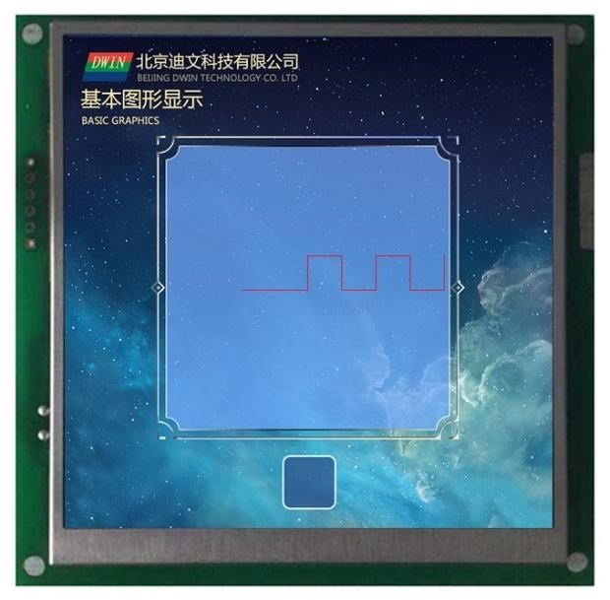

Figure **7.27** Endpoint wire display.

**7.4.2.3.3** Rectangle shows a rectangle .

|  |  |  |  |
| --- | --- | --- | --- |
| 0003 | 0001 | 011E 012C | 01AA 018C F800 |

5A A5 13 82 5440FF00

含义：0x5A A5帧头；0x13数据长度；0x82写指令；0x5440变量地址；

0x 0003:画矩形；

0x 0001:画一个矩形；

0x 011E 012C:(286,，300)左上坐标;

0x 01AA 018C:（426，396）右下坐标；

0x F800:颜色； 0x FF00:绘图操作结束。

Two rectangles are displayed.

|  |  |  |  |  |  |
| --- | --- | --- | --- | --- | --- |
| 0003 | 0002 | 011E 012C | 01AA 018C F800 | 01AB 018D | 01E6 01E6 F800 |

5A A5 1D 82 5440FF00

含义：0x5A A5帧头；0x1D数据长度；0x82写指令；0x5440变量地址；

0x 0003:画矩形；

0x 0002: Draw two rectangles; ；

0x 011E 012C:(286,，300)左上坐标;

0x 01AA 018C:（426，396）右下坐标；0x F800颜色；

0x 01AB 018D:(427,397) ;坐标; 0x 01E6 01E6:(486,486)右坐标;0x F800颜; 0x FF00:绘操 . . .结束 . . . . . . . . . . . . . . . . . . . . . . . . . . . . . . . . . . . . . . . . . . . . . . . . . . . . . . . . . . . . . . . . . . . . . . . . . . . . . . . . . . . . . . . . . . . . . . . . . . . . . . . . . . . . . . . . . . . . . . . . . . . . . . . . . . . . . . . . . . . . ..

Three rectangles are displayed.

|  |  |  |  |  |  |  |  |
| --- | --- | --- | --- | --- | --- | --- | --- |
| 0003 | 0003 | 011E 012C | 01AA 018C F800 | 01AB 018D | 01E6 01E6 F800 | 01E6 01E6 | 0162 022C F800 |

5A A5 27 82 5440FF00

含义：0x5A A5帧头；0x27数据长度；0x82写指令；0x5440变量地址；

0x 0003:画矩形；

0x 0003: Draw three rectangles; ；

0x 011E 012C:(286,，300)左上坐标;

0x 01AA 018C:（426,96）右下坐标；0x F800颜色；

0x 01AB 018D:(426.96) 坐标;

0x 01E6 01E6:（486,486）右上坐标；0x F800颜色；

0x 01E6 01E6:（486,486）左上坐标；

0x 0162 022C:（354,556）右下坐标；0xF800颜色； FF00:绘图操作结束。

Effect: ： .

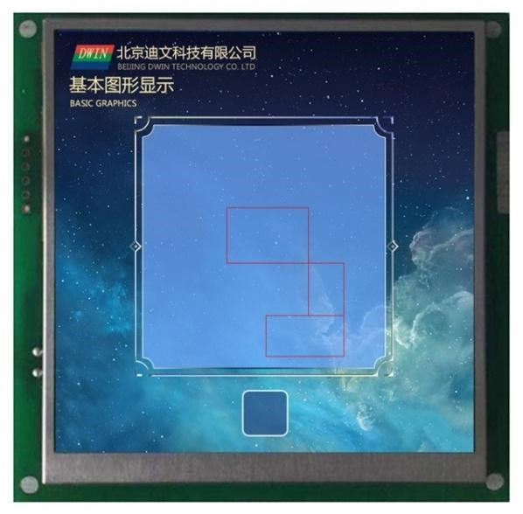

Figure **7.28 Basic** graphic rectangle display effect.

**7.4.2.3.4** Rectangular fill fills a rectangle.

|  |  |  |  |  |
| --- | --- | --- | --- | --- |
| 0004 | 0001 | 011E 012C | 01AA 018C | F800 |

5A A5 13 82 5440FF00

含义：0x5A A5帧头；0x13数据长度；0x82写指令；0x5440变量地址；

0x 0004:矩形填充；

0x 0001: Fill a rectangle; ；

0x 011E 012C:(286,，300)左上坐标;

0x 01AA 018C:（426，396）右下坐标；

0x F800:颜色； 0x FF00:绘图操作结束。

Fill two rectangles.

|  |  |  |  |
| --- | --- | --- | --- |
| 0004 | 0002 | 011E 012C 01AA 018C F800 | 01AB 018D 01E6 01E6 F800 |

5A A5 1D 82 5440FF00

含义：0x5A A5帧头；0x1D数据长度；0x82写指令；0x5440变量地址；

0x 0004:矩形填充；

0x 0002: Fill two rectangles; ；

0x 011E 012C(286.00)左上坐标;）左上坐标；0x01AA 018C(426, 96)右下坐标;0xF800颜色; 0x 01AB 018D（(427.97)左上坐标;）左上坐标；0x01E6 01E6(486,486)右下坐标;0xF800颜色; 0xFF00:（绘图操作结束。

Fill three rectangles.

|  |  |  |  |  |
| --- | --- | --- | --- | --- |
| 0004 | 0003 | 011E 012C 01AA 018C F800 | 01AB 018D 01E6 01E6 F800 | 01E6 01E6 0221 022C F800 |

5A A5 27 82 5440FF00

含义：0x5A A5帧头；0x27数据长度；0x82写指令；0x5440变量地址；

0x 0004:画矩形；

0x 0003: Fills three rectangles; ；

0x 011E 012C（(286.00)左上坐标;）左上坐标；0x01AA 018C(426,,396)右下坐标;）右下坐标；0xF800（颜色颜色;

0x 01AB 018D(427.97) 坐标;0x01E6 01E6(486,486)右坐标,0xF800颜; 0x 01E6 01E6(486,486)坐标;0x0221 022C(545,556)右坐标;0xF800颜; 0xFF00:绘操结束 填充时右下角坐标要大于左上角坐标。 显示效果:

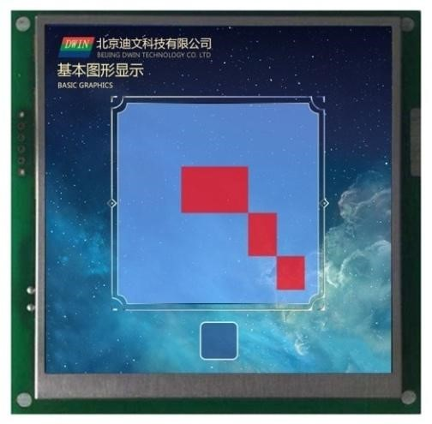

Figure **7.29 Basic** graphic rectangular fill shows the effect.

**7.4.2.3.5** 图片复制粘贴 Picture copy and paste This instruction is used more frequently and can be used for the cut display of the progress bar.

|  |  |  |  |  |
| --- | --- | --- | --- | --- |
| 0006 | 0001 | 0000 | 0021 002700A3 0040 | 0168 0168 |

5A A5 17 82 5440FF00

含义：0x5A A5帧头；0x17数据长度；0x82写指令；0x5440变量地址；

0x 0006 picture copy and paste; ；

0x 0001 Cuts an area ;

0x 0000剪切第0页；

0x 0021 0027（33, 39）第0页左上坐标，

0x 00A3 0040（163,64）第0页右下坐标； 0x 0168 0168（360,360）粘贴到当前页坐标； 0xFF00绘图操作结束。

Effect: ： .

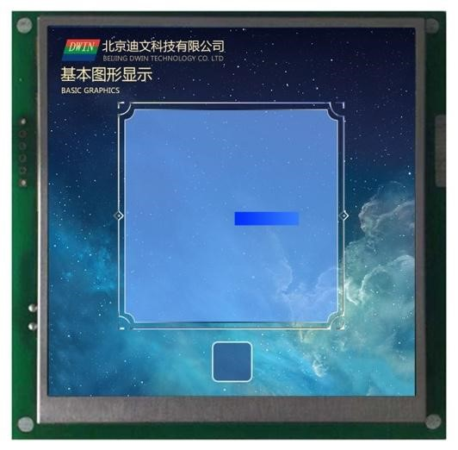

Figure **7.30 Basic graphics** copy-and-paste display.

**The 7.4.2.3.6** spectrum display shows a spectrum.

|  |  |  |  |  |  |
| --- | --- | --- | --- | --- | --- |
| 0009 | 0001 | F800 | 0168 | 0168 | 0190 |

5A A5 11 82 5440FF00

含义：0x5A A5帧头；0x11数据长度；0x82写指令；0x5440变量地址；

0x 0009频谱显示；

0x 0001 shows a spectrum; ；

0x F800颜色；

0x 0168 x0坐标，

0x 0168 Y0s开始坐标；

0x 0190 Y0e结束坐标； 0xFF00绘图操作结束。

Two spectrums are displayed.

|  |  |  |  |
| --- | --- | --- | --- |
| 0009 | 0002 | F800 0168 0168 0190 | F800 0190 0168 01C2 |

5A A5 19 82 5440FF00

含义：0x5A A5帧头；0x11数据长度；0x82写指令；0x5440变量地址；

0x 0009频谱显示；

0x 0002 shows two spectrums; ；

0x F800颜色；0x 0168（360）x0坐标，0x0168（360）Y0s开始坐标；0x0190（400）Y0e结束坐标； 0x F800颜色；0x 0190（400）x1坐标；0x0168（360）Y1s开始坐标；0x01C2（450）Y1e结束坐标； 0xFF00绘图操作结束。

Three spectrums are displayed.

|  |  |  |  |  |
| --- | --- | --- | --- | --- |
| 0009 | 0003 | F800 0168 0168 0190 | F800 0190 0168 01C2 | F800 01C2 0168 01F4 |

5A A5 21 82 5440FF00

含义：0x5A A5帧头；0x11数据长度；0x82写指令；0x5440变量地址；

0x 0009频谱显示；

0x 0003 shows three spectrums; ；

0x F800颜色；0x0168（360）x0坐标，0x0168（360）Y0s开始坐标；0x 0190 (400) Y0e结束坐标；

0x F800颜色；0x0190（400）x1坐标；0x0168（360）Y1s开始坐标；0x 01C2（450）Y1e结束坐标； 0x F800颜色；0x01C2（450）x2坐标；0x0168（360）Y2s开始坐标；0x 01F4（500）Y2e结束坐标； 0xFF00绘图操作结束。

Four spectrums are displayed.

|  |  |  |  |  |  |
| --- | --- | --- | --- | --- | --- |
| 0009 | 0004 | F800 0168 0168 0190 | F800 0190 0168 01C2 | F800 01C2 0168 01F4 | F800 01F4 0168 020D |

5A A5 29 82 5440 FF00

含义：5A A5帧头；0x11数据长度；0x82写指令；0x5440变量地址；

0x0009频谱显示；

0x0004 shows four spectrums; ；

0x F800颜色；0x 0168（360）x0坐标，0x 0168（360）Y0s开始坐标；0x 0190 (400) Y0e结束坐标；

0x F800颜色；0x 0190（400）x1坐标；0x 0168（360）Y1s开始坐标；0x 01C2（450）Y1e结束坐标；

0x F800颜色;0x 01C2(450)x2坐标;0x 0168(360)Y2s开始坐标;0x 01F4(500)Y2e结束坐标;； 0x F800颜色;0x 01F4(500)x3坐标;0x 0168(360)Y3s开始坐标;0x 020D(525)Y3e结束坐标;； 0xFF00绘图操作结束

Displays five spectrums.

|  |  |  |  |  |  |  |
| --- | --- | --- | --- | --- | --- | --- |
| 0009 | 0005 | F800 0168 0168 0190 | F800 0190 0168 01C2 | F800 01C2 0168 01F4 | F800 01F4 0168 020D | F800 |

5A A5 31 82 5440

|  |
| --- |
| 0226 0168 0226 |

FF00 含义：0x5A A5帧头；0x11数据长度；0x82写指令；0x5440变量地址；

0x0009频谱显示；

0x0005 shows five spectrums; ；

0x F800颜色；0x 0168（360）x0坐标，0x 0168（360）Y0s开始坐标；0x 0190 (400) Y0e结束坐标；

0x F800颜色；0x 0190（400）x1坐标；0x 0168（360）Y1s开始坐标；0x 01C2（450）Y1e结束坐标；

0x F800颜色；0x 01C2（450）x2坐标；0x 0168（360）Y2s开始坐标；0x 01F4（500）Y2e结束坐标；

0x F800颜色;0x 01F4(500)x3坐标;0x 0168(360)Y3s开始坐标;（0x 020D(525)Y3e结束坐标;；

0x F800颜色；0x 0226（550）x4坐标；0x 0168（360）Y4s开始坐标；0x 0226（550）Y4e结束坐标； 0xFF00绘图操作结束。

The Y0s Y0e setting cannot be the same.

Effect: ： .

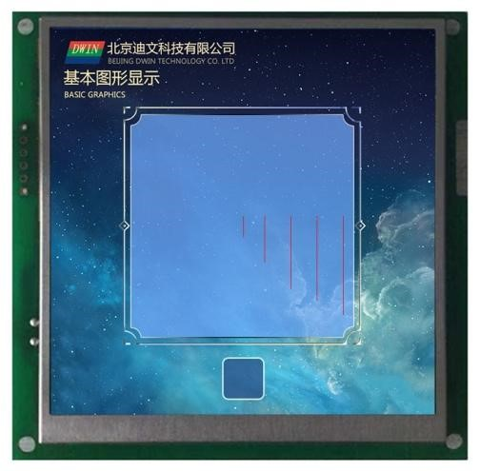

Figure **7.31 Basic** graphical rectangular spectrum display effect.

**7.4.2.3.7** Segment Display .

A segment is displayed.

|  |  |  |  |  |
| --- | --- | --- | --- | --- |
| 000A | 0001 | F800 | 0168 0168 | 0190 0168 |

5A A5 13 82 5440FF00

含义：0x5A A5帧头；0x11数据长度；0x82写指令；0x5440变量地址；

0x 000A画线段；

0x 0001 draws a line; ；

0x F800颜色；

0x 0168 0168（360,360）坐标；

0x 0190 0168（400,360）坐标； 0xFF00绘图操作结束。

Two segments are displayed.

|  |  |  |  |
| --- | --- | --- | --- |
| 000A | 0002 | F800 0168 0168 0190 0168 | F800 0168 0190 01C2 0190 |

5A A5 1D 82 5440FF00

含义：0x5A A5帧头；0x11数据长度；0x82写指令；0x5440变量地址；

0x000A画线段；

0x0002 Draw two segments; ；

0x F800颜色；0x 0168 0168（360,360）坐标；0x 0190 0168（400,360）坐标； 0x F800颜色；0x 0168 0190（360,400）坐标；0x 01C2 0190（450,400）坐标； 0xFF00绘图操作结束。

Three segments are displayed.

|  |  |  |  |  |
| --- | --- | --- | --- | --- |
| 000A | 0003 | F800 0168 0168 0190 0168 | F800 0168 0190 01C2 0190 | F800 0168 01C2 01F4 01C2 |

5A A5 27 82 5440FF00

含义：0x5A A5帧头；0x11数据长度；0x82写指令；0x5440变量地址；

0x 000A画线段；

0x 0003 draws three segments; ；

0x F800颜色；0x 0168 0168（360,360）坐标；0x 0190 0168（400,360）坐标；

0x F800颜色；0x 0168 0190（360,400）坐标；0x 01C2 0190（450,400）坐标； 0x F800颜色；0x 0168 01C2（360,450）坐标；0x 01F4 01C2（500,450）坐标； 0x FF00绘图操作结束。

Four segments are displayed.

|  |  |  |  |  |  |
| --- | --- | --- | --- | --- | --- |
| 000A | 0004 | F800 0168 0168 0190 0168 | F800 0168 0190 01C2 0190 | F800 0168 01C2 01F4 01C2 | F800 |

5A A5 31 82 5440

|  |
| --- |
| 0168 01F4 0226 01F4 |

FF00

含义：0x5A A5帧头；0x11数据长度；0x82写指令；0x5440变量地址；

0x000A画线段；

0x0004 Draw four segments; ；

0x F800颜色；0x 0168 0168（360,360）坐标；0x 0190 0168（400,360）坐标；

0x F800颜色；0x 0168 0190（360,400）坐标；0x 01C2 0190（450,400）坐标；

0x F800颜色；0x 0168 01C2（360,450）坐标；0x 01F4 01C2（500,450）坐标；

0x F800颜色；0x 0168 01F4（360,500）坐标；0x 0226 01F4（550,500）坐标； 0xFF00绘图操作结束。

Effect: ： .

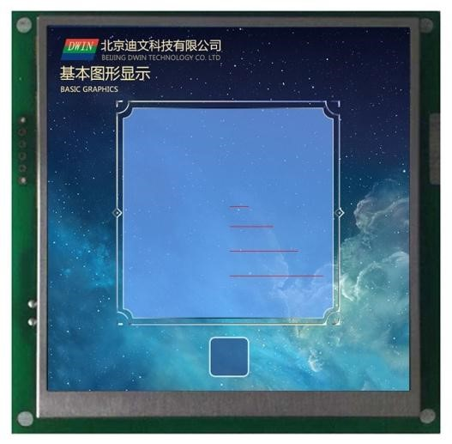

Figure **7.32 Basic** graphical segments show the effect.

**7.4.2.3.8** Rectangular domain **XOR** highlights the anticolor display.

Rectangular field XOR,highlighted in reverse colors once.

|  |  |  |  |  |
| --- | --- | --- | --- | --- |
| 000D | 0001 | 0168 0168 | 0190 0190 | F800 |

5A A5 13 82 5440FF00

含义：0x5A A5帧头；0x13数据长度；0x82写指令；0x5440变量地址；

0x 000D矩形域XOR；

0x 0001矩形域XOR一次；

0x 0168 0168（360,360）坐标；

0x 0190 0190（400,400）坐标；

0x F800颜色；

The 0xFF00 drawing operation ends.

Rectangular field XOR,highlighted in reverse twice.

|  |  |  |  |
| --- | --- | --- | --- |
| 000D | 0002 | 0168 0168 0190 0190 F800 | 0190 0190 01C2 01C2 F800 |

5A A5 1D 82 5440FF00

含义：0x5A A5帧头；0x1D数据长度；0x82写指令；0x5440变量地址；

0x 000D矩形域XOR；

0x 0002矩形域XOR两次；

0x 0168 0168（360,360）坐标；0x0190 0190（400,400）坐标；0xF800颜色； 0x 0190 0190（400,400）坐标；0x01C2 01C2（450,450）坐标；0xF800颜色； 0xFF00绘图操作结束。

Rectangular field XOR,highlighted anticolor three times.

|  |  |  |  |  |
| --- | --- | --- | --- | --- |
| 000D | 0003 | 0168 0168 0190 0190 F800 | 0190 0190 01C2 01C2 F800 | 01C2 01C2 01F4 01F4 F800 |

5A A5 27 82 5440FF00

含义：0x5A A5帧头；0x1D数据长度；0x82写指令；0x9010变量地址；

0x 000D矩形域XOR；

0x 0003矩形域XOR三次；

0x 0168 0168（360,360）坐标；0x0190 0190（400,400）坐标；0xF800颜色；

0x 0190 0190（400,400）坐标；0x01C2 01C2（450,450）坐标；0xF800颜色；

0x 01C2 01C2（450,450）坐标；0x01F4 01F4（500,500）坐标；0xF800颜色； 0xFF00绘图操作结束。

Effect: ： .

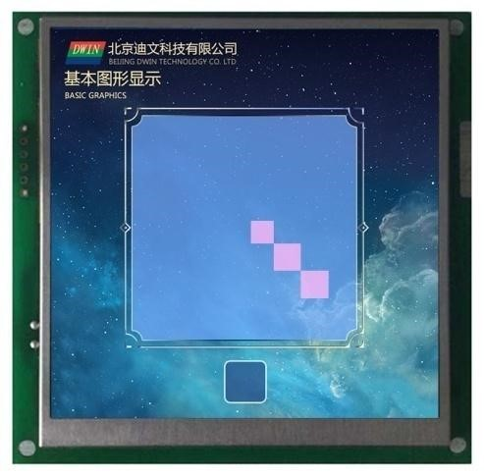

Figure **7.33 Basic** graphical **XOR** anti-color display.

#### **7.4.3** Zone Roll Display .

**7.4.3.1** Zone Scroll instruction storage format.

The area scroll is to move the contents of the specified area around, and the direction of movement can be set. Can be used to simply implement the flowchart, progress bar and other dynamic running effects on the screen. Variable addresses are processed by the underlying system and do not have to be set by the user. Its instruction storage format is shown in the table.

**7.21** Zone roll-screen display instruction storage format.

|  |  |  |  |
| --- | --- | --- | --- |
| **The** SP describes the pointer offset. | Defined. | The length of the data.  **(**字节**)** | Description. |
| **0x00** | *VP | 2 | The variable pointer. |
| **0x01** | (x_start,y_start) | 4 | The starting position in the upper left corner. |
| **0x03** | (x_end,y_end) | 2 | The display position ends in the lower right corner. |
| **0x05** | Speed | 2 | Roll-on speed. |
| **0x06_H** | Move_way | 1 | 滚动方式 0x00=左移，0x01=右移，0x02=上移，0x03=下移 |

**7.4.3.2** Zone Roll Software Settings Instructions.

In the DGUS development software, click the display key , area roll screen display, then use the mouse box to select the display range, and set the scroll speed on the right, the movement mode can achieve the area scroll screen display.

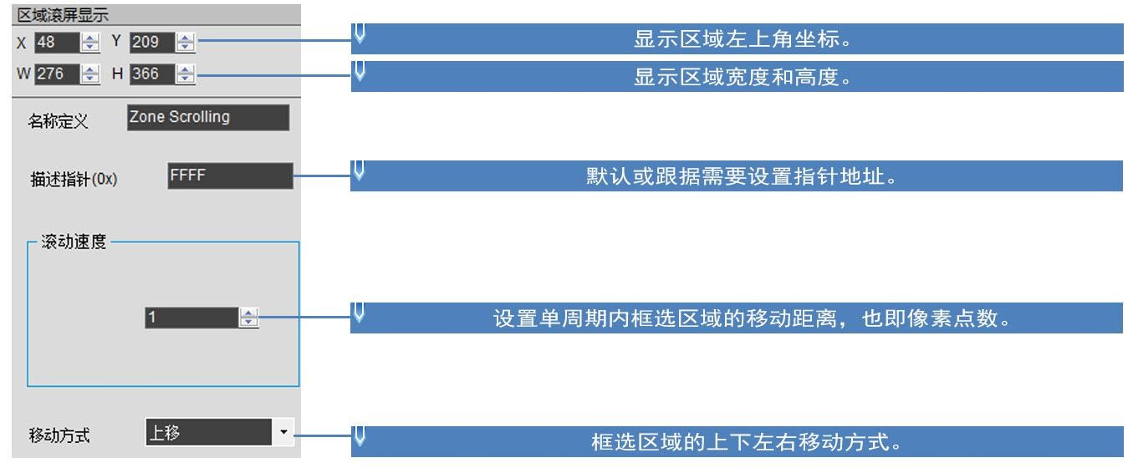

Figure **7.34 Description of** the roll-screen software settings for the area.

**7.4.3.3** Examples of regional roll-screen application instructions.

Variables are occupied by the system and users do not use .

**7.4.3.4** Zone Roll Screen Display.

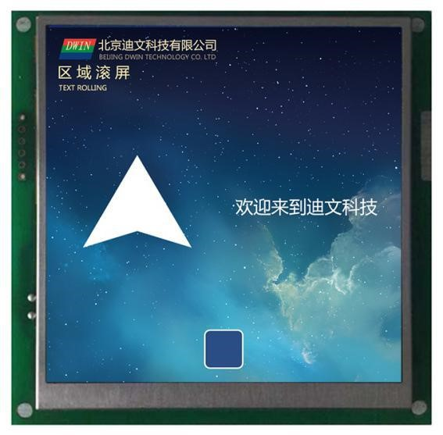

Figure **7.35** Area Roll Screen Display.

#### **7.4.4** QR code display .

**7.4.4.1** QR code instruction storage format.

The 2D QR code display feature displays the specified QR code graphic on the screen based on the specified content. Its instruction storage format is shown in the table.

**7.22** QR code display instruction storage format.

|  |  |  |  |
| --- | --- | --- | --- |
| **The** SP describes the pointer offset. | Defined. | The length of the data.  **(**字节**)** | Description. |
| **0x00** | *VP | 2 | The QR code displays the content pointer.  二维码内容最长 458Bytes,0x0000 或 0xFFFF 为结束符。 |
| **0x01** | (x,y) | 4 | The upper-left coordinate position displayed by the QR code.  The QR 单元像素（数据少于 code graphics are available in 45 x 45 单元像素（数据少于 unit pixels (less than 155 字节）和 bytes of data) and 73 x 73 unit pixels (less than 459 Bytes). 两种 |
| **0x03** | Unit_Pixels | 2 | The size of the physical pixel array used by pixels per QR unit,0x01-0x07.  Set Unit_Pixels to4,and each cell pixel will bedisplayed as a 4x4 dot matrix size. |
| **0x05** | Keep. | 18 | 未定义，写 0x00。 |

**7.4.4.2** QR code instruction software setup instructions.

In the DGUS development software, 开发软件中，点击显示控键 click on the display key QR QR code display, then use the mouse box to select the display range, and in the right-hand settings menu on the variable address, each two-dimensional code unit pixels occupied by the physical pixel size, etc. configuration can achieve QR code display.

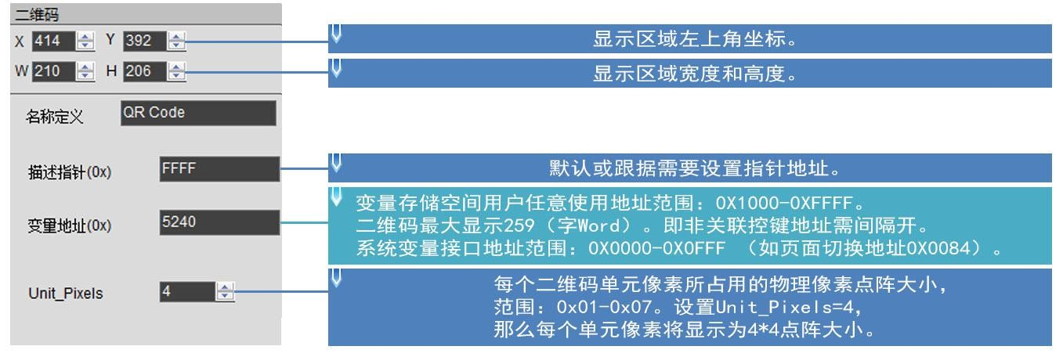

Figure **7.36 QR** code instruction software setup instructions.

**7.4.4.3 Examples** of QR code instruction application instructions.

Send instructions to display the URLhttp://www.dwin.com.cn/ and scan and open the website using WeChat.

|  |  |  |  |  |  |
| --- | --- | --- | --- | --- | --- |
| 5AA5 | 1C | 82 | 5240 | 68 74 74 70 3A 2F 2F 77 77 2E 64 77 69 6E 2E 63 6F 6D 2E 63 6E 2F | FFFF |

0x 5AA5：帧头；

0x 1C：数据长度；

0x 82：写指令；

0x 5240：变量地址；

0x 68 74 74 70 3A 2F 2F 77 77 77 2E 64 77 69 6E 6E 6E 6E 63 6F 6E 2E 2F :址い ASCII 码; 0x FFF:F 结いい **7.4.4.显码 4效果**二维码指令显示效果

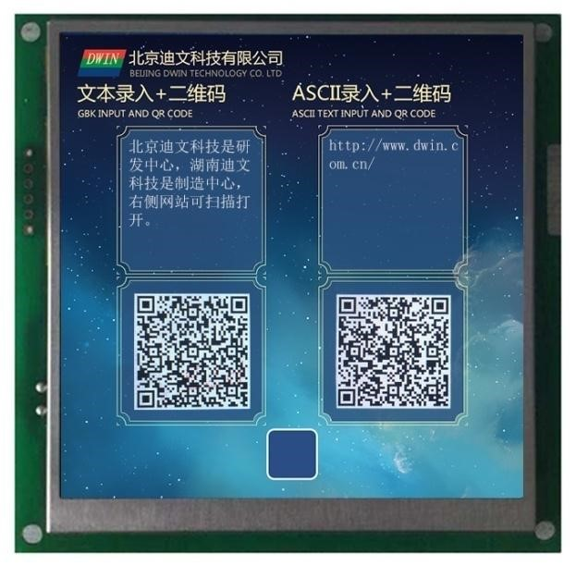

Figure **7.37 QR** code instruction software setup instructions.

# Chapter 8 Software commonly used functions.

## **8.1** Import restore .

If there is only one DWIN_SET folder, you can restore the project through the import feature. Export refers to the export project's 13 touch file,14 display file pointer address EXCEL table.

Step 1: Open the software in welcome to use the interface to create a new project, resolution and picture consistent;

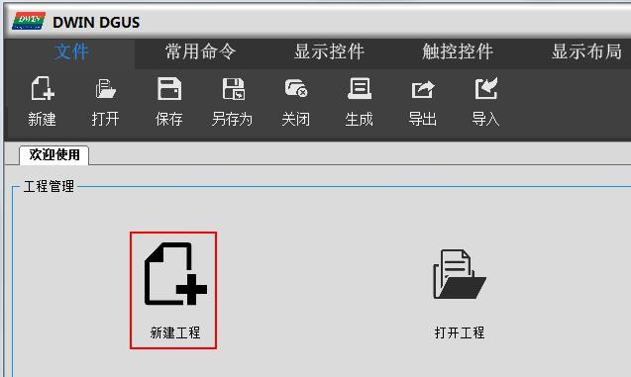

Step 2: Add DWIN_SET the picture inside the new project; ；

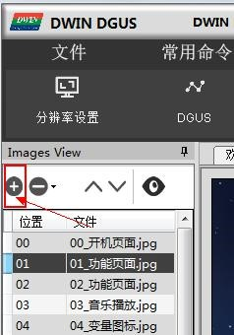

Step 3: Select the original DWIN_SET folder, click Import, you can see that the project keys have been restored.

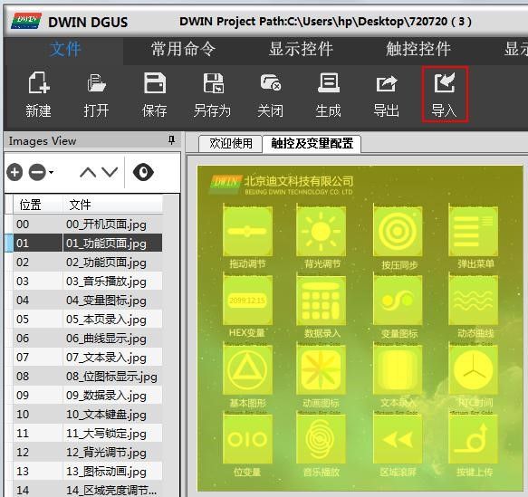

Step 4: After the successful import, the original DWIN_SET inside the icon library, word library and other files are copied to the new project's DWIN_SET inside, adjust the key position appropriately.

## **8.2** Key alignment.

Key alignment makes it easy to align the touch and display controls of the demo, making them neat, beautiful, and orderly.

Step 1: The left mouse button box selects the keys that need to be aligned; ；

Step 3: Click on the standard key as a reference, at which point the other keys will be aligned with it as a reference.

Left-aligned, right-aligned, key size equal use method.

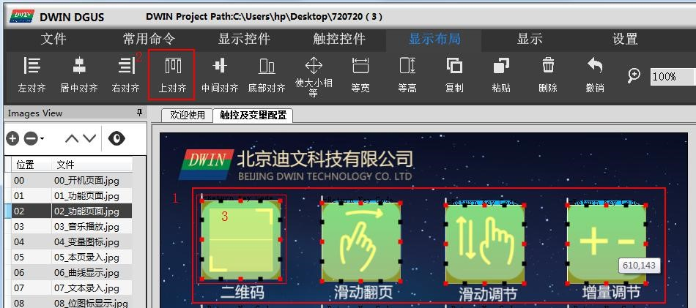

## **8.3** Key-controlled front and rear functions.

Slide gesture page-turning and drag-adjusting overlays, and if you drag-adjust in front of the swipe gesture page-turning, the drag-adjusting does not work, just tap The swipe gesture turns the page before you turn. More applied to the icon display on the small picture to add data variable overlay display and other functions.

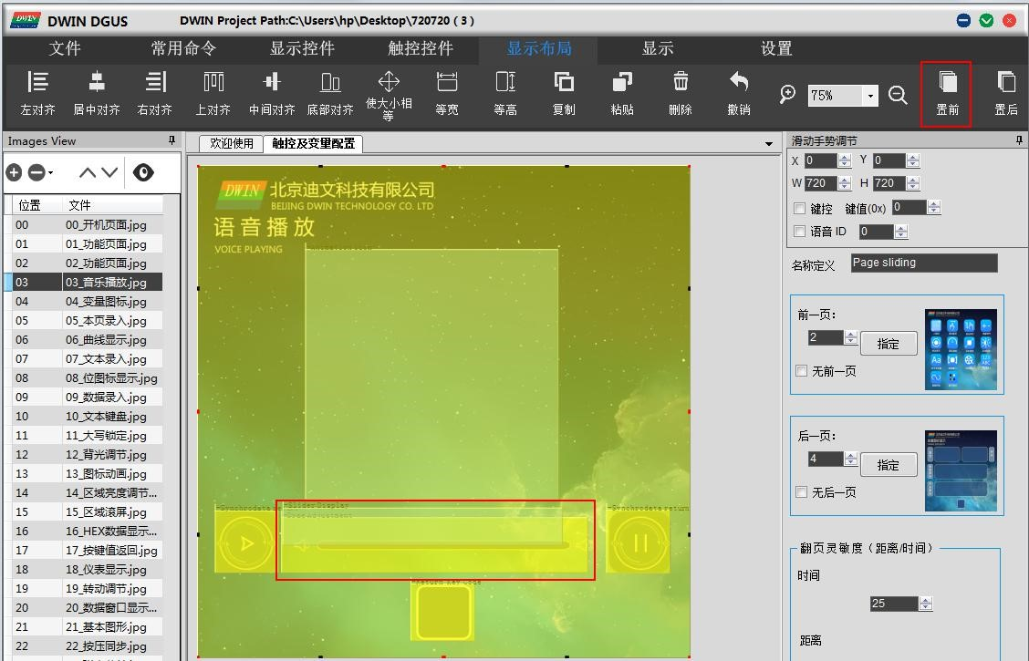

## **8.4** View variable address usage planning.

During development engineering, you sometimes need to see if the current project VP 变量地址或 variable address or SP 描述指针地址是否冲突，此时点击显示 description pointer address conflicts, and then click Show s to see the set pointer address.

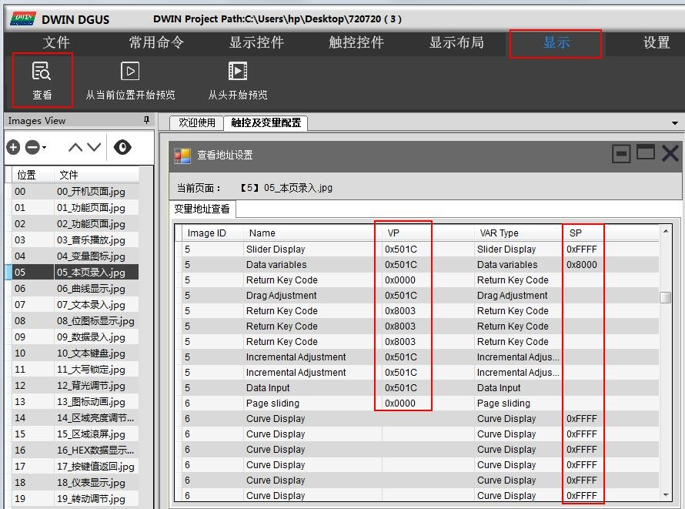

## **8.5 Software** feature preview.

During the development of the project, you can check that the project is set up correctly by clicking Show , starting with the preview from the current location.

Entry keys such as and slide page-turning keys overlay, you can slide page-turning keys first zoom out, to avoid the preview invalid, double-click the preview black border can exit.

The preview starts from scratch and starts on page 0. 页开始预览

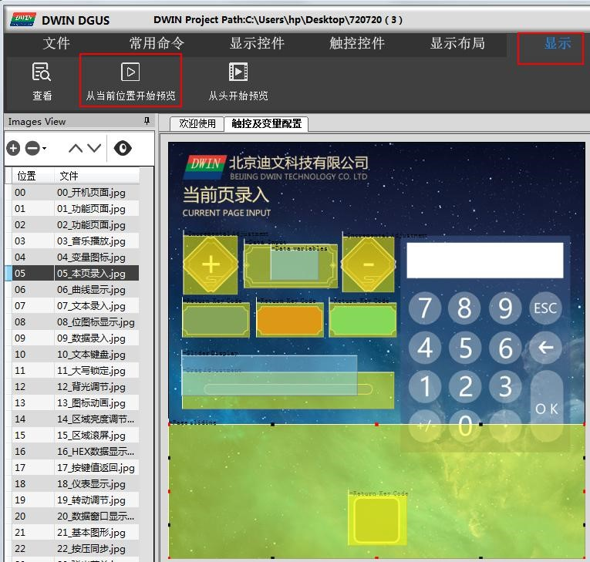

## **8.6** New resolution.

When you start a new project, you can manually enter thedesired resolution(W-H)W）数值即可 value.

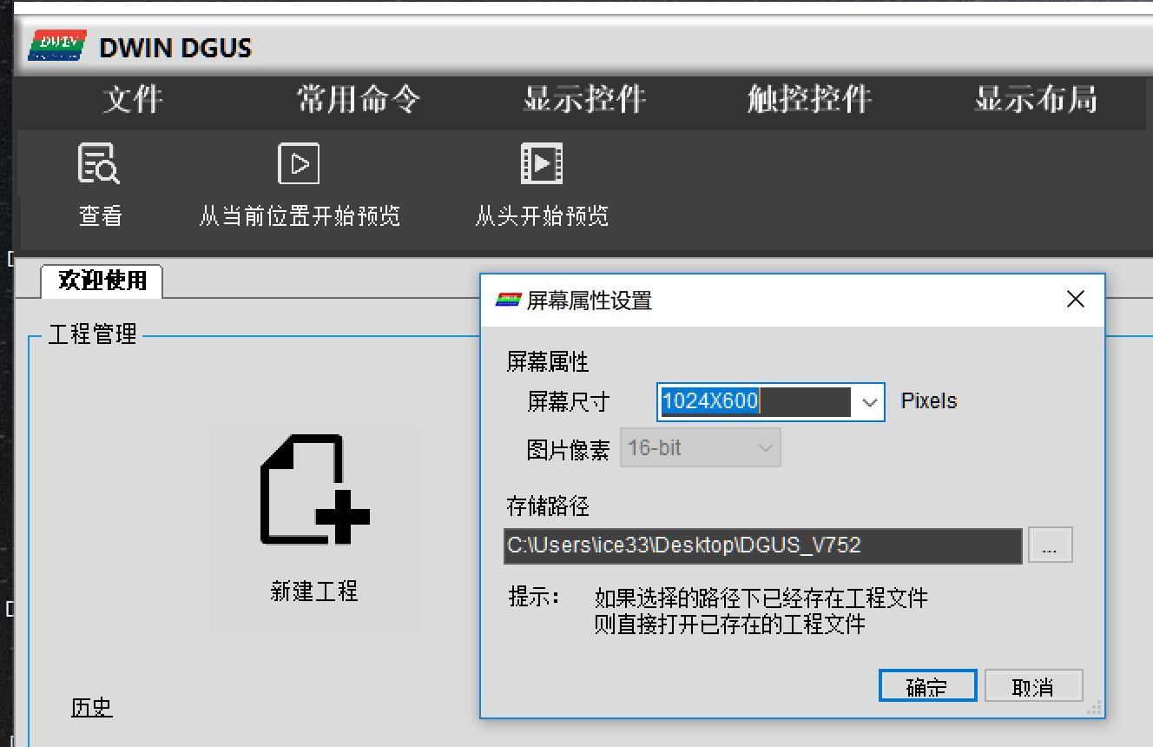

## **8.7** Conversion resolution.

For example, to change the resolution of 720 x 720 分辨率改为 to 新建一个文件夹保存；第三步：再点击文件 _ 480 x 480, inorder to avoid damage to the original project conversion, please make a copy backup of the original project, do on the copy above: firststep: _ 分辨率设置，选择所需要的分辨率，点击确定；第二步：点击文件 _ 另存为，选择 click settings , resolution settings, select the desired resolution, 是 ” click OK;

If the user copies the large-resolution DEMO project key to the small-resolution DEMO key, the key interface disappears. Click on the keyboard 左移键，边侧会看到相应控键，移到合适位置即可 Ctrl-A all-select, click on the keyboard """"""""""""""""""""""""""""""""""""""""""""""""""""""""""""""""""""""""""""""""""""""""""""""""""" 上移键或 “←”

Software function keys can support Ctrl-C, Ctrl-V-in-line replication for the same project and different engineering windows. Because the overall pixels of the screen have changed, if the icon icon is used, the size of the icon generally needs to be re-adjusted, if the text and other data show that the font size also needs to be modified.

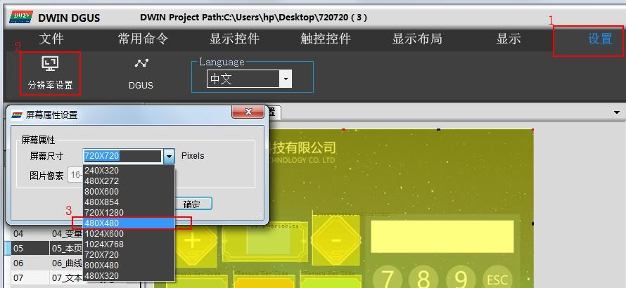

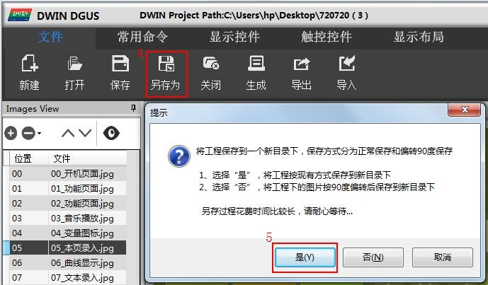

# 附录 **1**：**T5L_DGUS II** 屏常见应用问答 **FAQ**

1. After **downloading DWIN_SET the** image, a black screen (only a faint light) is displayed.

A: The kernel firmware version T5L_UI_TA_V10. BIN to T5L_UI_TA_V11. BIN adds a feature that background picture space can be customized with the SD card CFG file. Causes the original earliest batch of users not to configure the correct CFG file, background picture . The ICL file is not loaded and is therefore black.

1. Only one picture appears as a black screen.

|  |
| --- |
| Because images such as picture gradient colors are not displayed in consistent complexity, especially the higher the resolution, the last, compressed into . JPG . |

|  |
| --- |
| Small may exceed 252KB. |

答：对于 T5L1 平台，ICL 格式的文件包中，单个 JPG 图片大小不要超过 252Kbytes。 T5L2 平台中，单个 JPG 图片不能超过 764Kbytes。 大

, the user needs to lower the JPG image quality percentage slightly. You can use the latest PC version of the tool software to convert beyond .

The size is prompted.

# **Appendix 2:**Revised records.

|  |  |  |
| --- | --- | --- |
| Date. | The revision. | DGUS版本 |
| 2019-02-02 | Published for the first time. | V1.0 |
| 2019-03-04 | Increasing the location of the background picture can be configured with CFG file customization on the SD 卡配置 文件自定义功能 card. | V1.1 |
| 2019-03-22 | Added network communication interface 0x0400,which can be connected directly to The Devon Cloud through the Devon WiFi module. | V1.2 |
| 2019-04-06 | Added icon display background filtering,PC software version updated to 7.52. | V1.4 |
|  |  |  |